Volunteer Role – Event day Assistant

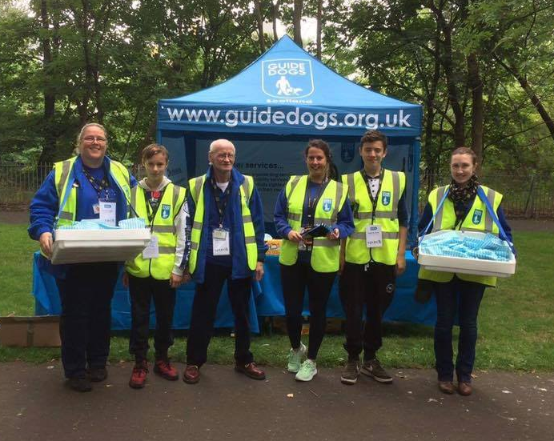 | To support the Event Manager with the planning, co-ordination, logistics and delivery of the event as required.    The time commitment for this role is very flexible, you can volunteer for 1 day or many more depending on the events you choose to help with.

What does the role involve?
- This role is all about getting stuck in! Tasks will vary, allowing you to be involved in many elements of the event such as: pre-event planning, set up, de-rig, cheering, event co-ordination tasks and much more!
- Assist with arranging ‘on the day’ requirements as required by the Event Manager, ensuring that event participants have a great time!
- Depending on the event you attend, tasks include but are not limited to: setting up branding, covering registration, bag drop or stalls, cheering on our participants, co-ordinating sports massages, escorting participants to the post-race reception, handing out medals, helping at one of our Sense Stations or marshalling the route.

Location: Varied – depending on the event chosen

What skills or experience are required?
- Reliability and punctuality
- Able to work independently using own initiative
- Friendly with good interpersonal skills
- Able to work in an environment with dogs
- Able and willing to undertake any training relevant to the role

What will I get out of it?
- Support Guide Dogs to provide services that enable people who are blind and partially-sighted to enjoy the same freedom of movement as everyone else
- An understanding of how the different parts of Guide Dogs work
- An opportunity to attend Guide Dogs events across the U.K
- An opportunity to build experience for your CV
- Payment of out of pocket expenses in line with Guide Dogs volunteer expenses policy

What support / training will I get?
- Volunteer induction to Guide Dogs and to the role
- Regular and ongoing support from your supervisor before, during and after the event you support
- General and specific communications from Guide Dogs as relevant to your volunteering

Will I need to do a Disclosure check?
No

Minimum Age: 18

This role is managed by:
Events team

