Guide Dogs Appeal 2023: Template Social Media examples
Here are examples of how to make the most out of our social media assets. All assets are available in 1080x1080 (Instagram) or 1200x630 (Facebook, Twitter, or LinkedIn) for optimal use. Images can be downloaded via Facebook Sharing Ideas and VIP.

Facebook banner examples:
We have options for your Facebook group or page banners this October:

Facebook banner 1:
Visual description: Text ‘Get together this October’ with a family walking their dog together on a sponsored walk.

Facebook banner 2:
Visual description: Text ‘Get together this October’ with a money box having a coin inserted into it.

Social media post examples:

Post 1: Get together key messages
Sight loss can affect anyone, at any age or stage of life. Often, it makes people feel alone and isolated. From friends and loved ones, from careers and communities, from the world they knew and the lives they’d planned.

For this year’s Guide Dog’s Appeal in October, we’re asking all our supporters to get together - and raise money to help tackle the loneliness and isolation caused by sight loss.

Support our local fundraising this October or find out more about this year’s Guide Dogs Appeal at guidedogs.org.uk/appeal

Together, we can break down the barriers that keep people apart. Family by family, person by person, penny by pound, we can end the loneliness and isolation caused by sight loss.

[Visual description: Text ‘Get together’ with people at work smiling and laughing while enjoying cake in the staff room]

Post 2: How can supporters Get Together?
Join the Guide Dogs Appeal this October and raise money to help tackle the loneliness and isolation caused by sight loss. Sign up for a free fundraising pack at guidedogs.org.uk/appeal

⭐ Get Together with your friends and family for a sponsored challenge that everyone can get involved in - no matter their age.
⭐ Get Together with colleagues for a Guide Dogs fundraising dress down day, bake sale or raffle at work.
⭐Get together life-changing cash donations using our free fundraising pack includes puppy sweepstakes, coin collector, and money box.

[Visual description: Text ‘Get together this October’ with a family walking their dog together on a sponsored walk]
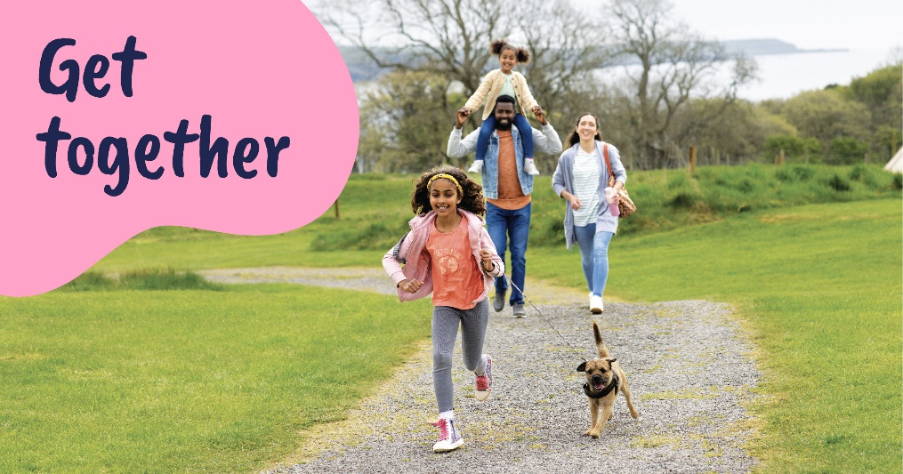

Post 3: Editable for local activities
There is lots of ways you can help support our Guide Dogs Appeal fundraising this year!

⭐Get together life-changing cash donations by coming to support us at one of our October collections at <insert local collection locations>.
⭐Get together and have fun at our Guide Dogs Appeal social fundraising event <insert local social event details>.
⭐Get Together with your friends, family or colleagues and organise a fundraiser of your own. You can sign up for a free pack at guidedogs.org.uk/appeal and family for a sponsored challenge that everyone can get involved in - no matter their age.

[Visual description: Text ‘Get together’ with a Guide Dogs money box having a coin inserted into it]

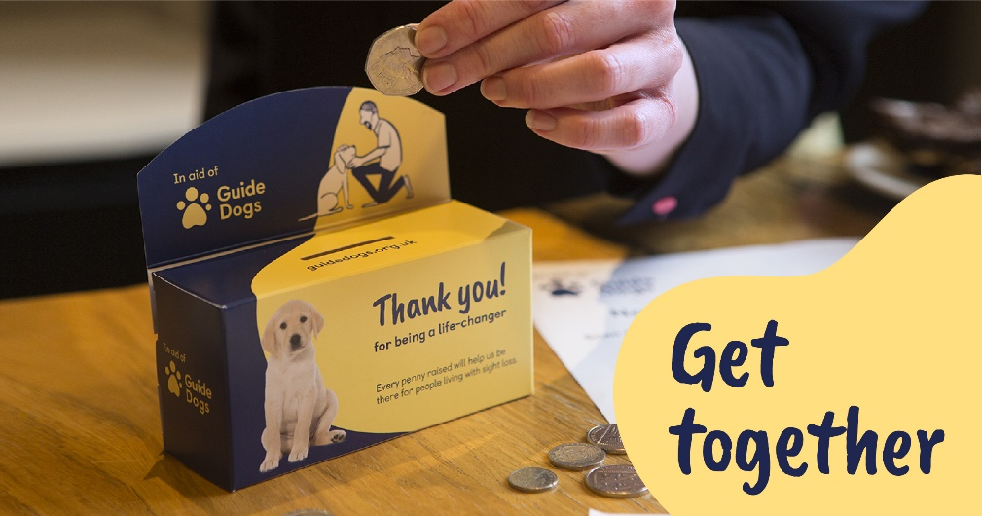

End of document.

