Guide Dogs Appeal 2023:

Get together this October and fundraise with your family, friends, colleagues, or community for the Guide Dogs Appeal 2023.

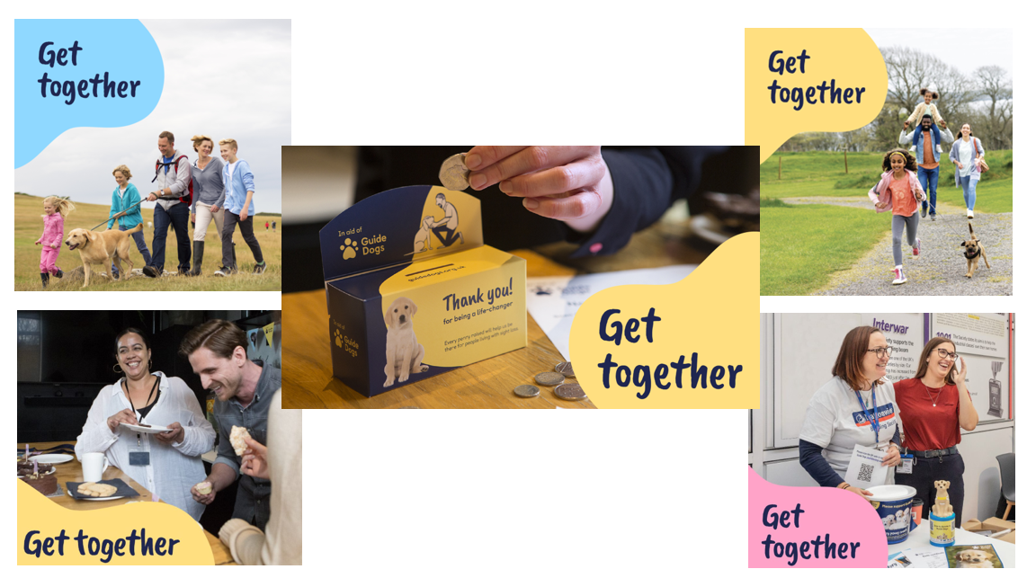

For this year’s Guide Dogs Appeal, we’re asking all our supporters to get together – and raise money to help tackle the loneliness and isolation caused by sight loss.
Our aim is to sign up around 2,160 supporters to fundraise this October and raise £135,000, with each individual or group supporter receiving a brand-new fundraising pack including a fundraising guide, cardboard money box, reusable coin collector, puppy sweepstake and more!
Whether hosting an event, completing a sponsored challenge, or popping pounds in the pot, supporters can choose to fundraise however they like. Big or small, however supporters fundraise they will be making a difference to the lives of people living with sight loss.

Key messages to the public
- Sight loss can affect anyone, at any age or stage of life.
- 1 in 5 people will live with significant sight loss in their lifetime.
- Often, it makes people feel alone and isolated. From friends and loved ones, from careers and communities, from the world they knew and the lives they’d planned.
- We know that nearly 50% of all people with a vision impairment feel cut off from the people and places around them, while 80% of parents believe their child’s sight loss has a negative effect on their ability to make friends.
- Guide Dogs offers lifelong support and services, with and without dogs, for everyone living with sight loss. Children and adults, friends and family, we give people the tools and the confidence to live independently, live actively and live well.
But we need your help.
- For this year’s Guide Dogs Appeal in October, we’re asking all our supporters to get together – and raise money to help tackle the loneliness and isolation caused by sight loss.
- Cross the generational divide and assemble your friends and family, to fundraise for Guide Dogs. Or simply come together with colleagues and community to raise money and show people with sight loss they’re not alone.
- And for those who prefer to take on a challenge alone, you can still raise awareness and funds amongst those who are supporting you.
- With the money you raise, we can help a child born with a vision impairment to take their first steps into the world or support a grandparent as the relearn to live a full life with sight loss.
- Together, we can break down the barriers that keep people apart. Family by family, person by person, penny by pound, we can end the loneliness and isolation caused by sight loss.
Some updated costs used in this year’s messaging:
- £6 could support a guide dog partnership for a day.
- £16 could buy a ‘puppy in training’ jacket for a puppy starting their journey to become a guide dog.
- £27 could help fund an hour of training for a future guide dog.

How can supporters get involved?
Third party supporters can sign up via our website guidedogs.org.uk/appeal and receive a free postal fundraising pack, downloadable tools, and everything they need to make a difference.

Our top Guide Dogs Appeal fundraising ideas are:

Get Together with your family and friends for a sponsored challenge that everyone can get involved in - no matter their age. Teach the kids the importance of kindness with their first sponsored walk, or challenge grandma to give up sweets with them for a week, or bake together across the generations and sell your goods at the school and the bingo hall!
Get Together with colleagues for a Guide Dogs fundraising day at work. Organise a dress down day, bake sale, or raffle and watch the donations roll in. Invite a free speaker to visit for a Lunch & Learn and you could even meet one of our life-changing dogs.

Get Together life-changing cash donations using our free fundraising pack which includes puppy sweepstakes, coin collector, and money box. Place them at work, ask your local pub, or even use at home for loose change – every penny counts.

However supporters choose to fundraise, we’ll support them all the way!

You can watch more of our top fundraising tips from our experts via YouTube here.

What do supporters get when they sign up?

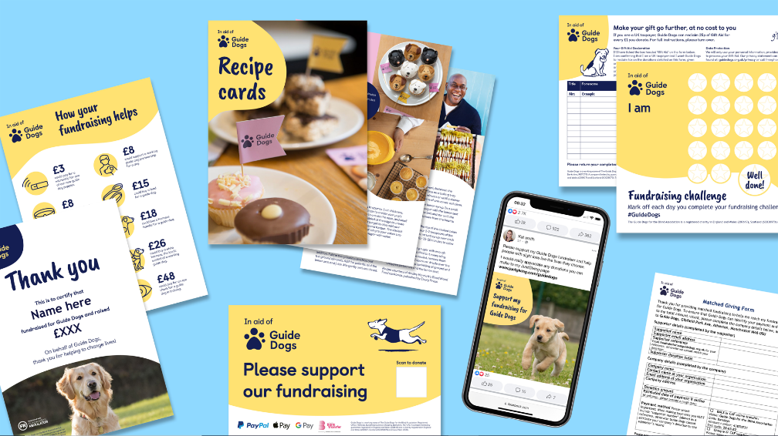

Fundraisers who sign up to get together receive:
- Postal fundraising pack sent within 10 working days of their registration, including a new 12-page guide, cardboard money box, puppy coin collector, sweepstake, and more!
- Access to our new digital fundraising advice hub which goes live this August: guidedogs.org.uk/fundraisingpack.
- Bespoke fundraising advice from our Community Fundraising experts as part of our stewardship to build life-time value from each new supporter, in addition to an automated email journey.
- ‘I’m fundraising in aid of Guide Dogs’ t-shirt and dog ears can also be ordered on request.

Exclusive invitation to visit Guide Dogs
Fundraisers will also receive an exclusive invite to our National Centre once they pay in the funds they have raised. This is to help welcome them to the Guide Dogs family and inspire them to do more fundraising or volunteering by showing them first-hand how their fundraising helps with a behind the scenes tour, guide dog demonstration, and talk from a volunteer speaker and guide dog owner.

Top tip: The easiest way for third party supporters to pay in is via guidedogs.org.uk/payin.

How can volunteers get together and support this year’s appeal?
Volunteers can access all the promotional and fundraising tools via the Community Fundraising Volunteer Newsletter, Intergroup meetings, VIP and Facebook.

Our top Guide Dogs Appeal tips are:
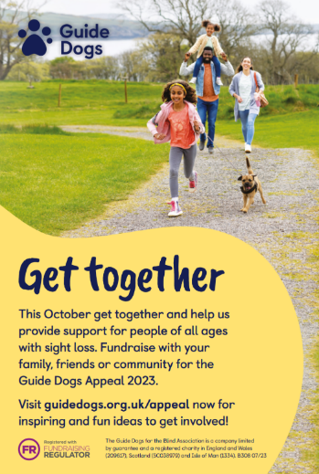
- Promote the appeal locally using our social media images and printable English and Welsh flyers.
- Use our template email to let any local contacts, your workplace, or community groups you are part of know about how they can get involved too.
- Book extra collection dates in for October. Use our appeal as a reason to get your foot in the door with local businesses.
- Re-engage with volunteers by inviting everyone to take part, even those who may not have been coming to collections recently.
- Organise a social fundraising event – a great way to get together as a group and fundraise your way, or even invite the wider Guide Dogs family. Don’t forget when paying in the money you raise, to use the code ‘Social Event’ on your banking slip.
- Share your fundraising plans using our template press releases. Contact your local newspaper or radio station and let your local community know how they can support your fundraising efforts.

Got a question?
Your local Community Fundraising Relationship Manager is here to help you or your group. If you want any additional fundraising resources, you can also contact your regional Supporter Care team.

Contact the Guide Dogs Appeal team via guidedogsappeal@guidedogs.org.uk or call 0345 143 0192.

End of document

