Guide Dogs Puppy Appeal 2024

Training life-changing dogs with your support


This October, we’re launching the Guide Dogs Puppy Appeal – our new look going forward in our annual fundraising appeal.

From donating or raising valuable funds, to volunteering an hour of your time. To even signing up to sponsor a puppy and follow one of our pups on their journey to becoming a guide dog. However supporters choose to support with their friends and family, colleagues, community or even their own, they’ll be helping our puppies to become life-changing guide dogs, giving freedom and independence to people with sight loss.

Key messages to the public
- Training life-changing dogs, with your support.
- Every six minutes someone starts to lose their sight in the UK.
- Living with sight loss can be incredibly difficult. Without the right support, people can be left feeling alone and isolated. From their friends and family, careers and communities, from the world they knew and the lives they planned.
- But our dogs transform the lives of people with vision impairments; being partnered with a guide dog reduces loneliness and enables people with sight loss to get out and live the life they choose.
- This year 1,300 puppies will start their journey to become a guide dog. And we need your help to turn these pups into partnerships. The guide dog service receives no government funding, we rely on donations to continue our life-changing work.
- This October support the Guide Dogs Puppy Appeal and help us to transform our pups into partnerships.

Updated costs used in this year’s messaging
- £3 could pay for a microchip for one of our guide dog puppies.
- £8 could support a working guide dog partnership for a day.
- £16 could buy a ‘puppy in training’ jacket for one of our puppies.
- £26 could buy a white harness, the iconic symbol of a working guide dog.
- £80 could buy a puppy raising kit for the volunteers who look after our puppies during their first year.
- £141 could buy a starter kit for a guide dog partnership, containing everything they need to start their new life together.

Supporters

What are supporters being asked to do?
Become a Guide Dogs Puppy Appeal Champion and:
- Organise a fundraiser at their work, school, community group or a local business during October.
- Visit shops, businesses, or community spaces and encourage them to fundraise by having a Guide Dogs Puppy Appeal fundraiser.
- Rally a team of friends, family, or colleagues to donate an hour of their time to support a Guide Dogs organised fundraising event in their local area.

Donate an hour
Being a Champion might not be for everyone, so if co-ordinating a fundraiser or a team of people isn’t for a supporter, then they can donate an hour of their time to provide help to collections being co-ordinated by volunteer fundraising groups, or via staff in areas where there are gaps in volunteer support and the potential to fulfil extra collections, we wouldn’t normally be able to host. The donate an hour website is guidedogs.org.uk/hour.

How can a supporter get involved?
Third-party fundraisers can sign up via our website and receive a free postal fundraising pack, downloadable tools and everything they need to help turn our pups into partnerships.

What is the role of a Guide Dogs Puppy Appeal Champion?

- To contact locations in their area and inspire them to fundraise for our appeal.
- Order and drop off the fundraising packs to each location they’ve got involved in the build up to October.
- Support the locations, or do their own fundraising activity, during October.
- Co-ordinate paying in the funds raised by each location either online, at the bank, over the phone, or via cheque, as soon as possible after your fundraising is complete.

What is a Champion asking places to do?
Champions are asking local shops, businesses, community spaces to fundraise in October. Locations can fundraise any day, any way they like!

But anything goes if they are having fun and raising life-changing funds! We’ll provide the Champion with a fundraising pack for each location the Champion signs up with everything they need to make a difference.

What do supporters get when they sign up?
You can view all the Guide Dogs Puppy Appeal resources available on VIP but supporters will get access to downloadable resources which will be available on the digital fundraising hub.

What’s in the Champion fundraising pack?


Automatically via digital format:
- New digital PDF Champion fundraising guide on how to be a Champion.

Requested via post:
- Print version of the new Champion fundraising guide along with a welcome letter confirming pay in reference/slip.
- Fundraising mini guide/leaflet that can be used to engage locations and left with them if they aren’t sure about whether to get involved or not. This has an editable section for the Champions own contact details.
- Not an existing volunteer? We’ll send a proof of fundraising letter, ‘I’m fundraising in aid of Guide Dogs’ t-shirt, and some wearable fluffy dog ears to make sure everyone knows you are part of our pack.
- Fundraising pack for each location they sign up to fundraise in October. Our packs are not a standard one size fits all. The CFRM will work the Champion to decide what resources are sent out within each pack.

What’s in the locations fundraising packs?
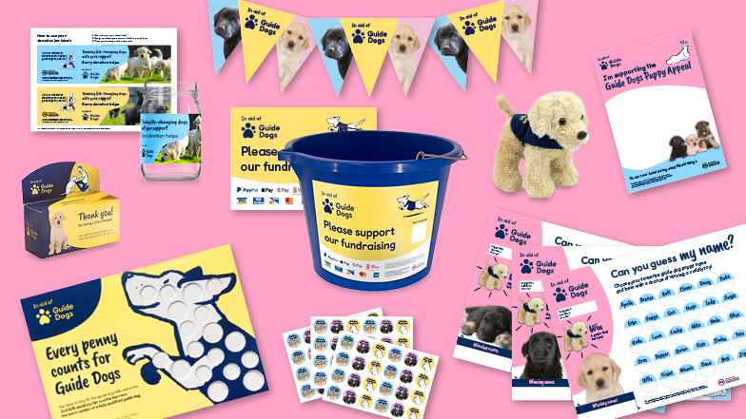

We’ll provide the Champion with a fundraising pack for each location the Champion signs up with everything they need to help turn our pups into partnerships. It is the Champions responsibility to give the pack to the location. The CFRM will liaise with the Champion to understand what is needed in each bespoke pack and place an order for the pack to be posted.

The bespoke pack could include:
- Information about the Guide Dogs Puppy Appeal and our top fundraising tips such as wearing it bright for the day – just like the colours on our iconic guide dog harnesses.
- Posters, bunting, and other promotional tools to showcase their fundraising for Guide Dogs.
- Bucket labels, jam jar labels, cardboard coin collectors or money boxes to help collect donations.
- Puppy sweepstake game including a free fluffy guide dog toy as the winning prize.

What’s in the donate an hour pack?
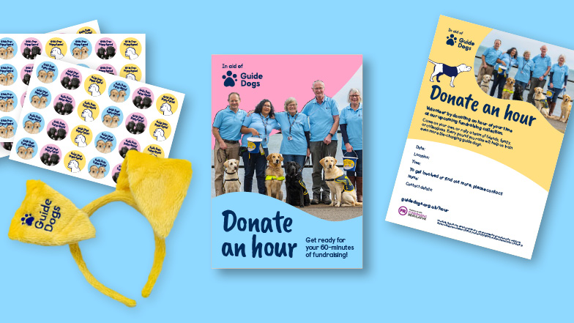

Requested via post:
- A welcome letter including a donate an hour guidance booklet containing all the information they ned in the build up to, and on the day, including facts about the journey our pups take to become guide dogs, and some frequently asked questions by the public.
- Wearable fluffy dog ears which they will be encouraged to wear whilst collecting.

All supporters will receive bespoke fundraising advice from our Community Fundraising experts as part of our stewardship to build life-time value from each new supporter, in addition to an automated email journey.

Volunteers

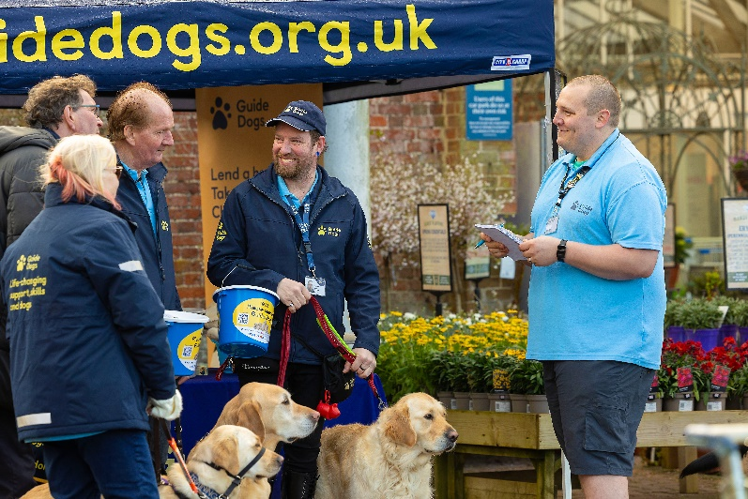
How can you support as a volunteer?
As in previous years, we want to encourage our volunteer groups to increase the collections they have planned across October. Individuals within the group can of course step up to be Champions also.

If a group wants to organise an event, that is also great. Whatever they like to do to support our annual appeal and boost their funds while having fun!

How can volunteers promote the appeal?
Volunteers can access all the promotional and fundraising tools via VIP, Community Fundraising Volunteer Newsletter, Intergroup meetings and Facebook.

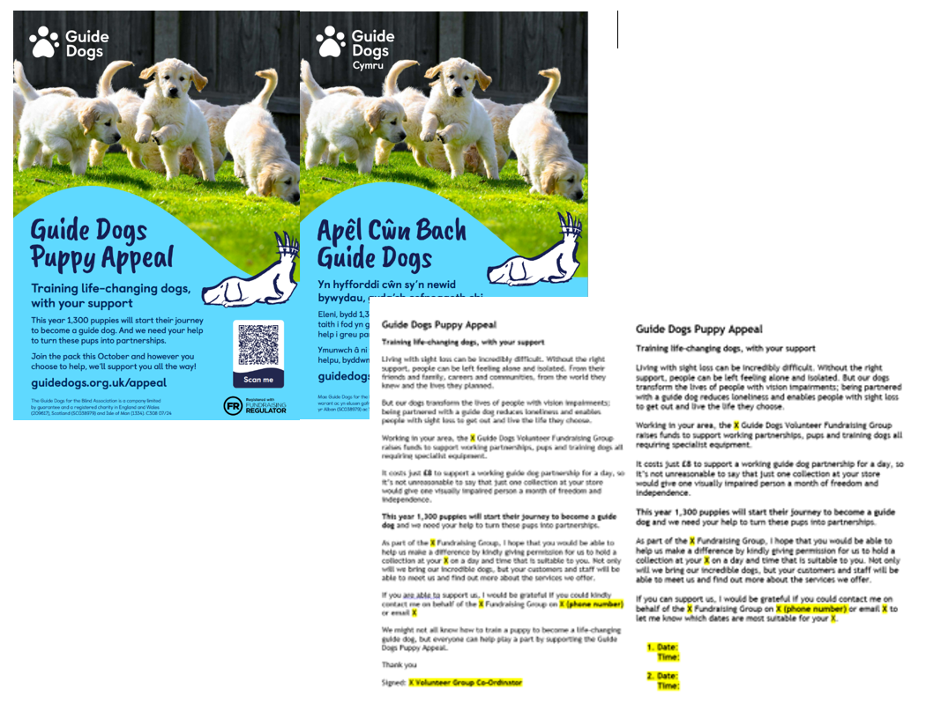

- Going to a local event and know people who may be interested in supporting? Promote our appeal by using our English and Welsh flyers.

- Use our template email to let any local existing contacts know about how they can get involved.

- Use our social media images and template social media posts to spread the word on Facebook, Instagram, Twitter or LinkedIn. Check out our Word Document on VIP named ‘Template social media posts’ to find some suggested social media posts to use on your Facebook pages to promote this year’s Guide Dogs Puppy Appeal.

- Book extra collection dates in for October! Use our appeal as a reason to get your foot in the door with local businesses by using our single and multiple date collection request templates.

- Re-engage with volunteers by inviting everyone to take part, even those who may not have been coming to collections recently.

- Share your fundraising plans using our template press releases. Contact your local newspaper or radio station and let your local community know how they can support your fundraising efforts.

If any additional resources are required, volunteers can contact their regional Supporter Care team.

Paying in the funds raised
If you have fundraised as part of your volunteer fundraising group activities, please use your paying in books to bank the money you raise. Income should be banked under FR4US.

All third-party fundraisers who sign up via the website will receive information on how to pay in as part of their supporter journey.

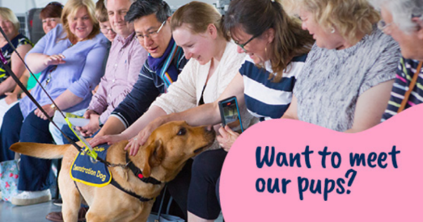

Fundraisers will also receive an exclusive invite to our National Centre once they pay in the funds they have raised. This is to help welcome them to the Guide Dogs family and inspire them to do more fundraising or volunteering by showing them first-hand how their fundraising helps with a behind the scenes tour, guide dog demonstration, and talk from a volunteer speaker and guide dog owner.

Got a question?
Your local Community Fundraising Relationship Manager is here to help you or your group. If you want any additional fundraising resources, you can also contact your regional Supporter Care team.

Contact the Guide Dogs Puppy Appeal team via guidedogsappeal@guidedogs.org.uk or call 0345 143 0192.

End of document.

