# Guidance notes

Huge thanks for choosing to support us. Now we want to help you spread the word about the amazing things you’re doing. Share your event with parents and carers to get their support and donations to make it an even bigger success. Plus, let everyone know how much you are promoting pupil development.

We want to make sure that our fundraising is inclusive and not extra workload for anyone, so we encourage you to give plenty of notice before a fundraising event and to use anonymous online donations instead of collecting cash in school.

We’ve drafted up a letter for parents and carers to fill them in on your fundraiser – just add a few details on the next page and share, share, share! Use it on your newsletter, pop it on your website, pin it to your noticeboard, share on social media, or post on your online community like Tapestry or ClassDojo.

Tell them why you’ve decided to support Guide Dogs and use our resources to share your favourite Guide Dogs facts, including how we rely on donations to fund our life-changing services. You might want to share:

### Why Guide Dogs?

**1 in 5 people will have significant sight loss in their lifetime.** There are 28,000 young people with a vision impairment in the UK. Guide Dogs are the largest employer of specialists dedicated to helping children with vision impairment learn, grow, and access the same opportunities as everyone else.

### Where does the money go?

**£8** could support a guide dog partnership for a day. **£26** could pay for a child to attend a Guide Dogs My Time to Play session, where they can learn important skills through play. **£51** enables us to produce a tailor-made, large print book for a child with sight loss, so they can enjoy reading just like their friends.

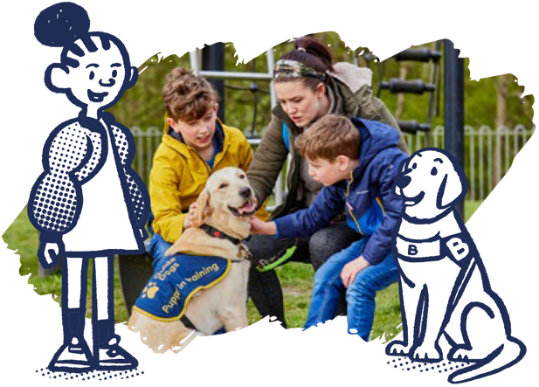Dear families,

### [Name of fundraiser]

#### [Date of fundraiser]

Each year, we plan a small number of fundraising activities for our students to enjoy and learn about important issues that affect their community. We are excited to share that this [date], we will be putting the fun in fundraising and supporting Guide Dogs to help people with sight loss live the life they choose. [Insert information here as to why you have chosen our charity. You are more likely to gain support if they know the background to this – any personal connections or how students/staff decided on us]. If you’d like to learn more about the work of Guide Dogs across the UK, please visit [www.guidedogs.org.uk](http://www.guidedogs.org.uk/).

We will be [details of event and what students will be expected to do]. Our targeted goal is to reach [insert figure and any reason why you have selected this]. Every pound raised makes a difference.

We would be very grateful for any donations via ParentPay/JustGiving link/by scanning the QR code below. We’d love for you to make this event even more successful by [insert details here – do you want them to attend, do you need any help with running the event, can they help provide resources or help spread word about it?]

We are continually amazed by the support and generosity of this school community – thank you! Let’s come together and raise life-changing funds while making lasting memories.

Yours faithfully,