Safeguarding Awareness 2020 - Level 1
(England)
On completion of this e-learning you will:

- Be able to explain what Safeguarding is.
- Understand why it is important to Guide Dogs.
- Identify how it relates to you as an employee or volunteer.
- Demonstrate an understanding of confidentiality and
consent.
- Use the codes of conduct to work within professional boundaries.

Introduction to Safeguarding
- Guide Dogs is an organisation that works with potentially vulnerable people. Within your role you may encounter people who are potentially vulnerable or at risk of harm.
- We have a duty of care that all staff members and volunteers are equipped to respond to concerns that may arise.
- Guide Dogs requires all staff and volunteers who work directly with our service users to complete mandatory Safeguarding training.

Safeguarding Training
Level 1 eLearning – all staff will complete this during their induction. This training is also mandatory for all volunteers in disclosure roles.

At the end of this e-learning you will be asked to complete a short quiz.

Level 2 workshop
This a half day workshop that follows on from the eLearning. It is delivered locally and is mandatory for staff and volunteers in disclosure roles.

During the Covid-19 pandemic, face to face sessions will not be held. Please discuss with your line manager or the Safeguarding team for more info.





Help and Advice
Safeguarding can be a sensitive topic. During this e-learning you will be reading about aspects of abuse which some people may find difficult to read.
If you have been affected by any issues and feel you cannot complete this, please contact:
- your line manager.
- your volunteer supervisor.
- or a member of the Safeguarding team on 0345 143 0199 or email
- safeguarding@guidedogs.org.uk

What is Safeguarding?

Safeguarding has a wide remit which requires us to:
- Promote the welfare of vulnerable groups;
- Prevent harm from occurring to all, including staff, volunteers, service users and the public.;
- Protect those that have been or are likely to be exposed to the risk of harm.



Agencies that investigate and prosecute such as police and social care, rely on people such as us that work with potentially vulnerable people to inform them of any safeguarding concerns and play our part in protecting them, the same as the fire service relies on the public to alert them to a fire!

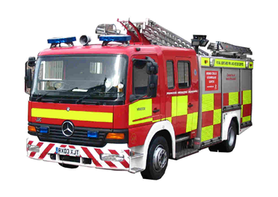

Guide Dogs has a legal duty of care to protect all those we come into contact with, from risk of harm.
Having appropriate and effective safeguards in our service provision and our day to day working ensures that we;
- Meet this duty of care;
- Embed safeguarding practice into our day to day working and the culture of our organisation
- Promote our reputation as a trustworthy and safe service provider;
- Protect our finances by being an organisation that is open, honest and ethical.

Why do I need to know about Safeguarding?


- Safeguarding is everyone’s responsibility from frontline staff and volunteers through to the board of trustees that govern us.

- To ensure the safety of yourself and those you come into contact with you need to understand what safeguarding is and what to be aware of.

- Our insurers require us to recruit and operate safely. The Charity Commission also expects us to ensure all staff and volunteers understand about safeguarding.

- You need to know what to do if someone tells you something or you have any concerns about a vulnerable person, service user, volunteer or staff member.

What Makes Guide Dogs a Safe Organisation?
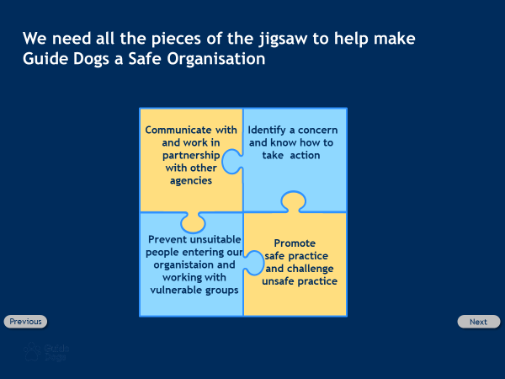

Government Guidance
Legislation states that:
- ‘Organisations in the voluntary sector need to have safeguarding arrangements’, and
- ‘paid and volunteer staff need to be aware of their responsibilities for safeguarding’.

This includes Guide Dogs having the right policies and procedures in place, safeguarding training, criminal disclosure checks and promoting a safer working environment for vulnerable people.

What makes a person vulnerable?
Miss Smith
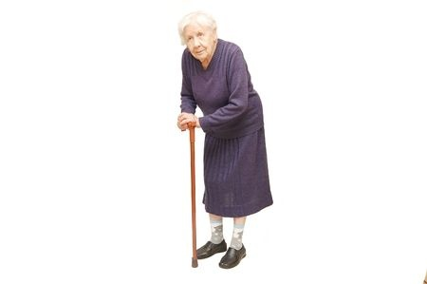

- Miss Smith is 84 years old, she is an ex headmistress who lives alone. She suffers from arthritis, is quite bent over and is fiercely independent.
- She told you that recently she had a visit from those interfering busy bodies at social services who tried to force her to have central heating installed in her little cottage and meals on wheels. Claiming these are for old people she refused and said she hadn’t had it for 84 years and wasn’t about to start having it now.
- She walks a mile in all weathers to the nearest shop and often has a sit down along the route feeling tired. When offered a lift she is offended, picks up her trolley and continues on her way.


Is Miss Smith considered to be vulnerable? Yes or No?

Miss Smith is not vulnerable.
Although Miss Smith is elderly she is able to make clear decisions on how to live her life.

Alex
- Alex is 23 years old with a steady job, she lives in a comfortable house with her two small children.
- You contact Alex to arrange for her to attend training, it has been difficult to contact Alex over the last couple of weeks but this time she has picked up the phone.
- Alex apologises and says she will have to cancel coming in for training, her excuse is quite vague.
- During the conversation she mentions she has become anxious to leave the house lately, that this happens sometimes but she can normally manage it.
- She apologises for it being noisy in the background and says the kids hate being cooped up.
- She sounds much more reserved than previously.


Is Alex considered to be vulnerable? Yes or No?

Alex could be considered to be vulnerable.
- Alex has indicated issues with her mental health.
- It seems that Alex is currently having difficulty leaving the house which leaves concerns over how she will access food, work, school etc. and may need some support at this time.
- Anyone can be vulnerable at any time due to a change in their circumstances, their physical health or mental health.
- Contact Safeguarding who will chat it through with you and can make enquiries with necessary agencies to support Alex should she need it.

Significant Safeguarding Case – Victoria Climbie

We’re now going to look at a tragic case involving the death of a young girl, Victoria Climbie.
Victoria died in 2000, despite being known to many agencies including voluntary and statutory agencies.
There was an inquiry into her death which identified many failures in protecting children.
These included:
- Failure to share information properly.
- Lack of understanding of their role in protecting children believing it to be the sole responsibility of police and social workers.
- Lack of training for staff.
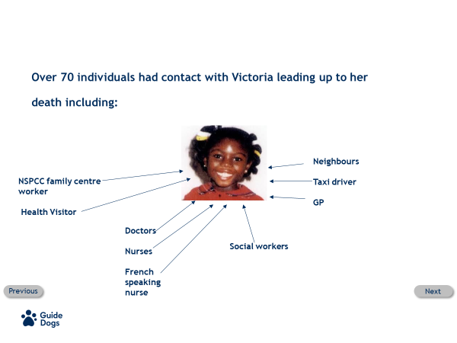
Over 70 individuals had contact with Victoria leading up to her death.
Including:
Teachers, dinner ladies, teaching assistants, doctors, nurses, French speaking nurse, social workers, neighbours, taxi driver, GP.

Who was it that took action that brought the abuse to light?
A taxi driver who realised Victoria was very sick, and against the wishes of Victoria’s aunt locked the taxi doors and took her an ambulance station where the extent of her injuries were discovered.

There was a lack of understanding that individuals had a responsibility to report their concerns. When concerns were raised there was a lack of information sharing across the various agencies.

Safeguarding History
The inquiry into Victoria’s death lead to changes in legislation, creating the 2004 Children Act and a children’s commissioner for NI and Scotland.

We are now going to look at more of the steps in Safeguarding history that have formed some of the key pieces of legislation and guidance we work with today.

Over the next couple of pages are timelines that show the development of key pieces of legislation and other cases that have influenced this.

Safeguarding Definitions England
Safeguarding can be defined as: Protecting vulnerable groups from harm and promoting their wellbeing.

It’s important to understand the difference between the legal definitions for children and adults in relation to Safeguarding.


A child is:

- Someone who is under the age of 18 who has a right to be protected in law. It’s important to note that all children are potentially vulnerable.


An adult is:

- Someone who is 18 years or over who is and may not be able to protect themselves from abuse and harm.
- Every adult has the right to live how they choose, even in risky situations, unless by doing so they put others at risk or if they are deemed to lack the mental capacity to make a reasonable judgement about the risk posed to themselves and others.

Children’s legislation Timeline

2004: Children Act
Guide Dogs has to evidence how we meet Section 11 compliance when we enter into a contract with Local Authorities.
We need to demonstrate how:
- Staff and volunteers are recruited safely.
- Staff and volunteers are trained appropriately.
- Staff and volunteers are supported and supervised.
- Staff and volunteers know how to safeguard children.

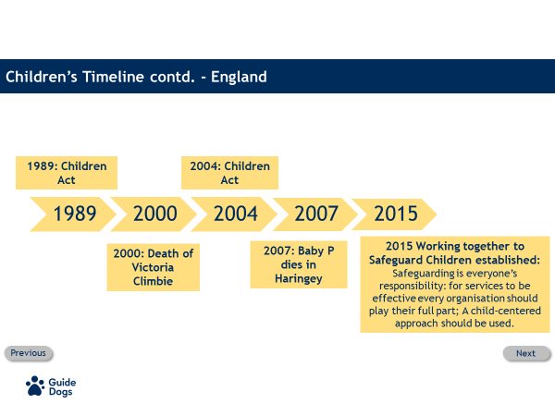

2004 Bichard Inquiry
Holly Wells and Jessica Chapman died at the hands of caretaker Ian Huntley, in Soham.
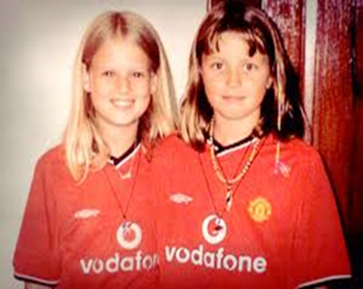

Following his inquiry, Sir Michael Bichard made 31 recommendations to improve processes and practice around children and vulnerable adults including:

- Ensuring that those who work with vulnerable people, are safely recruited, have a criminal disclosure check, are trained in safeguarding and are monitored and supervised appropriately.
- ‘Safer recruitment’ methodology was developed which included assessing a candidate’s motivation, values and behaviours alongside of the competency skills needed for a role.
- The legislation that followed was the Safeguarding Vulnerable Groups Act of 2006.

The inquiry into Ian Huntley murdering Jessica and Holly identified flaws in the current disclosure process which led to the processes we have today.
- Huntley was a caretaker at the school, his partner was a teaching assistant.
- Living in a close-knit community they had links with others already working at the school.
- Huntley didn’t have references checked and at the time there was no disclosure check process in place.
- Huntley had lived in various locations, several police forces had information relating to serious criminal behaviour that he had committed or was suspected of, including burglary and rape and “inappropriate relationships with young girls”.
- The Headteacher of the school did not have access to this information and reported that he would never have employed him if he had.
- Offenders do not always seek out potential victims, but rather seize an opportunity to offend. Huntley was able to place himself in a situation where he had the opportunity to offend.

Disclosure and Barring Service
2012 Disclosure and Barring Service (DBS)
- The DBS provides a service which allows us to do background checks on anyone in a role that involves working closely with children and or vulnerable adults.
- The DBS replaced what was the Criminal Records Bureau (CRB) and the Independent Safeguarding Authority (ISA).
- Guide Dogs have a duty to carry out disclosure checks on all staff and volunteers who provide support and training to our service users on a regular basis.
- We also have a duty to refer staff and volunteers to the DBS where we believe harm has been caused to a vulnerable person, even if that staff member or volunteer is no longer in our organisation.

Adult Legislation Timeline
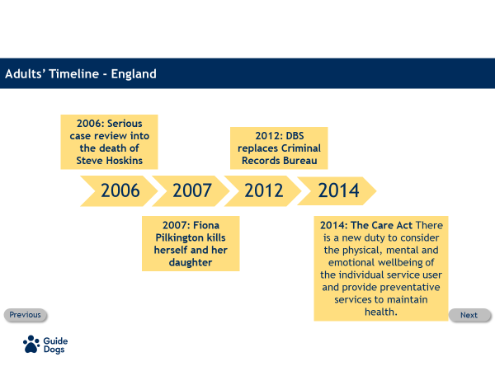

2014 The Care Act
The Care Act has taken safeguarding of vulnerable people to another level. There is a new duty to consider the physical, mental and emotional wellbeing of the individual service user and provide preventative services to maintain health.

Values and Motivations
Sam
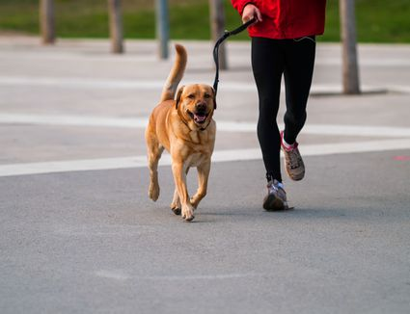

Sam has applied for a trainee GDMI role:
- Sam has 20 years experience as a dog handler in the army and was a trustee of an old people’s home for 10 years.
- They have exemplary references from the army.
- During the interview, when asked a question about managing stress as part of a busy workload, Sam’s responses include:
- They believe to get results they should clear goals with high targets.
- Sam describes them self as a hard task master with high expectations on them self and others with an attitude of ‘winners don’t quit and quitters don’t win’.
- Sam suggests that stress is a weakness and doesn’t tolerate it from them self or others.
- Sam does not give any examples as to how they manage stress or demonstrate any self awareness as to how their attitude and behaviours may cause stress in others.


Would you employ Sam? Yes or No?

We wouldn’t employ Sam.
Traditionally this would be a very good candidate, but safer recruitment would highlight concerns about values, behaviours and attitudes which are not aligned to our organisation.

Confidentiality and Consent

When to Break Confidentiality
- Confidentiality is an essential part of the trusting relationship we build with our service users;
- However, there are occasions when confidentiality can be broken as in the case of a genuine safeguarding concern;
- In general, a decision to share confidential information outside of Guide Dogs would be made by the line manager along with the safeguarding team;
- Any concerns that you may have can safely be shared with your line manager and the safeguarding team, so a decision can be made about next steps, without getting consent from the individual at risk.



Concerns or disclosure about a child

- If you have a concern about a child you must speak to your line manager and need to be aware that:
- In general the person with parental responsibility for the child must give consent to their information being shared with other agencies.
- However you DO NOT need to request this if doing so will put the child at further risk of harm.
- Or it is suspected a crime has taken place;

If you do have a concern about a child please follow Guide Dogs procedures as detailed later in the training.



Concerns or disclosure about an adult
- All adults have the right to make their own decisions even if they seem unwise or risky to others;
- And adults must consent to information being shared externally.
- Exceptions to this are:
- They are at risk of harm – contact emergency services if they are in immediate risk of harm.
- They are deemed to not have full mental capacity.
- There is a need to safeguard others that would be put at risk as a result.
- It is suspected a crime has taken place.

If you do have a concern about an adult please follow Guide Dogs procedures later in the training.



Nicola
- Nicola is a fellow volunteer:
- She makes cards to sell and brings them into the office where you work from. She has two children, Sophie nine and Amber who is almost one.
- When you see Sophie she always appears to be scruffy and smells of urine. She only speaks to you when her mother is not around.
- Sophie told you she is very responsible and can be trusted as she often does all the work for her mum whilst she is in bed. She said she ‘gets a lot of headaches’. Sophie can often be seen with her younger sister Amber perched on her hip, bottle in hand, they are very close.
- You see Sophie walking back from her local shop with Amber in the buggy, a heavy bag of shopping is hanging on either side of the pushchair. It’s a cold day, it’s pouring with rain and neither child has a coat on. They are soaked to the skin, there is no sign of Nicola.

Should you be concerned about Sophie? Yes or no?

Yes, this is a concern.

You should be concerned, speak to your manager and call the Safeguarding team who will take the appropriate action which may result in calling the local social services team due to concerns over the welfare of the children.

Each case received by Safeguarding is assessed on an individual basis and the course of action may change depending on an individual’s circumstances.



Concern about a colleague
- One of your colleagues has been having problems at home for quite a while and has been putting a brave face on things.
- They have come to work today and you are sure that they have been drinking.
- You are worried that they may be using alcohol to cope with the situation.
- You are also worried that they will be driving a van to take the dogs out.

What should you do? Do you speak to them or just let it be?

You should be concerned, speak to a manager immediately, who will need to take the appropriate action, the Safeguarding team should also be informed ASAP.

Safeguarding is everyone’s responsibility, we have a duty of care to protect people from harm, that includes service users, volunteers, staff and the public.

Should you have a concern around a member of staff’s behaviours or a concern for their wellbeing, you must inform a manager and safeguarding.

Concerns about the behaviour of a member of staff or a volunteer

- You must bring concerns about the unacceptable behaviour or practices of any individual to the attention of your line manager without delay.
- A concern about a line manager should be reported to Safeguarding.
- No matter how difficult it may be to ‘blow the whistle’, doing nothing is not acceptable.
- Allegations are thoroughly investigated, no action will be taken against you if the allegation proves to be unfounded as long as it was made in good faith.
- Line managers have a responsibility in law to protect whistle blowers from harassment or victimisation and confidentiality is extended to whistle blowers whenever possible.
- Guide Dog’s whistleblowing policy can be found on the intranet and VIP.


Recognising Abuse
There are various forms of abuse:

- Sexual
- Physical
- Neglect/ Self Neglect (Adults)
- Emotional /Psychological
- Institutional
- Financial
- Discriminatory
- Domestic Violence/abuse
- Modern slavery

The training workshop will give you the opportunity to understand these categories of abuse in more depth and recognise further signs of abuse.

Recognise, Report, Record, Respond

Recognise
Never promise to keep a secret. If you are told something or have a gut feeling that something isn’t right remember you have a duty to pass information onto your line manager, even if you don’t have permission to do this.

Report
Speak to your line manager and/or a member of the Safeguarding team on 0345 143 0199 as soon as possible.
In the rare event that a person is in immediate danger, or the situation is so serious, call the emergency services by dialling 999.

Record
Make a brief note as soon as possible after so that you can share this with your line manager. All referrals are recorded by the Safeguarding team in a confidential database for future reference.

Respond
Where appropriate thank the person for telling you and explain that you need to speak to your line manager next.
Once you have spoken to your line manager they and Safeguarding will take any action needed.

Key Safeguarding Principles
Key Safeguarding Principles ensure that children, young people and adults at risk are treated with respect and are free from all forms of abuse or mistreatment.
These can be found on the intranet and on VIP and cover:

The Key Principles
1.Prevention of abuse
2.Recognition of Abuse
3 Responding to abuse or harm
4.Reporting Abuse
5.Record-Keeping
6.Whistleblowing
7.Allegations against staff and volunteers
8.Safe Working Practices
9.Recruiting Staff and Volunteers Safely
10.Professional Development of Staff and Volunteers

Codes of Conduct
All staff and volunteers should be fully acquainted with the contents of Guide Dogs policies and procedures in relation to the protection of vulnerable groups, to ensure that these principles ‘live and breathe’ within Guide Dogs.

Guide Dogs Safeguarding policies, procedures and Codes of Conduct for working with vulnerable groups can be found on our intranet pages and VIP.

If you are a volunteer and you don’t have access to these your line manager can provide a copy of these for you.

When taking on a role working at Guide Dogs we agree to adhere to the Codes of Conduct, these enable us to..

- Identify best practice when working with vulnerable groups.
- Understand how to work within professional boundaries.

This way of working applies not just to our interactions with service users, but to any one that we come into contact with e.g. our colleagues, volunteers and other staff.

Codes of Conduct - Scenario
- You find yourself on a call with a service user known to you who lives nearby.
- They appear upbeat initially but start to tell you that they are struggling. They have no food left in the fridge they have been eating half a tin of soup twice a day.
- They are more concerned about the dog food not being delivered and can’t get out to the shop and don’t have anyone to collect shopping for them.
- They become frightened and tearful and think they may have caught corona virus as they have a high temperature.
- What do you do?

What should you do to make sure you are operating within Guide Dogs Codes of Conduct?
- Offer to pop round with some shopping for them as they are known to you and live locally?
- Provide a listening ear, reassure them and give them your number in case they want to talk further?
- Acknowledge their concerns and advise that you will contact Safeguarding?

Answer:
- There is an obvious concern for the individual’s welfare and this is a safeguarding concern. You must contact Safeguarding and advise your line manager ASAP.
- Safeguarding will follow up and contact the relevant support networks to escalate concerns, monitor the situation and ensure support is put in place.
- A record of your concern must be recorded and will be held in Guide Dogs confidential database.

Code of Conduct Scenario

- Billy works in the office of a local community team.
- A local Guide Dog owner, Joyce, pops into the office every so often to collect fundraising materials for various events.
- They strike up conversation and get on really well.
- At home Billy goes onto Facebook and decides to look Joyce up to connect.
- Billy starts to send Joyce lots of jokes and funny messages which he is sure Joyce will enjoy.

Is this professional behaviour within professional boundaries?

- No it isn’t. Communication between Adults and staff members or volunteers, by whatever method, should take place within professional boundaries. This includes the wider use of technology such as social media, mobile phones, text messaging, emails, digital cameras, videos, web-cams, websites and blogs.
- Staff and volunteers should avoid any communication with Adults which could be open to misinterpretation of their motives or behaviour.

Safer Workforce Cycle
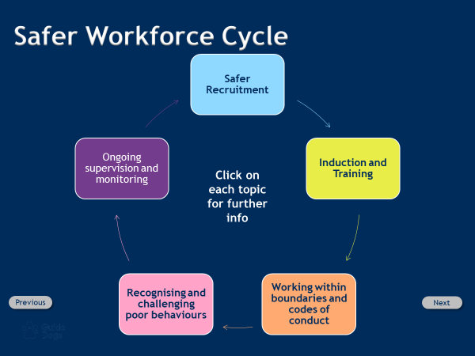

Safer Recruitment
- Guide Dogs is committed to Safer Recruitment.
- Safer Recruitment practice helps prevent unsuitable individuals gaining access to the organisation.
- Safer Recruitment training equips those responsible for recruiting with an enhanced awareness of how to identify potentially unsuitable people and supports a robust recruitment process.
- Ultimately this helps to protect all from abuse and harm.

Induction and Training
A robust induction and training programme ensures staff and volunteers:
- Are aware of their roles and responsibilities.
- Understand policies and procedures to support safe practice.
- Gain awareness of working within the boundaries of their role.
- Keep knowledge and skills up to date, attending refresher training as and when required.

Working within Boundaries and Codes of Conduct
- All Codes of conduct/safe working practices should referred to and consistently applied.
- A positive obligation to safeguard all vulnerable groups is placed on all staff and volunteers. The needs of both children and adults at risk are seen as being paramount.

- All staff and volunteers must:
- fully understand what constitutes safe working practices;
- have read and understood the Safeguarding Codes of Conduct for working with children and young people and with adults at risk.

Recognising and Challenging Poor Behaviour
- Complaints, from whatever source will be paid attention to.
- Guide Dogs have clear mechanisms for reporting concerns of all kinds; all issues raised will be followed up rigorously.
- You must bring concerns about the unacceptable behaviour or practices of any individual to the attention of your line manager/safeguarding without delay.

Ongoing Supervision and Monitoring
- Complaints, from whatever source will be paid attention to.
- Guide Dogs have clear mechanisms for reporting concerns of all kinds; all issues raised will be followed up rigorously.
- You must bring concerns about the unacceptable behaviour or practices of any individual to the attention of your line manager/safeguarding without delay.

Further Information
Follow this link for Guide Dogs Safeguarding leaflet.
Our codes of conduct can also be found on Safeguarding’s intranet pages.
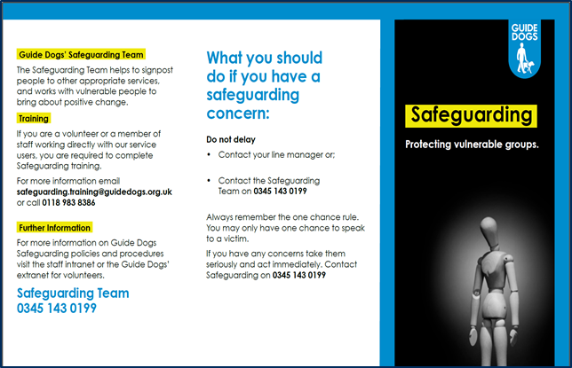

Next Steps
1. To complete Level 1 you will now need to successfully complete a short quiz.

2. If you are a member of staff in a service user facing role you are required to book onto the Level 2 workshop local to you, via Gateway.

3. If you are a volunteer My Guide, a free runner, a dog exerciser or a driver, please book your place on the level 2 workshop via your volunteer manager.

During the Covid-19 pandemic, face to face sessions will not be held. Please discuss with your line manager or the Safeguarding team for more info.

Level 1 Assessment
This assessment quiz is available online at https://www.surveymonkey.co.uk/r/VDNYXM5 however if you would prefer to use a paper version this is provided below. Please type your answers below each question and email to safeguarding@guidedogs.org.uk.

The questions below are multiple choice, some, as indicated, will have more than one correct answer, for these select all that apply. To successfully complete this assessment you will need to achieve a score of 80%.

*Personal Details
Name

*What is your role in Guide Dogs?

*Mobility Team (location) or Directorate

*Name of your Line Manager/Volunteer Manager

*Your FETCH number if known (volunteers only)

- In Guide Dogs, whose responsibility is Safeguarding? Select one of the following options.
- The Chief Executive
- Your line manager.
- The Safeguarding team.
- Everyone's

2. According to the Charity Commission the remit of Safeguarding includes preventing harm from occurring to:
Select one of the following options
- Service Users
- The Public
- Staff
- Volunteers
- All of the Above

3. An individual can become vulnerable at any time due to a change in their circumstances.
Select true or false.
- True
- False

- Without exception the person with parental responsibility must consent before personal information about a child is shared with another agency.
Select true or false.
- True
- False

6. Which of the following concerns should Safeguarding be made aware of?
Select all that apply.
- Concern for the welfare of a child in the household of person you come into contact with
- A member of staff or line manager operating outside of the boundaries of the role and putting others at risk.
- A hazard blocking a fire escape.
- The welfare of a guide dog.
- An individual discloses to you that they are struggling with their wellbeing.

7. On a call to a service user it becomes apparent that there are concerns for their mental and physical wellbeing. What should you do?
- Find out more about their issues and try your best to help them.
- Don't do anything, it's not something that is within the remit of your role.
- Arrange to pick them up and take them to the GP.
- Contact your line manager and Safeguarding to register your concern. In an emergency situation contact 101 or 999.

Thankyou for completing the Safeguarding Level 1 Assessment. Please email your completed quiz to safeguarding@guidedogs.org.uk

End of document

