- Treasurer Guidelines
Contents
1. Group Income 3
1.1 Types of income 3
1.2 Cash handling 4
1.3 Insurance 4
1.4 Collecting boxes and Life Size Dogs 5
1.5 Receipting and recording 5
1.5.1 Yellow/White receipt books 5
1.5.2 Blue receipt books 6
1.5.3 Gift Aid 6
1.6 Paying in 8
1.7 Fundraising/Supporter Group credits 8
1.7.1 Gift Aid 9
1.7.2 Legacies 9
1.7.3 CAF Vouchers 9
1.7.4 Matched Funding 9
1.7.5 Trusts 9
1.7.6 Restricted funds 9
1.8 Statement of Fundraising Group Income 10
1.9 Auditing of accounts 10
1.10 Guide Dogs Anti Bribery Policy 11
1.11 Whistle blowing 11
2.1 Group Expense Claim Form (reimbursement of out of pocket expenses) 13
2.2 Fundraising Group float accounts 13
2.2.1 Float account limits 14
2.2.2 Float account cheque books 14
2.2.3 Reimbursement of float accounts 14
2.2.4 Amending and closing accounts 15
2.2.5 Cash floats 15
2.2.6 Reimbursement of Fundraising/Supporter Group Members’ expenses 15
2.3 Direct Payment to Supplier 16
2.4 Change of Treasurer 16
2.5 Visually Impaired Treasurers 16
2.6 Treasurer Training 16
2.7 GDPR 16
Appendix 1a 17
Example Statement of Income 17
Appendix 1b 18
Example Statement of Income page two – Transactions 18
Appendix 2 19
Example Paying-In Slip and completion guidelines 19
Appendix 3 21
Definition of Codes 21
Appendix 4 23
Expense Guidelines – 23
Appendix 5 24
Sample Individual Claim Form (for use by groups who hold a float account) 24
Appendix 6 25
Sample Reimbursement of Fundraising Group Float Account form (for use by groups who hold a float account) 25
Appendix 7 26
Sample Fundraising Group Direct Payment Form (For use by all groups) 26
Appendix 7a 27
Sample Group Expense Claim Form (for use by Groups who do not hold a float account) 27
Appendix 8 28
Example completed book receipts 28
Appendix 9 31
Receipt book cycles 31
Appendix 10 32
Example Collection Box Record sheets 32
Appendix 11 33
Guidelines for servicing and placing Guide Dog Collecting boxes 33
Appendix 12a 36
Example Gift Aid Declaration 36
Appendix 12b 37
Example Gift Aid Declaration: Receipts 37
Appendix 12c 38
Example Gift Aid Declaration: Donation envelopes update 38
Glossary of terms 40
Where to go for help? 42

Important note – As government advice is constantly changing in response to the Covid-19 pandemic please consult the current Guide Dogs guidance for volunteers and self checklist before undertaking any fundraising activities for your group. Please call the Community Fundraising Supporter Care Team on 0345 1430192 should you wish to discuss a particular fundraising opportunity.

1. Group Income
For the sake of this document we will refer to Fundraising Groups, Supporter Groups and Individual Fundraisers, however, some groups may prefer to refer to themselves as a Guide Dogs Branch or use a name of their choice for their letterhead

Fundraising Groups
A Fundraising Group is a group of volunteers who raise funds and awareness for Guide Dogs through collections and activities within their community. A Fundraising Group must have a Treasurer and a Coordinator.

Supporter Groups
Some Fundraising Groups may have Supporter Groups attached to them. A supporter group consists of a minimum of two volunteers and have a key lead/coordinator. They work with the Fundraising Groups to raise awareness and raise funds for Guide Dogs.

Individual Fundraiser
An individual fundraiser is a volunteer who raises funds and awareness for Guide Dogs through their local fundraising activities. Some Individual Fundraisers are attached to a fundraising group, however, some are completely independent.

1.1 Types of income
There are three main types of income a Fundraising Group receives:

Monies from Fundraising, including Group collections, donations, and collecting box money. These are paid into Guide Dogs’ main account.

Any trading or tombola items ordered through the Fundraising/Supporter Group catalogue. Guide dogs Trading Company Ltd is a separate legal entity. This money has to be banked into the trading account, using the separate trading paying-in book, which is to be used solely for the paying in of trading and tombola income. A separate guide on trading is available from the Trading Department.

Monies not banked by the Fundraising/Supporter Group, but which have been raised by the efforts of the Group members (see Fundraising Group credits, 1.7), for example, legacies and Gift Aid. These will appear in the Branch Credits section on your Fundraising Group Income Statement provided by Guide Dogs.

The bank accounts for income are completely separate from the individual expense accounts that are provided to some Fundraising Groups

1.2 Cash handling

When you are transporting large amounts of cash to the bank try not to travel unaccompanied. Insurers would expect one person to only carry up to £2500, two people should accompany amounts between £2500 and £5000, three people for between £5000 and £7500, and four for amounts between £7500 and £10,000. Insurers would normally expect amounts of cash exceeding £10,000 to only be carried by professional security companies, because as well as the risk of the theft of cash, there is also the risk of injury to the persons carrying the cash. Try and make your visits to the bank irregular, e.g. not on the same day at the same time each week.

Cash MUST be collected, counted and recorded by two unrelated individuals, wherever possible. (Collection boxes MUST only be examined and opened by a registered fundraising volunteer and one other responsible person or by an official of a bank).

All cash should be banked as soon as practically possible.

Important note – In the current Covid-19 pandemic please follow the tips below when banking income:

- try to pick quieter times to visit branches
- maintain social distancing, hand washing and personal hygiene
- clean any equipment before and after use
- consider how you will travel to the bank safely

Cash should not be allowed to “accumulate” and there should be arrangements
to deposit the cash in a bank or bank night safe if one is available.

Check with your bank if they have a ‘Drop and Go’ facility where you will be able to leave the cash in a bank bag and not have to wait for it to be counted there and then.

Any cash kept at home should be limited. Our insurers would expect a safe
to be used if the amount of cash exceeds £2000.

If you have any reason to suspect fraud please see section 1.11 Whistleblowing

If you have any concerns regarding the banking of monies, or insurance level provisions as part of your normal Fundraising Group activity and prior to larger events please discuss with your Community Fundraising Relationship Manager or contact the Community Fundraising Supporter Care Team.

1.3 Insurance
Fundraising/Supporter Group Members and Individual Fundraisers are covered for amounts up to £2000 held in their custody (this is per household).

It is best practice to bank all cash at the earliest possibility and within 48 hours or 96 hrs on a bank holiday weekend. If local banking hours make this impossible, then money is to be banked on the first day of the banks opening.

When the amount of money collected is expected to be £2000 or more, an application for additional temporary cover should be made to your Community Fundraising Relationship Manager or the Community Fundraising Supporter Care Team who will consult our insurance team. There will be no additional cost incurred by Guide Dogs. As mentioned in the previous section, insurers expect a safe to be used if the amount of cash exceeds £2000.

1.4 Collecting boxes and Life Size Dogs
The Treasurer must:

• Keep a master copy of where all collecting devices (collecting boxes and life
size dogs) are placed.

• Send a copy of the master list to the Community Fundraising Supporter Care Team annually (after 31 December).

See Appendices 10 for example audit forms for static collecting devices.

Please see Appendix 11 for Collecting Box Co-ordinator guidelines

As Fundraising Group Treasurer you may have several Collecting Box Co-ordinators operating as part of the Fundraising Group. As treasurer please ensure that each collecting box co-ordinator provides you with a copy of all receipts issued and any paying in slips used to enable you to reconcile monthly Fundraising Group income. All Collecting Box Co-ordinators must inform you of box location details in order for you as treasurer to provide a full and complete list of all box locations (collecting and life sized dogs) to The Community Fundraising Supporter Care Team.

Please ensure that all Collecting Box Co-ordinators are issuing receipts correctly and completing the paying in slip correctly.

NB Please ensure that all counter top boxes and life size dogs have your local
contact details on so that the venues are able to request boxes to be serviced.

1.5 Receipting and recording
There are two kinds of receipt book: the yellow book, which is held only by the Treasurer, and the blue, which is for use by Fundraising/Supporter Group Members. Please note, yellow and blue books are our current stock, however we do have the superceeded white and green books that can still be used where we are NOT claiming Gift Aid.

All receipt books need to be made available upon request as required by the Fundraising Group Treasurer or Guide Dogs. Receipt books can be used over multiple financial years. Where possible receipts should be issued at the time of receiving a donation (if in person) or within 5 working days.

1.5.1 Yellow receipt books
Treasurers will be issued with one yellow receipt book for their use only.
The Treasurer must:

- Allow 14 days when ordering replacements from The Community Fundraising Supporter Care Team
- Issue a receipt for all monies received, stating the date received and the sources (see Appendix 8).
- Issue one yellow receipt for blue receipt(s) with monies handed to you by your fellow Fundraising Group Member.
- If a mistake is made in issuing a receipt:
Keep the top copy attached to the book.
Score it through with the word ‘cancelled’.
If a mistake is discovered after a receipt has been issued you must seek advice from the Community Fundraising Supporter Care Team.

1.5.2 Blue receipt books
Fundraising Group Members who are receiving cash donations can be issued with a blue receipt book by the Treasurer. These can be ordered via the Community Fundraising Supporter Care Team.

The Treasurer must:

- Keep a list of the holders of the receipt books.
- Make sure all blue receipts state the amount received and sources of income (see Appendix 3 for a list of income codes).
- Record details of when the income has been banked for Gift Aided receipts.
- Ensure all full receipt books are returned to be kept by the Treasurer as part of the audit process.

Guide Dogs has a printable receipting process available for visually impaired treasurers who use Excel. If you are interested in this please contact Jo Boland jo.boland@guidedogs.org.uk.

1.5.3 Gift Aid
Gift Aid allows individuals to make tax-free donations to charities if they are UK
taxpayers. Since the donor has already paid tax on earnings or capital gains, the
charity can claim this tax back from HM Revenue & Customs (HMRC), boosting
the value of their donation by a quarter. Please note: Gift Aid cannot be claimed by groups of people, only individuals may claim for personal donations. When HMRC audit our accounts they generally expect to see round amounts on gift aid receipts. If the amount on the receipt is an odd amount e.g. £23.78 can you please put a few words of explanation on the receipt e.g home coin collection or jam jar collection.

You can help Guide Dogs claim its share.

In order to claim, we need to obtain a declaration from the donor. You can use any of the following self-supporting tools, available from your local Community Fundraising Supporter Care Team:

• Receipt books. Yellow and blue
• Donation envelopes.
• A4 gift aid forms.

In order to complete the declaration, please follow these steps:

- Ask the donor if they are a UK taxpayer and would like us to Gift Aid their donation. You must ensure that the donor reads (or you read to them) the section on the receipt starting ‘please tick this box to confirm…’.

- Take the donor’s full name, (title, first name and surname) postcode and first line of their address (we need all of this information to claim), and tick the Gift Aid box if they have agreed to the declaration (you may wish to ask the donor to complete these details themselves).

- When the donation has been banked, complete the banking details on the declaration. This will include the date banked, the total on the paying-in slip that included the donation and the Fundraising Group number. This enables us to prove to HMRC that we received the money. We cannot claim gift aid without this information.

- Send the declaration to Finance, Guide Dogs, Burghfield Common, Reading, Berkshire, RG7 3YG. If the receipt book has been used, the third copy of the Blue, or second copy of the Yellow receipt will need to be sent, depending on which book the original was issued from, and must always be a copy of the original receipt issued to the donor, not the consolidated receipt issued by the Treasurer. It is more than acceptable to send several declarations at one time.

- Although HMRC only requires one declaration per donor, our internal processes currently require a new declaration for each donation made via a Fundraising Group (even if the donor has already completed one). The process is the same for all types of form including Gift Aid envelopes. Examples of all of these are contained in Appendices 12a, 12b and 12c. You should always discard old versions of the receipts, envelopes and declarations when new versions are issued. This is because HMRC may require changes to the wording used from time to time as the regulations change.

1.6 Paying in
Fundraising Group income, with the exception of trading, Gift Aid, legacies, and CAF Vouchers must be banked directly into the Fundraising Group income account, using the paying in book provided. The only exception to this is when groups have been set up to use the Post Office – see note below.

Under no circumstances should Guide Dogs income be paid into a non Guide Dogs account.

Additional paying-in books can be provided on request to other Fundraising Group Members, collecting box coordinators and supporter groups. New books need to be ordered from the Community Fundraising Supporter Care Team.

The Treasurer should:

- Keep a record of everyone who holds a paying-in book within the Fundraising Group network.
- Ensure all paying in book holders adhere to Guide Dogs cash handling, insurance and the paying in of income procedures.
- Make sure a copy of each paying-in slip used is returned to the Treasurer as soon as money is paid in.
- Ensure income is banked using the correct codes on the paying-in slip. (A list of codes and definitions we would like you to use is shown in Appendix 3.)
- Please see Appendix 2 for an example of a correctly filled in paying-in slip and instructions.

Guide Dogs has a printable paying in process available for visually impaired treasurers who use Excel. If you are interested in this please contact Jo Boland jo.boland@guidedogs.org.uk.

The Post Office

Where possible all income should be paid into a local branch of Barclays Bank. Where this is not possible we are able to use the Post Office by arrangement. If you are having difficulties banking with Barclays and would like to use the Post Office please contact Jo Boland jo.boland@guidedogs.org.uk. Please note that this must be arranged in advance as it requires us to use a different process, bank account and a deposit card. There are also restrictions to the amount of coin we can bank with the Post Office.

1.7 Fundraising/Supporter Group credits
Monies not banked by the Fundraising Group, but which have been raised by the efforts of the Fundraising Group Members will appear in the Branch Credits section of your Fundraising Group income statement provided by Guide Dogs.

Please contact the Community Fundraising Supporter Care Team if you need credits for income sources not listed here.

1.7.1 Gift Aid
Gift Aid will be automatically credited back to your Fundraising Group once the gift aid declaration has been processed by Guide Dogs.

1.7.2 Legacies
Your Fundraising Group will receive automatic credits for any legacies that have been left to your area. Any legacy cheque received by a Fundraising Group must be sent to our Central Office at Hillfields. Legacy income is recorded and credited separately from donations.

1.7.3 CAF Vouchers
CAF is an abbreviation for Charities Aid Foundation. The foundation was set up to
provide an easy way for both individuals and companies to make tax-free donations to charities. Donors set up a deposit account with CAF; they are then provided with vouchers that they can use to make their donations.

CAF Vouchers must be forwarded to the Community Fundraising Supporter Care Team, who will ensure they are sent to the Income Team at Hillfields to process. NB CAF vouchers will appear on your Fundraising Group statement as a Fundraising Group credit.

1.7.4 Matched Funding
Matched funding is where a company matches a supporter donation. For any matched funding that Guide Dogs is expected to receive the following information is required in order to credit your fundraising group:

The name of the payer/company the matched funding is coming from
The amount of payment expected
The date and method of payment

If your matched funding is part of a larger amount please let the income processing team know - incomeprocessingteam@guidedogs.org.uk

1.7.5 Trusts
Please code any income received from a trust to TRUSTS on the paying in slip. If you receive an enquiry from a trust please contact your Community Fundraising Relationship Manager who will liaise with our Trust team to provide support.

1.7.6 Restricted funds
Sometimes an organisation gives a donation on the understanding that the money will be restricted to pay for a certain item, if this is the case we will need to ensure that the money is clearly identified as it will need to be shown in the main Guide Dog accounts. If you do receive a donation from an organisation to pay for some equipment for the Fundraising Group or if you are intending to apply for funds from a group/organisation who is offering to meet the costs of equipment or putting on an event, we will need to check that the fund is not a Trust that could be receiving an application from our central team. In all these circumstances please contact The Community Fundraising Supporter Care Team or your Community Fundraising Relationship Manager prior to banking the income, under no circumstances should any money be paid in to your Fundraising Group expense account - this is purely an expenditure account and cannot be used to bank income.

1.8 Statement of Fundraising Group Income
You will receive your Statement of Fundraising Group Income approximately the10th working day (for December the 16th working day) of the month by email, posted copies will take a couple of additional days to arrive as they are sent from the Community Fundraising Supporter Care Team.

- If you do not receive your Fundraising Group statement please contact the Community Fundraising Supporter Care Team.
- You will receive a copy of your Statement of Fundraising Group Income even if no monies have been paid in during that month.
- On receipt of your Statement of Fundraising Group Income you must ensure that you check off all the income that has been banked by everyone in the Fundraising Group to make sure that it appears. Income banked during the last few days of each month may not show on your monthly statement until the month after. If missing income does not appear in the following month please contact the Community Fundraising Supporter Care Team. Monies received in December must be banked by the date specified by Income Processing which will be different each year depending when Christmas falls. Any funds banked after this may not appear on your statement until the following financial year.
- Statements are available by both email and post (upon request)
- See Appendices 1a and 1b for example statements.

As part of our insurance requirements a duplicate Fundraising Group statement will be sent (preferably by email) to a secondary independent (not related) Fundraising Group member. The duplicate Fundraising Group statement is for information purposes only, but provides other Fundraising Group members with financial information which can be shared with the Fundraising Group at meetings in the absence of the treasurer for times of illness and/or holidays.

1.9 Auditing of accounts
Guide Dogs’ financial year ends on 31 December. Fundraising Group accounts will be audited as part of the national Guide Dogs annual audit. Fundraising Group Treasurers must check and sign the final end of year statement to confirm that it is an accurate record of the accounts and return this to Guide Dogs no later than the end of February please post or email your statements to The Community Fundraising Supporter Care Team. This is a legal requirement and must be completed in order to operate as a group.

A sample of Fundraising Groups will be chosen at random to have more detailed audits. You will be notified if your group has been selected and given further instructions. Please note that any member of Guide Dogs can request to see copies of treasurers and Fundraising Group paperwork.

The following must be kept for a minimum of six years:

• All bank statements and cheque books from the float account.
• All used or partly used receipt books.
• All paying-in books.

1.10 Guide Dogs Anti Bribery Policy
In line with current legislation and the Bribery Act 2010, Guide Dogs has an anti- bribery policy in place. Bribery is the accepting of gifts, money, hospitality or other favours in return for providing something of value to the person offering the bribe. Under no circumstances should a Guide Dogs volunteer accept, request or offer any financial or other reward (gifts in kind) in return for personal gain. If you have any questions or concerns about Guide Dogs anti-bribery policy, please contact your Community Fundraising Relationship Manager.

Gifts to Individuals
From time to time you may be offered items of value in connection with your volunteering. This could be a small item or something of considerable value. Other than “token” gifts such as advertising merchandise given by suppliers which amount to £5 or less (for example, branded pens, mugs, confectionery etc), all gifts, however small, must be reported to your Community Fundraising Relationship Manager. No gifts to the value of more than £50 may be accepted. If a gift is offered of more than £50 and refused, it must still be reported to your Community Fundraising Relationship Manager.

Under no circumstances can gifts of cash be accepted of any amount (this does not include vouchers which can be accepted up to a value of £50).

Hospitality
The Bribery Act 2010 does not prohibit reasonable hospitality. From time to time customers, suppliers or other persons may invite a volunteer to a hospitality event. All such invitations must be reported to your Community Fundraising Deveopment Officer whose prior permission must be sought before the invitation is accepted whose decision shall be final.

1.11 Whistle blowing
Volunteers, like our staff, are encouraged to speak up about any genuine concerns they have about malpractice and financial irregularities within Guide Dogs. Guide Dogs is committed to developing a culture of openness and has a policy and procedure to allow the airing of genuine concerns about suspected malpractice in a safe and supportive way.

The Whistle blowing policy and procedure which complies with the requirements of the Public Disclosure Act 1998 is bound by the following guiding principles:
the person raising the concern will not be victimised for doing so; victimisation of whistle blowers will be treated as a serious matter that may lead to disciplinary action that may include dismissal; Guide Dogs will not attempt to conceal evidence of poor or unacceptable practice; and Guide Dogs will liaise with relevant outside agencies relevant to investigating allegations of malpractice

Please discuss any concerns with your Community Fundraising Relationship Manager who can provide you with more information on our Whistle blowing policy and procedure.

This process can also be used to alert Guide Dogs to concerns about suspected fraud and/or irregularities. Any suspicion of fraud or financial irregularities will be treated seriously and will be investigated. If you become aware of a suspected fraud or irregularity:

- Record your concerns immediately i.e. make a note of all relevant information, for example, the details of phone or other conversations, the date, the time and the names of anyone involved:
- Report the matter immediately to an appropriate person who may be your Community Fundraising Relationship Manager who will in turn report to their Regional Community Fundraising Manager. If you do not feel able to approach your Community Fundraising Relationship Manager then report it direct to a member of our Anti –Fraud and Criminal Activity Team (AFCAT).

The Anti Fraud/Criminal Activity Team (AFCAT) regularly meets to consider and investigate any suspected criminal activity, and any matters arising from disclosures under the Guide Dogs Fraud Prevention Policy and any other actual or suspected fraud, theft, loss of funds or property.

To contact the AFCAT team please call , Central Office (0118 983 5555) or email AFCAT direct at afcat@guidedogs.org.uk

2. Fundraising Group Expenditure

We have three different methods of paying Fundraising Group Expenses:

The Group Expense Claim form
Most fundraising groups will use the Group Expense claim form to claim expenses. The Group expense claim form can be used to claim out of pocket expenses or to claim an advance for forthcoming events.

Fundraising Group Float Account
Some very active groups will hold a group float account instead of using the Group expense form.

Direct Payment to Supplier
This method can be used to pay larger sums directly to the supplier. All groups can use this method of payment as required.

2.1 Group Expense Claim Form (reimbursement of out of pocket expenses)

Most Fundraising Groups/Supporter Groups and Individual Fundraisers will claim for expenses using the Group Expense Claim form.

Once completed the expense form should be submitted together with the relevant receipts and sent to the Community Fundraising Supporter Care Team for authorisation. All claims must be submitted within three months of receipt. Reimbursements are then paid directly into the volunteer’s bank account.

Group Expense Claim Form – (payment of advance)
This method allows us to pay Fundraising Group members an advance directly into their bank account for any forthcoming expenditure or to use as a trading float. Receipts are then provided after the event has taken place or if the money is used as a trading float the full float should be returned when the float is no longer required. If more money is requested than used the excess should be returned to Guide Dogs Finance Office, Hillfields, Burghfield Common, Reading, RG7 3YG with a covering note.

The Group Expenses Claim Form is to be used to claim expenses relating to the Fundraising Group only. For any other non group related expenses the general volunteer expenses claim form should be used.

The Group Expense Claim Form can be used to claim out of pocket expenses or to arrange an advance payment. (See appendix 7a)

2.2 Fundraising Group float accounts
Some of our established Fundraising Groups may have access to a bank account, known as the float account. Float accounts must only be set up by Guide Dogs and not by the Treasurer. Please note: Only Fundraising Groups who have regular expenditure will have access to a float account, Supporter Groups, Individual Fundraisers and Fundraising Groups with minimal expenditure can use the Group Expense Claim Form (see appendix 7a) When the float account is ready to be activated, we will write to the treasurer asking them to return a signature slip to enable them to sign on the account. The only form signed by the Treasurer for the bank is the signature form. Treasurers are not permitted to sign any bank mandates requested by the bank.

The Treasurer is usually the only person authorised to use the float account, although in some instances there may be more than one signatory. The account comes with a cheque book. This account must only be used to pay Fundraising Group expenses; no income is to be paid into this account.

2.2.1 Float account limits
New Fundraising Groups will be able to claim expenses via the Group Expense Claim Form, however, if the Group becomes more active we may suggest we set up a float account. Treasurers should agree with their Community Fundraising Relationship Manager a level for the float account. This will be based on how ‘active’ the Fundraising Group is. The average level is around £150, however, this can vary depending on how active the group is.

Guide Dogs does not authorise overdraft facilities for Fundraising Group float accounts, and if the account becomes overdrawn Guide Dogs will be charged a fee and the cheque will not be honoured. If you find that the Fundraising Group’s activity levels have increased and that you require your float account level to be increased, please contact your Community Fundraising Relationship Manager to discuss this with them.

Note: Banks will make any accounts that have not been used for 12 months dormant so please ensure reimbursement forms are submitted regularly. The float account is made available to groups to pay for minor expenses such as room hire, postage and mileage and we want to ensure that the funds are available to you to pay these out of pocket expenses. Some of our volunteers would not be able to afford to cover out of pocket expenses so It's important that expenses can be paid if needed in line with our volunteer expenses policy.

2.2.2 Float account cheque books
- Cheque books for the float account will be issued to the Treasurer. When there is a change of treasurer the cheque book can be passed on to the new treasurer, however, the float account must be balanced first.
- All new bank mandates will be set up so that Treasurers can only sign cheques to a maximum of £250 or the amount available in the bank account, subject to float account limits. Expenditure over this amount should be paid directly to the supplier by Guide Dogs.
- Cheque books must be kept in a secure place to avoid theft of the book or individual cheques. A secure place is a locked drawer, cupboard, safe or strong box that only the Treasurer has access to.
- Cheques must not be pre-signed without filling in the payee details.
- Cheques must only be used for Fundraising Group expenses.

2.2.3 Reimbursement of float accounts
Guide Dogs will top up funds to the pre-agreed spending limit on receipt of
the Treasurer’s expense claims. Expense claims for the reimbursement of float
accounts need to be filed regularly to stop the account going overdrawn and must be made a minimum of once annually.

- Receipts or vouchers must be attached to the form (It is acceptable to send a scanned copy if emailing the claim).
- If a receipt is unobtainable, then the float account cheque number should be written on the claim reimbursement form.
- If an expenditure payment is refunded directly to you, i.e. the cheque returned after a cancelled event, please contact the Community Fundraising Supporter Care Team, please do not bank the cheque.
- Claims for reimbursement need to be made each year by 30th November for each financial year using the Fundraising Group Reimbursement Form. A minimum of one claim must be made per year if monies have been spent. See Appendix 6.
- Please allow at least 21 days’ processing time for the reimbursement claim to be paid into the float account.
- If you get bank interest credited to the float account it should be deducted from claims in order to ensure that the float account is maintained at the correct level.
- Notification that the monies have been paid in is available by letter or email.

2.2.4 Amending and closing accounts
Any amendments or changes to the Fundraising Group float account need to be approved and processed through your Community Fundraising Relationship Manager or the Community Fundraising Supporter Care Team.

These include:

• Address changes.
• Signatory changes.
• Account closure requests.

2.2.5 Cash floats
It is possible to set up a cash float for the convenient purchase of smaller items
such as stamps and postage and for use at shows etc.

The Treasurer must:

• Nominate a Fundraising Group Member to be the responsible cash float holder.
• Gain the Fundraising Group Officer’s approval.
• Gain receipts for each item purchased.
• Submit itemised lists of expenditure with receipts attached.

The float holder must submit itemised lists of expenditure with receipts
attached in order to have the float topped up.

2.2.6 Reimbursement of Fundraising/Supporter Group Members’ expenses
If the Fundraising Group holds a float account the Treasurer is responsible for the payment of Fundraising/Supporter Group expenses to Fundraising/Supporter Group Members. All expenses must be presented to the Treasurer within three months of incurring them, and be accompanied by a valid receipt where appropriate. Expenses incurred by Treasurers must be signed as approved by another Fundraising Group Officer before being paid. Where Fundraising Group officials are related the treasurer must ensure that approval and signatures for expenses are sought from the Community Fundraising Supporter Care Team.

An Individual Claim Form should be completed and receipts attached.

See Appendix 4 for expense guidelines, and Appendix 5 for a sample Individual
Claim Form.

Treasurers should encourage members to cash cheques promptly.

Note: The Fundraising Group Expense form and the Fundraising Float account should be used for expenses incurred relating to Fundraising Income only. If a group member has incurred expenses for Guide Dogs work outside of the Fundraising Group they should complete a Volunteer Expenses form.

2.3 Direct Payment to Supplier
A pre-arrangement can be made for expenses to be paid directly by Guide
Dogs, for example large shows often require a payment that is higher than your limit and Guide Dogs can arrange to pay these fees direct to the show by cheque or direct payment. See Appendix 7 for Fundraising Group Expenses Direct Payment to Supplier forms. This form should be completed and sent to the Community Fundraising Supporter Care Team with a copy of the invoice or event booking form to enable payment

2.4 Change of Treasurer
Please contact your Community Fundraising Relationship Manager or the Community Fundraising Supporter Care Team.

2.5 Visually Impaired Treasurers
We have a range of information to support visually impaired treasurers and Collecting Box Co-ordinators we have specific visually impaired guidelines to support any variants to our processes outlined in the treasures guidelines. For further information about our visually impaired specific items please contact your Community Fundraising Relationship Manager in the first instance.

2.6 Treasurer Training
If you feel you require future training or support please contact your Community Fundraising Supporter Care Team.

2.7 GDPR
All Volunteers will receive Essential Guidance on GDPR. Volunteers who hold and process data, which includes Branch Treasurers, will receive a further, short GDPR training module
If you have any concerns and questions, please contact your Community Fundraising Relationship Manager who will work with you to do an annual audit of the information your group hold. Further Information can be found on the Volunteer Information Point.

Appendix 1a

Example Statement of Income

Appendix 1b

Example Statement of Income page two – Transactions

Note : the date is the date processed at Central office, not the date the income was banked

Appendix 2

Example Paying-In Slip and completion guidelines

Wigan & District Fundraising Group has paid in monies using the paying-in slips. They had:
27/07/2020

• £150.00 in donations (DONB) – £100 was a cheque from Mr Smith.
• £37.02 from a counter top box that had been emptied (CTBB).
• £140.00 donation from In Memory (IN Memory).

Please ensure that on completing your paying-in slip you:

1. Insert the date.

2. Write your name or initials clearly in the “paid in by” section.

3. Break down the monies into the correct codes and write the income next to the code. Note income paid in under “other” – the donation amount (£140) is written on the line and the code is written next to it. Please always ensure that you enter the income and the income code on all ‘other’ income entries.

4. List the details for the cheques that you are paying in.

5. List the breakdown of the coins you have collected. This will enable you to cross-check monies paid in and identify any mistakes more easily.

6. List notes, coins and cheques.

7. Total figure – please double-check that the income breakdown on the allocated codes equals that of your total income.

8. Write the number of cheques included with the paying-in slip.

9. Insert the total amount of monies to be paid in (this should be the same amount as the total figure listed under point 7 above).

Appendix 3

Definition of Codes
Coding of Income
The coding of income is really important for guide dogs as an organisation. It allows us to monitor the different income streams and use the information for long term financial planning. We really appreciate your help and support with the coding of income.

Definition of Codes
Code | Definition | Description
Donation | Donation | General monies donated – not for any specific fundraising product/initiative as listed below
Counter Box | Counter Top Boxes | Static counter top boxes left in outlets (permanent situ)
Floor Box | Life Size Dogs | Large static life sized boxes in permanent situ
Collection | Collections | All monies raised using buckets/boxes at a collection (includes street collections, supermarket collections, meet Guide Dogs events etc.)
NAP | Name a Puppy (add a reference number) | Name a Puppy (add in reference number and if School NAP write School)
Other | Income | Please note that for all codes listed below you will need to write the relevant income code on the bottom half of the paying in slip
FR4US | Fundraising For Us | Fundraise for Us. Monies raised by an individual or group (not organised by the fundraising group) through an event or /activity eg dinner party, sponsored activity etc.
Tea Party | Tea Party | Monies raised through a tea party/coffee morning
Puppygrad | Puppy Graduation Scheme | Monies raised by a school & Youth groups towards a Puppy Graduation Scheme (add in School name)
Schools | Schools donations | School donations. All monies raised/donated by schools excluding those who are working towards a target to name or sponsor a class of pups
SPEAKER | Speaker | A donation given to a Guide Dogs speaker – not for any specific fundraising product/initiative and doesn’t fall in any other category
IN MEMORY | In Memory | Donation given in loving memory or in lieu of flowers
Name of Event | Sports & Challenge Events | Income from national sports & challenge events (add in event name and reference number)
TRIBUTE | Tribute Fund | Monies being raised towards a “Tribute Fund” in memory of a loved one (add in reference number)
FUNDRAISING GROUP EVENT | FUNDRAISING GROUP EVENT | Activity organised by the Fundraising Group excluding Fundraising for us

Additional Notes:
Reference codes for Name a Puppy, Tribute Funds are available from the Community Fundraising Supporter Care Team.
Puppy Graduation Scheme donations email the details to the Community Fundraising Supporter Care Team.
All sponsor forms received by the Fundraising Group should be returned to the Community Fundraising Supporter Care Team.
Sports and Challenge Events please write the event name and participants ID on the paying in slip under the “other amount” so that the income can be correctly recorded on their donor record. It is imperative that this is followed as each participant agrees to raise a minimum sponsorship target and the information provided on the paying in slip will ensure that they are officially thanked and then removed from any income chasing activity.
Please note that if any Fundraising Group mistakenly omits to include any of these details when paying in income please contact you the Community Fundraising Supporter Care Team with the correct break down of income as soon as possible.
We may also need to issue additional codes when we secure national accounts. This is to ensure that we can keep an accurate record of the income that the company/organisation has raised so that we can celebrate the success of the partnership and hopefully secure new ones.

Appendix 4

Expense Guidelines –

Volunteer Expense Policy
Guide Dogs values the work carried out by volunteers and believes volunteers should not be out of pocket through their volunteering activities with Guide Dogs, except where travel costs are agreed to be part of the voluntary contribution to the charity.

This expense policy applies to all Guide Dogs registered volunteers.

Main High Level Principles

- Expenses being claimed for must have been genuinely incurred for business purposes.
- Volunteers who intend to claim expenses must have them agreed with their line manager prior to their being incurred.
- Claims should be submitted on a regular basis.
- Volunteers claiming in excess of £20 per month should be reimbursed where possible via BACS payment directly into nominated bank or building society account. Where necessary, expenses may be paid in advance.
- A valid receipt (preferably a VAT receipt) must accompany every expense claim. Credit card slips are not acceptable as proof of payment unless they are one and the same as a detailed receipt showing purchases.
- All necessary dog food, veterinary costs and equipment necessary to volunteering activity will be supplied and paid for by Guide Dogs.
- Telephone, postage, and other pre-agreed expenses necessary to the volunteering activity will be reimbursed if supported by appropriate receipts.
- With line manager approval, any travel to and from the place of a volunteering activity where not part of the voluntary contribution will be reimbursed.
- All public travel will be reimbursed at standard class for rail / coach fare and economy class for air fare. Drivers using their own vehicle will be reimbursed at the standard mileage rate for volunteers.
- Food / beverages and accommodation necessary when volunteering activity takes place outside the normal geographical area, subject to prior agreement with a line manager and a minimum time commitment, will be reimbursed up to the limits in line with rates applicable to staff.

Other Relevant Details
Volunteer expenses should be built into all funding applications and budgets as part of the regular costs of a volunteer programme.
References and Related Documents
Further details of the expenses policy can be found on the Guide Dogs Volunteer Extranet.

Appendix 5

Sample Individual Claim Form (only for use by groups who hold a float account)

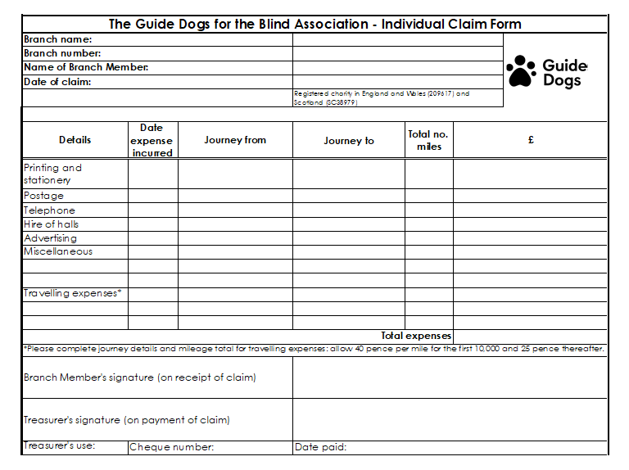

This form is relevant for Groups who hold a float account only.

This form has been created in Excel; the example shown above is smaller than the
‘real thing’, which is available in the fundraising section on the volunteer extranet or from the Community Fundraising Supporter Care Team printed and email versions are available.

Appendix 6

Sample Reimbursement of Fundraising Group Float Account form (for use by groups who hold a float account)
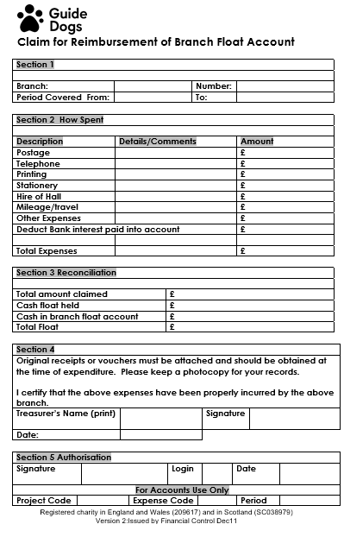

This form has been created in Word; the ‘real thing’ is available in the fundraising section on the volunteer extranet or from the Community Fundraising Supporter Care Team to complete online or print off and fill in.

Appendix 7

Sample Fundraising Group Direct Payment Form (For use by all groups)

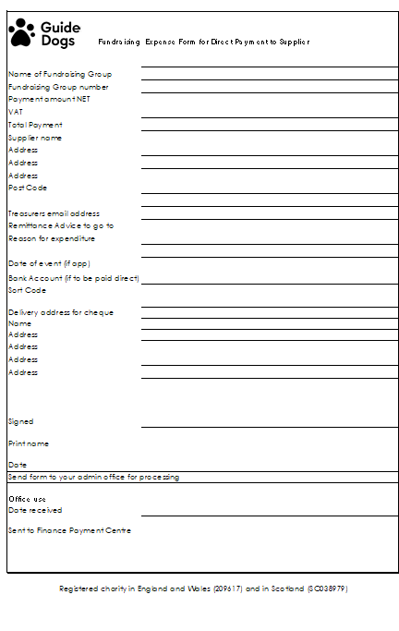

This form has been created in Excel; the ‘real thing’ is available in the fundraising
section on the volunteer extranet or from the Community Fundraising Supporter Care Team to complete online or print off and fill in.

Appendix 7a

Sample Group Expense Claim Form (for use by Groups who do not hold a float account)

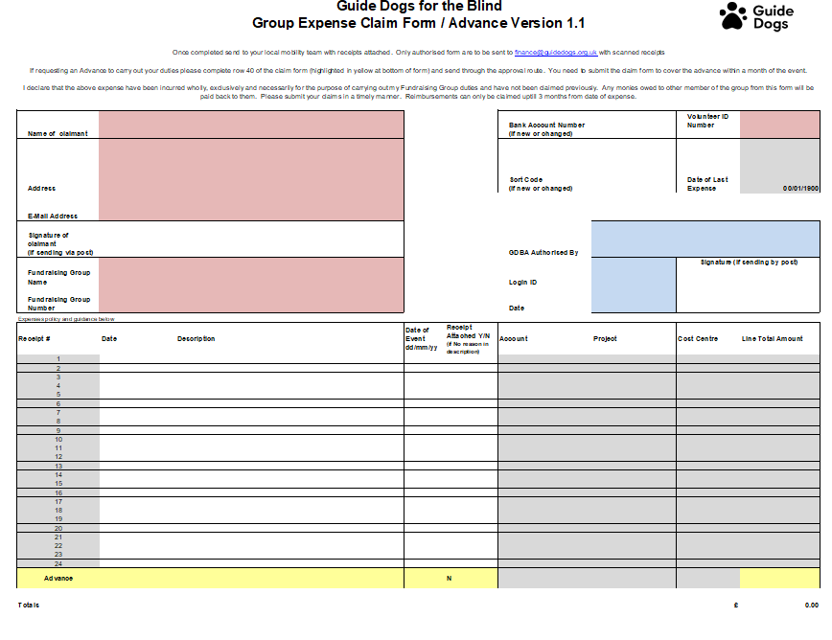
This form has been created in Excel; the ‘real thing’ is available in the fundraising
section on the volunteer extranet or from the Community Fundraising Supporter Care Team to complete online or print off and fill in. Guidance notes for completion are also availale on request.

Appendix 8

Example completed book receipts

Example 8a Yellow receipt
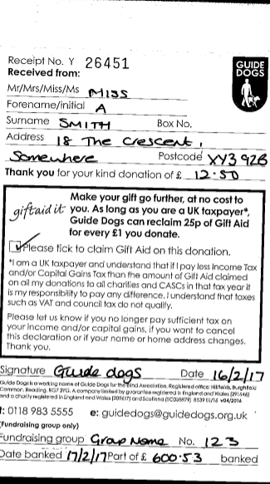

Example 8b blue Receipt from Fundraising Group Official

Example 8c yellow receipt to Fundraising Group Official from Treasurer

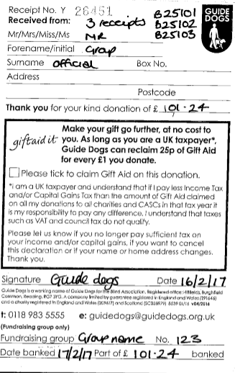

Appendix 9

Receipt book cycles

Yellow receipt donation cycle

1. Donation received by Treasurer.

2. Treasurer issues the top copy yellow receipt to the donor.

3. Treasurer retains the second and third yellow receipt unless the donation has been Gift Aided.

4. If the donation has been Gift Aided, remove the second copy of the Yellow receipt and send to Finance, Guide Dogs, Hillfields, Burghfield Common, Reading, Berkshire, RG7 3YG. The third copy of the yellow receipt stays in the book.

Blue receipt donation cycle

1. Donation made to Fundraising Group Member.

2. Fundraising Group Member gives first blue receipt to donor.

3. Fundraising Group Member gives second blue receipt to Treasurer. If the donor has ticked Gift Aid, then the Fundraising Group Member also gives the third blue receipt to the Treasurer.

4. Treasurer issues Fundraising Group Member with yellow receipt for blue/green receipts.

5. Treasurer files the second blue receipt and forwards the third blue receipt to Finance, Guide Dogs, Hillfields, Burghfield Common, Reading, Berkshire, RG7 3YG.

Appendix 10

Example Collection Box Record sheets

NB: This form has been created as one Excel workbook for ease of use. The ‘real thing’ is available in the fundraising section on the volunteer extranet or from the Community Fundraising Supporter Care Team to complete online or print off and fill in.

Appendix 11

Guidelines for servicing and placing Guide Dog Collecting boxes

- All volunteers/staff servicing or placing Guide Dogs collection devices should always carry their identity badge.

- To ensure that any attempt to tamper with the contents of a box can be spotted easily, all boxes in use must be sealed with an official Guide Dogs base label, please ensure that the label is completed with a contact telephone number so that the venue is able to contact you (or the Community Fundraising Supporter Care Team) for servicing if required. Life size dogs also need to have an official Guide Dogs base label placed on the base with contact details please use a counter top box seal for this.

- Before removing the box to count its contents, the Fundraising Group Collector/Collecting Box Coordinator should check for evidence of tampering around the security seal.

- If it is not deemed safe to count the money on site, the bung on the box should be placed on a replacement device and the uncounted cash should be removed whilst still in the original box.

- After swapping the numbered bung from the original box to the empty replacement, the empty box should have a new security seal placed on the base.

- Cash MUST be collected, counted and recorded by two unrelated individuals, wherever possible. (Collection boxes MUST only be examined and opened by a registered fundraising volunteer and one other responsible person or by an official of a bank).

- Fundraising/Supporter Group Members and Individual Fundraisers are covered for amounts up to £2000 held in their custody (this is per household).

- It is best practice that all cash should be banked at the earliest possibility and within 48 hours or 96 hrs on a bank holiday weekend. If local banking hours make this impossible, then money is to be banked on the first day of the banks opening.

- When the amount of money collected is expected to be £2000 or more, an application for additional temporary cover should be made to your Community Fundraising Relationship Manager or the Community Fundraising Supporter Care Team who will consult our insurance team. .There will be no additional cost incurred by Guide Dogs. As mentioned in the previous section, insurers expect a safe to be used if the amount of cash exceeds £2000.

- After donations are counted, a green or blue receipt should be issued to the premises and a record should be kept of each individual box and its contents using the forms provided; this information should be sent on an annual basis to your local Fundraising Group Treasurer or if you are an independent Collecting Box Coordinator or a staff member, this should be sent to the Community Fundraising Supporter Care Team.

- Please note that an independent auditor can request to see your receipt and paying-in books at any time as part of spot check procedures laid down by the Charity Commission guidelines.

- Donations not banked immediately must be placed in a sealed container in a secure place and should never be left in an unattended environment.

- Any expenses incurred in servicing the boxes should be submitted on an official Guide Dogs claim form accompanied by the relevant receipts. Under no circumstances should a deduction be taken from the monies collected.

- Collection Box Coordinator volunteers must be over 16 years of age.

- Guide Dog representatives should never place undue pressure on potential site holders to take or keep a collecting box device.

- If Fundraising Group Collectors/Collection Box Coordinators have reason to believe that the contents of a box are being interfered with in anyway, they must notify Guide Dogs as soon as possible.

- Volunteers Collectors/Collection Box Coordinators should return their official identity badge to Guide Dogs on ceasing to be active volunteers in this role.

- For Health and Safety reasons; preferably two people should be present when cash is transported. Where substantial sums of cash are involved, the money should be banked in stages, with routes/times of banking being varied.

Important note – In the current Covid-19 pandemic please follow the tips below when servicing collection boxes:

- try to pick quieter times to visit stores
- maintain social distancing, hand washing and personal hygiene
- clean any equipment before and after use
- consider how you will travel to undertake the activity.

Banking and Thanking

- Paying-in slips/books are issued to the Collection Box Coordinators or site holders by either a Fundraising Group Treasurer or by the Community Fundraising Supporter Care Team. Additional paying-in slips/books can be ordered from the same sources.

- Please ensure that all collecting box monies are paid in under the Counter Box code. Life Size Dog monies should be paid in under Floor Box. If you are unsure of how to use the coding system on the paying in book please contact the Community Fundraising Supporter Care Team who will be happy to provide you with the training, advice and support. Please ensure when completing a paying in slip that your clearly write your initials in the “Paid in by” section. This will ensure that if we have any queries we can easily identify who has paid the money into the bank.

- All Collection Box Coordinators should be issued with a green or blue receipt book. These books can be used over multiple years and are returned to the Community Fundrasing Supporter Care Team when they are full.

- If Collection Box Coordinators are attached to a local Fundraising Group; receipting/thank you letter, banking and record keeping processes need to be agreed with the Treasurer. It is advisable for Collection Box Coordinators to send a copy of each green receipt issued and a copy of each paying in slip to the Fundraising Group Treasurer on a monthly basis so all income banked can be accounted for by the treasurer.

- Where a volunteer is independent of a Fundraising Group, Guide Dogs will issue a quarterly statement of all income paid in by the Collection Box Coordinator or site holder. It is important that the Collection Box Coordinator or site holder reconciles this statement against their own collecting box donations records. Collection Box Coordinators or site holders should contact their local Community Fundraising Relationship Manager or the Community Fundraising Supporter Care Team if there are any anomalies.

The process for recording collecting box information for audit

- The Collection Box Record spreadsheet is available (in paper format or on Word and Excel) and needs to be used to record both the locations of each collecting box and the income from these boxes.

- The form has been designed to allow Collecting Box Coordinators to record where each box is located and this information will need to be sent to the Fundraising Group Treasurer and or the Community Fundraising Supporter Care Team on an annual basis as part of the year end audit procedure.

- If boxes are stolen, please contact the Community Fundraising Supporter Care Team as soon as possible.

- An updated Collection Box Coordinator role description, which includes what we ask of our Collection Box Coordinators and Guide Dogs responsibility to those volunteers, is available from the Community Fundraising Supporter Care Team.

- If you also empty Life Size Dogs in your local area please refer to the Life Size Dog Risk Assessment and the Life Size Dog collecting boxes user manual. Both of these are available on request from the Community Fundraising Supporter Care Team.

Appendix 12a

Example Gift Aid Declaration

Appendix 12b

Example Gift Aid Declaration: Receipts

Appendix 12c

Example Gift Aid Declaration: Donation envelopes update
Correctly completed donation envelope

Incorrectly completed Donation Envelope

Note: We would be unable to claim the above gift aid donation as we cannot prove to HMRC that the money has been banked and the Gift Aid box is not ticked on the front of the envelope.

Glossary of terms

- Audit – Professional examination and verification of a company’s accounting data.
- Auditor – A person who audits an organisation’s accounts to make sure that they are accurate and being used correctly.
- Groups, volunteers and supporters.
- Community Fundraising Supporter Care Team – A Central Guide Dogs team who provide support to Fundraising Groups.
- Fundraising Group/Supporter Group – A group of volunteers who raise funds and awareness for Guide Dogs through collections and activities within their community.
- Individual Fundraiser – An individual volunteer who raises funds and awareness for Guide Dogs through collections and activities within their community.
- Income and expenditure statement – A statement of income for your Fundraising Group which shows the income broken down by codes on a monthly and year to date basis, with a transaction report showing all monies paid in/expenses and any credits issued to you from national incentive. This is issued monthly by your local Mobility Team
- Fundraising Group credits – Credits issued to your Fundraising Group for income which has been received centrally such as legacy income and gift aid.
- Fundraising Group Officer – A volunteer who holds an active role within a Guide Dogs Fundraising Group.
- CAF voucher – A special form of voucher issued through the Charities Aid Foundation, to supporters who have registered with them. The supporter sets up a special charity account, from which they can then use these vouchers to donate.
- Collection Box Coordinator – A Fundraising Group official or individual who is responsible for the collection of boxes and/or life size dogs, and emptying and counting funds.
- Collections – Usually referring to a street collection, where a group of supporters, such as a Fundraising Group, has obtained special permission from their local council to collect donations from the public in a specific area (for example, a town Team)
- Collecting box – An official sealed box provided by Guide Dogs for collecting donations. There is a hand held collecting box for use at events and street collections, and a static counter top box for placement in venues such as pubs.
- Committee – A group of Fundraising Group officers who hold active roles within a Guide dogs Fundraising Group.
- Expenditure account/float account – An account provided by Guide Dogs to a Fundraising Group Treasurer for basic expenditure costs incurred by the Fundraising Group in its fundraising activities.
- Drop and Go – A facility provided by banks that enables you to deposit funds without having to wait for them to be counted.
- Gift Aid – A government incentive that allows charities to claim back an additional 25p for every £1 donation, if the supporter is a tax payer and has provided us with permission. NB: the percentage claimed can vary with tax rates, and you should check with Guide Dogs to make sure you have the most up-to-date forms.
- Legacy – An item of value or provision for the donation of funds made in a person’s will for Guide Dogs.
- Legacy Ambassador – A person who is working on behalf of Guide Dogs to raise awareness of the importance of legacies to the organisation, and to encourage supporters to consider leaving a legacy to us.
- Life-sized dog – A collecting box ( floor box)that has been made to look like a life-sized guide dog. Is often referred to as a ‘Fred’.
- Name a Puppy – A fundraising incentive where for a £5,000 donation a supporter can name a guide dog puppy and follow its training through regular ‘Pupdates’ provided by Guide Dogs throughout its first year of life. One meeting with the named pup is also part of the scheme. Further fundraising products are available from donate a name £2,500 through to lifetime sponsorship of a Guide Dog. Please contact your local Community Fundraising Supporter Care Team for more information.
- Satellite groups – Small groups of supporters and individuals that raise funds for Guide Dogs and bank them through their local Fundraising Group.
- Speakers – Volunteers who speak to groups on behalf of Guide Dogs, about all the services we provide, and the work that we do.
- Trading – A subsidiary of Guide Dogs, the Trading company has been created to allow us to sell a variety of products on behalf of Guide Dogs. Fundraising Groups are able to sell products from Trading and receive the income that they have raised.

Where to go for help?

The Volunteer Information Point

For up to date volunteer information please visit the volunteer information point

https://www.guidedogs.org.uk/volunteer-information-point/

The Community Fundraising Supporter Care Team

The Community Fundraising Supporter Care Team is a central support team for Fundraising Groups. You can contact the team by calling 0345 143 0234 or by email:

Mail box | Community Team
MidlandsGroups@guidedogs.org.uk | Birmingham, Coventry, Nottingham, Peterborough
NorthEastGroups@guidedogs.org.uk | Hull, Leeds, Newcastle
NorthWestGroups@guidedogs.org.uk | Liverpool, Manchester, Shrewsbury
ScotlandGroups@guidedogs.org.uk | Edinburgh, Glasgow
WalesGroups@guidedogs.org.uk | Cardiff
BelfastGroups@guidedogs.org.uk | Belfast
SouthEastGroups@guidedogs.org.uk | London, Maidstone, Welwyn
SouthWestGroups@guidedogs.org.uk | Exeter, Reading, Southampton

Address: Community Fundraising Supporter Care Team, Guide Dogs, Gibfield Park Avenue
Atherton, MANCHESTER,Lancashire, M46 0SU.

Please see below details of where to go for to get specific resources or assistance:

General Stationery
Paying in books | The Community Fundraising Supporter Care Team
Receipt books | The Community Fundraising Supporter Care Team
Headed Paper | The Community Fundraising Supporter Care Team
Donation Envelopes and collection resources (e.g. tabards, stickers etc) | Appointed branch officials can order resources from the Europa Fulfilment House (formally known as Orbital/Menzies)
Blank gift aid declaration forms | The Community Fundraising Supporter Care Team. The completed forms should be returned to Guide Dogs Central Office, Hillfields.
All group expenditure claim forms and direct payment forms | The Community Fundraising Supporter Care Team
Collection box record forms | The Community Fundraising Supporter Care Team

Queries/General Assistance
Queries regarding banking of monies or insurance provisions | The Community Fundraising Supporter Care Team or your Commmunity Fundrising Development Officer
Gift Aid queries | The Community Fundraising Supporter Care Team
Difficulties banking and Post Office | Jo Boland jo.boland@guidedogs.org.uk
Income statement queries | Income processing Team IncomeProcessingTeam@guidedogs.org.uk
The Anti Fraud/Criminal Activity Team (AFCAT) | The Community Fundraising Supporter Care Team, Central Office (0118 983 5555) or email AFCAT direct at afcat@guidedogs.org.uk
Fundraising Group Expenditure/reimbursement of expenses | The Community Fundraising Supporter Care Team
Change of Fundraising Group officials | Your Community Fundraising Relationship Manager or The Community Fundraising Supporter Care Team

We also have Advisory Treasurers which are more than happy to assist you with any queries/advice you may need whilst carrying out your treasurer role. Please see contact details below:-

Region | Area Covered | Contact Details
South East | London, Maidstone, and Welwyn Mobility Teams | Bill Glover bill.glover6@btinternet.com
South West & Wales | Cardiff, Reading, Exeter, Bristol and Southampton Mobility Teams | David Nash nash.d@icloud.com
North East | Hull, Leeds and Newcastle Mobility Teams | John Gledhill johng93@hotmail.co.uk
North West | Liverpool, Manchester and Shrewsbury Mobility Teams | Vanessa Powell  ghsnessie1@gmail.com
Midlands | Nottingham, Peterborough,Birmingham, Coventry | Doug West a.west16@ntlworld.com
Scotland Northern Ireland | Belfast, Edinburgh and Glasgow Mobility Teams | Robert Blackwood robert049@btinternet.com

Registered charity in England and Wales (209617) and in Scotland (SC038979)

