Puppy Raising Information Pack

Dog Information Form
Whenever your puppy has to be placed temporarily with a different handler (staff or volunteer), for instance, if you go on holiday or in the case of an emergency, you can complete this form with specific information about your puppy which can be passed on to the new handler, with the request they follow the information to help the puppy settle in and minimize any anxiety.
In the event that this dog requires veterinary treatment please take this form with you to the veterinary surgery.
Dog’s name………………………………… Computer number…………………………………
Breed…………………………………………. Date of birth…………………………………………
Status………………………………………… Date of placement………………………………
Feeding and diet information
Toileting routine
Enrichment activities (toys/bone/play)
Off lead exercise (free run)
Note: you agree not to exercise this dog off lead until you have been advised that it is safe to do so.
Lead walking
Note: you agree not to walk this dog until you have been advised that it is safe to do so.
Social behaviour
Car travel
Leaving the dog

Dog Health
Vaccination due………………………… Flea control due………………………………….
Worming due……………………………. Current weight…………………………........
Details of any current treatment
Please seek further advice from your Guide Dogs staff contact, or the out of hours emergency contact number, before taking the dog to the vet except in the event of a genuine emergency.

In an emergency
The table below contains two rows and two columns.
Allocated veterinary practice | Guide Dogs contact number
Name and address of practice:  Contact number: | Guide Line:  0800 781 1444  Out of hours emergency contact number:  0345 143 0217
The veterinary surgeon is required to contact Guide Dogs for authorisation before undertaking any non-routine procedures such as laboratory tests, general anaesthetic, treating of wounds or illness, etc.
The only exception to this is in an emergency where emergency treatment should be administered, and Guide Dogs contacted at the first opportunity.
During office hours please ensure the veterinary surgeon contacts the Dog Health & Wellbeing Specialist using the details above for authorisation. Outside of normal office hours, and in emergencies only, please contact Guide Dogs on the out of hours emergency contact number: 0345 143 0217.

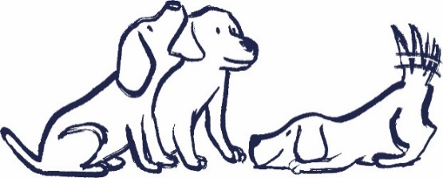
End of document

