Midlands and East region: puppy raising update – August 2023
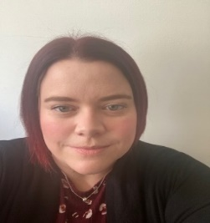
Hi all its Anna here, and I am the Canine Assistance Services (CAS) Operations Manager for Puppy Raising in the Midlands and East.

I firstly wanted to say that I hope you have been enjoying the summer months and the sometimes-lovely weather in our region.

I wanted to send a BIG thank you for all the support you have shown us in our region, providing a home for our pups, support to recruit other volunteers into our region and for those who have appeared on TV, radio and in person at events to support us. This is greatly appreciated, and we are very grateful for all you do to support us as we grow and develop our community.

We recently had a pup feature on TV with our brilliant Puppy Development Supervisor Jenny Mee with puppy Carol and Carol Kirkwood, see photo below:
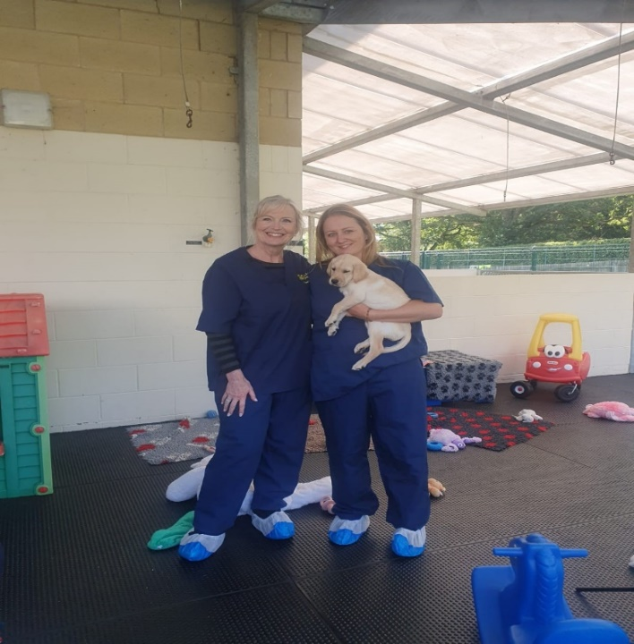

Team update
I hope you all managed to catch up with our update last newsletter where my team introduced themselves to you all. For those who may not seen this, my team consists of two Puppy Development Supervisors (PDSs) and 15 Puppy Development Advisors (PDAs).

We have now started placing our pups in these new areas, Norfolk, Suffolk, and Derbyshire and in the coming months will be starting puppy classes and adding more volunteers to these new areas as our new PDA’s continue to learn their new role and introduce themselves to their new and existing volunteers. A BIG welcome to these new areas into our puppy raising community.

Getting support from Guide Line
We are very fortunate as I have previously mentioned to have Guide Line who are supporting in our region to act as the front door for all volunteers' queries/questions and concerns. I just wanted to include this as a reminder to you to continue to use this contact route to access support if required between classes and visits. This also supports our fantastic PDAs to work with you and provide the support required.

This change we can already see has been allowing and supporting our Puppy Development Advisors time to work more closely with you all.
We continue to have a dedicated duty PDA daily to cover any urgent requests and can provide support as needed.

We ask that you continue to contact Guide Line as your first point of contact on 0800 7811444 or doghealth@guidedogs.org.uk.

Coffee mornings: dates for your diary
We are holding the following quarterly coffee sessions in September within our region on the following dates and venues and will have some colleagues from our breeding team to come and talk to us and answers questions.

- Wednesday 6 September, 10.30-12.30: Harbury Village Hall- South Parade, Harbury Leamington Spa CV33 9J.
- Thursday 7 September, 10.30-12.30: Peopleton Village Hall, Main Street, Peopleton, Worcestershire WR10 2EG.
- Tuesday 12 September, 10.30-12.30: Newark, Phoenix Community Hall, 47 Station Road, Collingham, Newark NG23 7RA.

These are informal sessions, please speak to your PDA if you would like to bring your pup and they will discuss with you further. If you would like to attend, please let myself or your PDA know. Any feedback on these sessions so far would be greatly received, I look forward to seeing as many of you who can make it at these events.

And finally
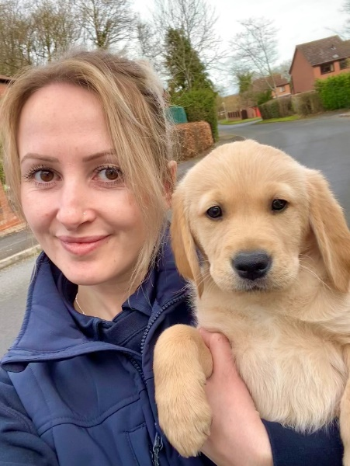
Nichola Geraghty who is our wonderful PDA over in Birmingham will be running the London Marathon next year (21 April 2024), her first ever one, on behalf of Guide Dogs. We will be cheering her on as she trains and completes this wonderful event in support of our organisation.

Well done Nic from us all, we are cheering you on!

You can find out more by visiting Nic's Marathon Fundraising Page: https://2024tcslondonmarathon.enthuse.com/pf/nicguidedogs.

Anna Standing
Canine Assisted Services, Operations Manager – Midlands and East

Document ends.

