North East region: puppy raising update – August 2023
Welcome to August’s regional puppy raising update for the North East.
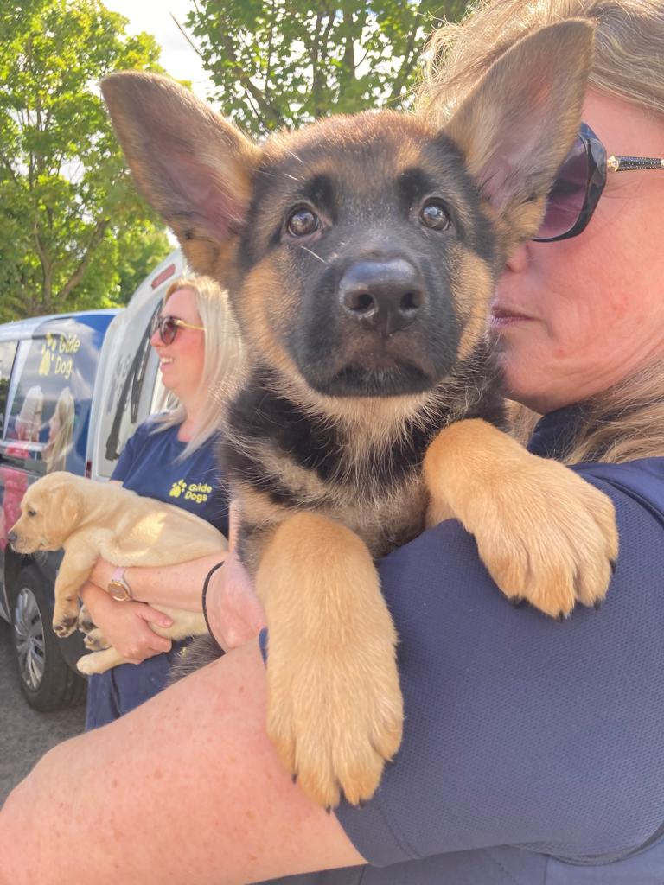
Firstly, a huge congratulations to all our amazing puppy raisers and fosterers, I am delighted to tell you that for the first time, the North East region is currently raising 160 puppies which is a fantastic achievement. Last year, we peaked at around 130 puppies.

I also would like to extend my gratitude for supporting us with another busy summer period. This is an extremely hectic time of year for puppy raising, and we couldn’t manage without your generosity and organisation with assisting us in moving pups for fostering and regularly planning all the logistics yourselves.

If you’re moving pups, on these occasions, please remember to let us know when and where your pups are moving to so we can update the computer system accordingly. The best way to ensure that the information gets through is to email NEPuppyRaising@guidedogs.org.uk.

Team update

New recruits settling in
Alana, Laura and Gillian are now four months into their roles as Puppy Development Advisors (PDA) and are getting to know what the job entails. We are also delighted to welcome another new starter to the team, Elise Finney who joined us at the start of August and will be gradually taking over the East Yorkshire section of Kays scheme which will also incorporate North Lincolnshire and up the East coast towards Scarborough.

Coming soon: Puppy Development Advisor introductions
Anyone who had pups go into training at the Hull Office may have come across Elise in her previous role as Dog Health and Wellbeing Technician. In October’s North East regional puppy raising update, I will be asking all the team to write short introductions so you can get to know us all a little more.

Helen Barley
For puppy raisers supported by Helen Barley you may already be aware she is currently off work poorly. If you think your PDA is Helen and you haven’t had a contact call from us, please contact NEPuppyRaising@guidedogs.org.uk.

Please use this email address to raise any issues or concern that you may need help with, as one of the team will respond, and ensure that we can support you in the best possible way.

Site update

Newcastle
Exciting times are ahead in the region as our long-awaited new premises gradually become available. Following its official opening earlier in the year, our Newcastle site is fully up and running. Rebecca, Lucy and Gillian are already using the facilities more and more for the puppy raisers based around the site. This currently involves running puppy classes and group visits from the site as well as specific sessions for individual pups who can benefit from controlled training sessions in an environment where we can minimise the unexpected. It’s also a great opportunity to introduce the pups to the type of situations they will face when they move into training. The brand new free running area at Newcastle is also under construction which will be a great support for the dogs in training up there as well as for our PDA run sessions.

Sheffield
By the end of August, we will have moved into our new premises in Sheffield and as that site becomes established we will also be planning a similar programme from there for our puppy raisers based around the South Yorkshire area.

Leeds
The Leeds office in Headingley is still under renovation and at this point in time I do not have a timescale for when the Leeds based team will move out of their temporary facilities back to Shire View. But again, once that site is opened puppy raising will be utilising the facilities as much as we can.

Hull
At the end of July, our small office in Hull closed permanently, the training staff who were based there have either remained working in the area or will be based from the Sheffield site. Any dogs in training who were at Hull will remain with their trainers wherever possible.

Making use of additional virtual support
As I mentioned in our previous update (June 2023), our twice weekly regional Zooms continue to be expertly run by Rebecca. These Zoom sessions are an opportunity to join us for further support and ideas as well as a chance to connect with other puppy raisers around the region. They are in addition to the one-to-one guidance you receive from your PDA and puppy classes that you can attend.

On a side note, we have been delighted by the uptake and attendance on these Zoom sessions and are currently planning a way of connecting with as many of our fosterers as possible in a similar way so we can keep our vital “part time puppy raisers” up-to-date and supported with ideas for common issues and expectations around fostering our pups. To be included in the mailing list to receive regular information about the regional Zoom sessions, please contact NEPuppyRaising@guidedogs.org.uk and we will pass your details on to Rebecca.

We fully understand that this virtual platform does not suit everyone, but by utilising it where it does work helps us keep consistency for our pups and free up time for PDAs to spend tackling issues that can’t be covered virtually.

Your suggestions
Please let me know if there is anything specific you would like me to include in these regional updates either by emailing janet.champion@guidedogs.org.uk or feel free to mention to one of our puppy raising mentors who meet with myself, Kay and Wendy once a month who can pass on ideas or comments on your behalf.

Thanks again,

Janet Champion
Canine Assisted Services, Operations Manager – North East

Document ends.

