North West region: puppy raising update – August 2023
Welcome to August’s regional puppy raising update for the North West.

Team update

Jan Johnston
We’ve now onboarded Jan Johnston following our recent advertisement for a Puppy Development Advisor. Jan will be mainly covering the Greater Manchester scheme area. Jan has been in Guide Dogs for many years as a Guide Dog Trainer working at Atherton and from the Liverpool Community Team.

Jan’s current job is working as an Operations Volunteering Officer for the region, her specialism is recruiting and training volunteers to foster dogs in training. We are very excited to have Jan on board, as part of the North West puppy development team.

Elaine Webster
Thank you to everyone who donated to Elaine Webster’s memorial bench. We raised £924 and will now be sourcing a bench to place in Atherton, so that staff and volunteers can visit to pay their respects.

Karin Snape
Also thank you to puppy raiser Karin Snape who completed a gruelling charity fundraising event, walking from John O Groats to Lands’ End for Guide Dogs, and has named a puppy Elaine. This will be a lovely addition to puppy Webster who will continue with Elaine’s legacy and her connection to Guide Dogs.

Rachel Adams (and puppy Dayta)
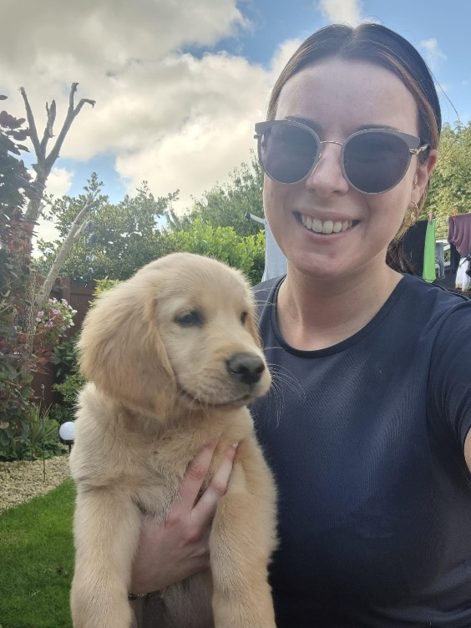

We are very excited to have our first puppy placed in Cumbria this month, Golden Retriever Dayta, placed by our lovely Puppy Development Advisor, Rachel Adams. I’m sure Dayta will gets lots of attention everywhere she goes and hopefully she will help to promote Guide Dogs and puppy raising in the area.

Thanks,

Vanessa Scott
Canine Assisted Services, Operations Manager – North West

Document ends.

