Puppy Raising Information Pack

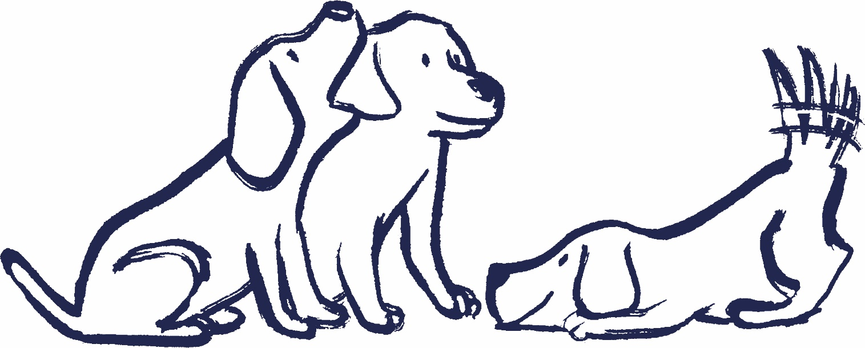

Version 1.1

A warm welcome to Puppy Raising
Please find enclosed some useful and important information.
- Documents in section 1 need completing, signing, and returning to us in the enclosed reply-paid envelope as soon as possible.
- Documents in section 2 can be read at your leisure and are there to support you in your role as a Puppy Raiser.

Key contacts
You will have a designated Puppy Development Advisor (PDA) who you can contact by phone or email as per details below;
Email:
Name:
Phone:
Guide Line
Phone: 0800 781 1444
For general queries or any health questions or concerns about your puppy contact Guide Line. We are open 9am-5pm, Monday to Friday (except bank holidays).
Out-of-hours emergency contact number
If you need to speak to us outside of office hours (including bank holidays) with an emergency query, please contact us on 0345 143 0217.

Section 1

Forms for completion, signing and returning
Agreement for the Provision of Temporary Accommodation for Dogs owned by the Guide Dogs for the Blind Association
This gives you the opportunity to read through the agreement prior to receiving a personalised copy which you will be asked to sign when you receive your puppy for the first time.
Data consent form
This form relates to the sharing of your personal details. The information in the form will be stored electronically on your record in accordance with GDPR.
Bank credit transfer authority form
Please complete this form whether you do or do not wish to receive the puppy raising allowance. The allowance is calculated on the days the pup is with you and will be paid directly to your bank on a monthly basis. If you change your mind to claim or no longer claim at a later date, just let us know and we will issue you with a new form. For information regarding the puppy raising allowance, refer to the ‘Expenses guidance - including puppy raising allowance’.
I’ve arrived pack & photograph request form
This form is about your preferences on whether and how you receive photos when your dog either enters training or is withdrawn.
Veterinary address details form
This form provides us with the details of your local Veterinary Surgery that you have chosen to take your Guide Dog puppy to. Please ensure that it is one with 24-hour emergency cover. If you do not know of a suitable practice in your area, then please contact your local Community Team via Guide Line for advice.
Please Note: We pay for all veterinary treatment the puppy needs whilst in your care, but we do ask that before making non-urgent appointments or agreeing to any treatment you contact Guide Line or the Emergency contact number (for out of hours) who will, if necessary, check with your Puppy Development Advisor or Dog Health & Wellbeing Specialist.

Section 2

Practical information
Communication with Puppy Raisers
When your puppy leaves you to continue its guide dog education, this document outlines when you can expect to hear about your dog’s progress from the handler responsible for them.
Volunteer voices & Volunteer information point (VIP)
Volunteer voices is a collaborative network of local and online volunteer groups which participate in conversations on volunteering, and the co-creation of ideas and solutions. The purpose of Volunteer Voices is to provide Guide Dogs with volunteer insight, suggestions/opinion, and feedback to improve the overall volunteer experience.
VIP is where Guide Dogs volunteers can find the latest Guide Dogs news, locate resources related to their volunteer roles and find out how to get in touch. It's a dedicated place for dedicated people. Click on the following link to find out more https://www.guidedogs.org.uk/vip/resources/volunteer-voices/
Accessing Kallidus
How we deliver some training and guidance through our learning management system.
Guide Dogs volunteer social media policy
Guide Dogs volunteer social media policy, that you should be aware of.
Expenses guidance – including puppy raising allowance
Information on how to reclaim expenses as part of your role.
Guide Dogs volunteer expenses form
The Volunteer Expenses Claim form is available on VIP. If you do not have access to the internet, please ask your Puppy Development Advisor for a hard copy.
Customer feedback and complaints
Guide Dogs values your comments, and we learn important lessons from the feedback we receive that help us improve our services. Please use the following link https://www.guidedogs.org.uk/contact-us/ to find out more.

Dog health information
Veterinary introduction letter
To be presented to your vet, so they can register you and your Guide Dog puppy.
VAT letter
To be presented to your vet, along with the veterinary introduction letter.
Dog information form
For you to share and provide specific information about your dog should they need to be placed with another Puppy Raiser or Fosterer due to holiday or in case of emergencies, etc.
How to order dog food
You can place a food order using the contact details below. Please allow five working days from placing your order to the delivery of the food.
When ordering food, it is a good idea to have your puppy’s health record to hand. You will need to give your name, your puppy’s name and computer number, delivery address, and the type of food you need (this is usually Royal Canin Maxi Puppy or Royal Canin German Shepherd Junior)
- Crown Pet Foods
Telephone: 0345 606 9498 (local rate)
Email: ProfOrders.GBR@royalcanin.com

Access information
Public access letter
Please keep this letter and your volunteer ID card with you when you are out and about with your puppy. Guide Dog puppies do not have automatic public access rights, we rely on the hospitality and goodwill of shop and café owners to allow you and your Guide Dogs puppy access.
Public transport
Speak to your Puppy Development Advisor about any informal agreements with local bus, train and tram companies who allow Puppy Raisers to take their puppy on local routes free of charge.
RDG – free rail travel letter
When your puppy is ready to be introduced to your local train station and trains, take this letter with you so you can show it to train staff. It allows free rail travel for you and your guide dog puppy on short train journeys (i.e., one or two stops).
and finally…
Should there be any change in your personal circumstances, please keep us informed, especially if it is a change of address, telephone number or email, by contacting Guide Line.

End of document

