Make Every Cuppa Count 2025

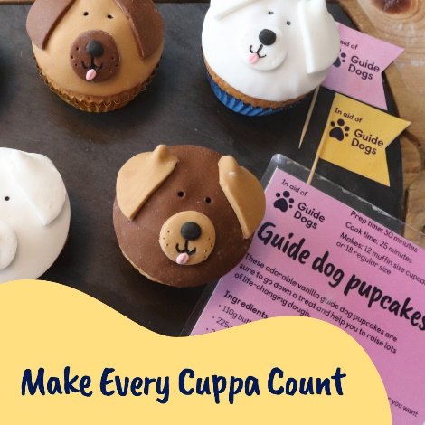
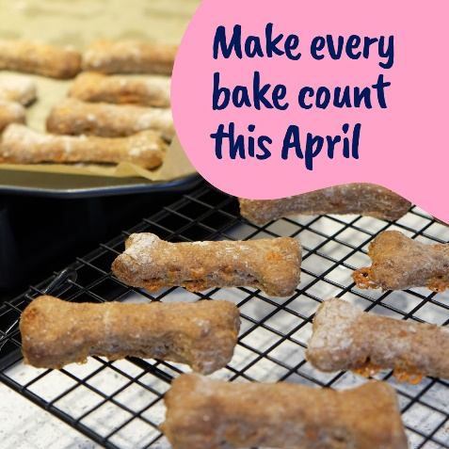
Volunteer toolkit
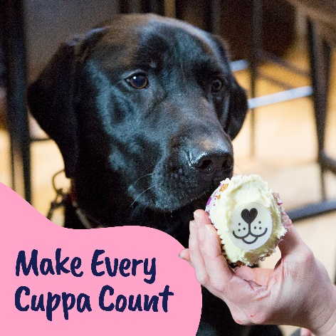

Introduction
Our annual tea-rrific fundraiser is back this April providing the paw-fect excuse for a cuppa and cake in the office, mixing up a mess in the kitchen with the kids, or even tempting pals and pups with some tasty treats.

We’re asking our supporters to Make Every Cuppa Count when they host a tea party, coffee morning or bake sale for Guide Dogs. Our official day to Make Every Cuppa Count is Friday 25 April, but as always, supporters can join in and celebrate any day they like. Small or large, at home, work or school, every penny a supporter raises will go towards helping us provide life-changing services.

If there’s a better excuse to get together over a cuppa cake, we haven’t heard it!

How can people get involved?
This year, our aim is to sign up 2,160 DIY supporters to fundraise this April and raise £100,000. We are also aiming to recruit one volunteer per fundraising group event across the UK.

This year we have teamed up with JustGiving where all our marketing for Make Every Cuppa Count 2025 will be driving supporters to sign up for their free fundraising pack at makeeverycuppacount.org.uk

Once signed up, supporters will automatically have an online JustGiving fundraising page created so that they can start collecting their donations.

What do supporters get when they sign up?
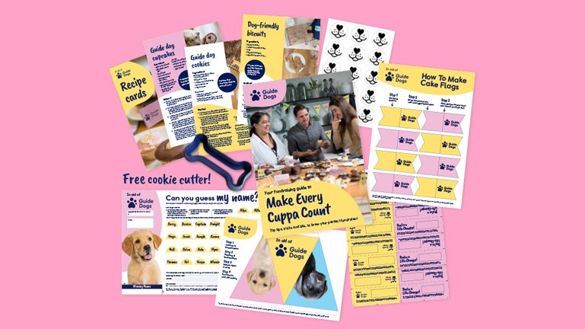

Supporters will receive a postal fundraising pack sent within 10 working days of their registration, including everything they need to Make Every Cuppa Count. They will also receive bespoke fundraising advice from our Community Fundraising experts, in addition to an automated email journey via JustGiving.

Fundraising hard copy pack:
- Welcome letter
- Make Every Cuppa Count guide
- Bone-shaped cookie cutter
- Poster
- Cake nose toppers – 2 sheets
- Donation labels
- Puppy sweepstake
- Bunting – x 4 sheets
- Cardboard collection box
- Gift aid form

Downloadable resources:
- Cake flags.
- DIY donation jar labels.
- Dog treat labels.
- Fundraising Group flyer.
- Guide Dogs flyer.
- Editable invitations.
- Bake off score cards.
- Recipe cards.

Ideas on how to Make Every Cuppa Count:
- Love to bake or just eat cake? – Whether supporters catch up together at home, work, school or in their community, they can decorate with our bunting and show-off their baking skills with our cake toppers and flags. Will they bake it or fake it?
- Cake to go – Our cupcake recipe is available for supporters to bake up some delicious treats either on their own or as a team. There’s even a recipe for our tail wagging friends too!
- Doggy delights – Supporters are encouraged to gather their dog-owning friends to organise a nice walk and warm up after with a brew and biscuits encouraging everyone to donate to take part. Every cake, cookie and crumb really does make a difference.

How can volunteers support this year’s campaign?
Volunteers can access all the promotional and fundraising tools via the Community Fundraising Volunteer Newsletter, Intergroup meetings, Facebook, Volunteer Information Point and Community Fundraising Supporter Care.

- Promote our Make Every Cuppa Count campaign to everyone!
- Share your fundraising plans using our template press releases. Contact your local newspaper or radio station and let your local community know how they can support your fundraising efforts.
- Re-engage with volunteers by inviting everyone to take part.
- Get involved with your own fundraiser and enjoy some cake and a cuppa – don’t forget your furry friends too!
- Share your photos and stories on social media and with press contacts. Our team would also love to see how you made every cuppa count – fundraiseforus@guidedogs.org.uk

If you need any additional fundraising resources such as a cookie cutter or cake toppers, please contact your regional Supporter Care team.

Top tip: Don’t forget when paying in the money you raised to use the code TEA PARTY on your banking slip.

Suggested Meta content for volunteers:

Promoting your fundraiser locally:

- Join us as we Make Every Cuppa Count on <Add date and location of your event>! ☕

Visual description: XXX

- Do you love to bake or just eat cake? 🧁

Join us to Make Every Cuppa Count and host your own tea party, bake sale, or coffee morning on 25 April!

Visual description: XXX

- We’re making every cuppa count this April! ☕

The XX team are raising funds from our cakes and bakes to support Guide Dogs this XX (specify date of your fundraiser) April. Why don’t you join us?

Visual description: XXX

Why not create your own event on your Facebook Fundraising Group pages! Here’s some content you can use to get you started:

Event name – <XX Enter organisers whole name e.g Sevenoaks Fundraising Group or your local Guide Dogs Team XX> Make Every Cuppa Count fundraiser ☕ 🧁

We are paw’sing for a cuppa to Make Every Cuppa Count and we would love for you to join us!

Let’s celebrate our life-changing work over a cuppa and lots of delicious cake at <venue> on <date> at <start time>-<end time>.

If there’s a better excuse to get together over a cuppa and cake, we haven’t heard it!

Visual description: XXX

Got a question?
Contact the Make Every Cuppa Count team at fundraiseforus@guidedogs.org.uk or call 0345 143 0192.

End of document.

