Samsung – Setting up your Guide Dogs Samsung Phone
Unique reference number: BF-IS-GN-216
Document Owner: Clare Breen
Version: 2.0

Purpose of Best Practice Guidance
If you have been allocated a Guide Dogs Samsung mobile phone, this guide will enable you to get set up.

Before you start
Use the cable & plug provided in your phone box to charge you r Samsung phone.

If you are upgrading from another Guide Dogs Corporate phone:
Carefully remove the Sim card from your older phone and insert it into your new phone.
If a Sim card was included in the box with your new phone do not use this; it will not have been activated.

If this is your first corporate phone:
Insert the sim card provided with your new phone.

To eject Sim cards
- An ejection pin is included in the box. Insert the ejection pin into the pin sized hole next to the Sim card slot. On your Samsung phone, this is located at the top edge of the casing on the left. Mild/moderate force of the pin in the hole will eject the sim card holder.

Caution - Authentication
If you use an existing work mobile phone as your method to authenticate Microsoft sign ins, you will need to ensure you have another way to do this, such as a text to your private phone or an email to your work account.
You can do this in your Microsoft Account.
You will be required to authenticate sign ins to Microsoft a few times during the set-up process.

Setting up your Corporate Samsung Phone
- Ensure the phone has been charged and your Sim card inserted.
- Power on the Samsung phone (press and hold the smaller button on the right hand side of the casing for 2 or 3 seconds.)
- Select the Start button to begin setup.
NB: If you require accessibility settings, select the person button in the bottom right corner of the screen

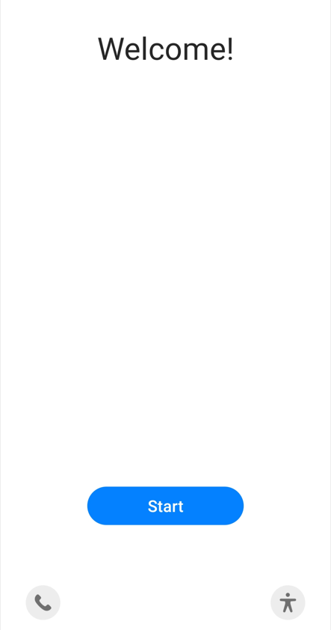
- Select your language (English, United Kingdom) from the list then select Next.
- On the legal terms and conditions page, accept both terms then select Next.
- Agree to the Permission for Samsung Services screen.
- A pop-up will appear at the bottom of the screen asking you to confirm it is ok to use mobile data, Select Continue.
- Your device will now check for updates, and perform any updates required. It will land on a screen stating that the device belongs to your organisation. Select Next.
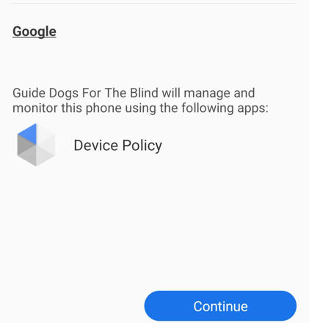
- The phone will display a message that it is getting ready for work setup, then display the Set up your phone screen. Select Continue.
- The phone will now set up your device, then land on a This
Device is not private screen. Select Next.
- On the Welcome to Chrome screen. Select Next
- Sign into your Microsoft account using your username@guidedogs.org.uk and your login password. You will need to verify your identity this with Microsoft, so have your authentication method handy.

- Your device will now start registering. It will land on the work checklist screen. To set up your screen lock method, select set up then enter your pin or password. Select continue, then re-enter your pin or password, and then continue.
- The next step is to allow your phone to install the required apps. It will install Microsoft Authenticator, Microsoft Intune, and Intune Company Portal. Select Done.
- On the Intune screen, select Sign in
- Enter your username@guidedogs.org.uk and your network password, then select Sign in. You will again need to verify your identity.
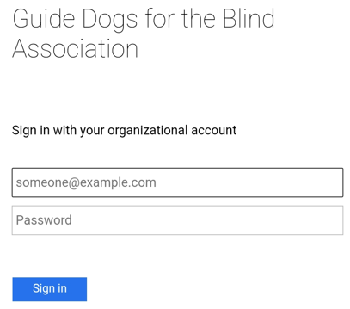
- You now need to register your device. Select Register
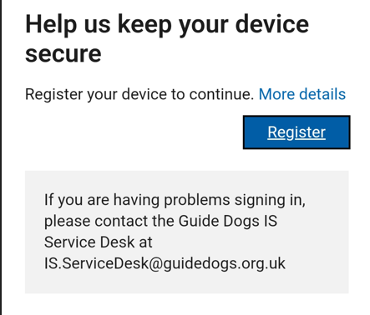
- Set up the Guide Dogs for the Blind Association access. Select Next
- Chose Device Category. Select Corporate Device, then OK.
- Your device is now ready to go. Tap Done.

Your device will begin installing your work applications in the background. This may take some time depending on your connection.

If you need assistance
Contact IS Service Desk on 0118 354 0354 or by emailing IS.Servicedesk@guidedogs.org.uk

The table below contains three rows and four columns. (Only the original approval date and the most recent amendment should be included in the table.)
Date | Version | Status | Details of Change
16/08/2022 | 1.0 | Complete | Creation GP
5/9/2022 | 2.0 | Complete | Amendment to process and addition of screenshots NW, GP
** Please see below when a document must be reviewed by governance.

Safeguarding - All documents with any reference to safeguarding, recruitment and training, working with clients (Adult and CYP).
Legal - All documents with any reference to agreements or contracts, third party partnerships, potential reputational risk, reference to compliance with any statutory or regulatory obligation.
Health and Safety - All documents where an activity could cause harm to a member of staff, service user, volunteer or third party or where there is reputational risk.
Insurance – A change to the way we deliver our services.

End of document

