Samsung – Advice on reducing mobile data use
Unique reference number: BF-IS-GN-220
Document Owner: Clare Breen
Version: 1.0

Purpose of Procedure
This Guide will help you make the best use of mobile data on your corporate phone, without incurring charges to Guide Dogs by going over your data allowance.
Contents
Samsung – Data Saving Advice 1
Purpose of Procedure 1
Guide Dogs Corporate Mobile Plans 2
Activities with high data use 2
Checking your data usage 3
Tips to minimise use of mobile data 3
Connect to Corporate Wi-Fi when in the office 3
Connect to secure home Wi-Fi networks when possible 3
Auto-reconnect to Wi-Fi Networks 4
Set a data warning 4
Set a data limit 4
OneDrive 5
OneDrive - Allow Camera back-up to OneDrive over Wi-Fi networks only 5
OneDrive – Sync Offline Files over Wi-Fi networks only 5
Microsoft Teams 5
Join Teams meetings by dialling in instead of using mobile data 6
Turn off your camera in Teams calls or meetings 8
Turn off Incoming Video in Teams calls or meetings 8
Reduce Video Call Data Usage 8
Offline Files 9
Further help and support 9
Version control table: 9
End of document 9

Guide Dogs Corporate Mobile Plans
Guide Dogs mobile plans allow only 250MB data use per month.
If users exceed this, they will dip into a small corporate shared data pool, but once this is used up Guide Dogs receive financial penalties.
- Please be aware of your data use and aim to stick to the 250MB allowance.
- Mobile data allowances are renewed at the beginning of each month.
- If you need to request additional data, please submit a business justification, along with approval from your Head of Department to IS Service Desk.

Activities with high data use
If you use your mobile phone when it is not connected to a Wi-Fi network, it will use mobile data to complete actions that require access to the internet, e.g.,
- Using a satnav app like Google Maps (5MB/hour)
- Streaming music (10MB/hour)
- Audio calls/meetings on Teams or Zoom (20MB data/hour)
- Browsing the internet (60MB/hour)
- Video calls/meetings on Teams or Zoom (500MB data/hour)
- Streaming videos (1GB/hour)
- Downloading applications (data use depends on app size)
- Sending/receiving emails (data use depends on file size)
- Sending/receiving files using apps (data use depends on file size)
Note: 1GB = 1000MB. Videos and images tend to be large files. Remember, you have a 250MB allowance.

Checking your data usage
- Open Settings
- Search and select on ‘Data usage’
- Select data usage again and your monthly usage will be displayed.
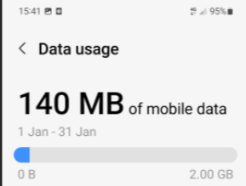
Note: Your phone may display 2GB by default. This is incorrect, and can be amended, see Set Data Limit.

Tips to minimise use of mobile data

Connect to Corporate Wi-Fi when in the office
If you are in a Guide Dogs office, please ensure you connect your mobile device to Corporate Mobile Wi-Fi.
- Open Settings
- Select Connections.
- Select Wi-Fi.
- Select the Wi-Fi network you want to join e.g., Guide Dogs Corporate Mobile
- Your device will connect to Guide Dogs corporate mobile Wi-Fi if it is compliant with Guide Dogs security settings. You should not be asked to enter a password. If your mobile does not connect, please email IS.Servicedesk@guidedogs.org.uk for support.
Note: Each time you re-enter the office, you will need to reconnect your phone to Corporate Wi-Fi.

Connect to secure home Wi-Fi networks when possible
When you are in a secure location such as your home, ensure that your mobile phone is connected to your Wi-Fi network.
- Open Settings
- Select Connections.
- Select Wi-Fi.
- Select the Wi-Fi network you want to join
- Enter your Wi-Fi password
- Your device will connect to your home Wi-Fi network.
Note: Avoid the use of public Wi-Fi where possible e.g., Coffee Shops, Café’s, Airport departure lounges and public transport. This is a data security consideration. More information can be found in the Working Remotely Policy.

Auto-reconnect to Wi-Fi Networks
- Open Settings
- Select Connections.
- Select Wi-Fi.
- Select the Wi-Fi network you would like to auto-reconnect to
- Ensure the Auto reconnect switch is toggles to the on (right) position
- Your device will automatically connect to this network when it is detected
Note: You will need to manually connect your phone to Corporate Mobile Wi-Fi each time you enter a Guide Dogs office.

Set a data warning
- Open Settings
- Use the Search tool (looking glass) to search Data Limit
- Select Data Limit
- Ensure Set Data Warning is toggled to the on position (right)
- Select Data warning
- Enter the number of GB to be used before the phone sends you a warning notification (e.g., with our 250MB data allowance, you might set a data warning at 200MB).

Set a data limit
- Open Settings
- Use the Search tool (looking glass) to search Data Limit
- Select Data Limit
- Toggle the Set data limit switch to the on position (right)
- Select Data Limit
- Enter the data limit you would like to set, e.g., 250MB.

OneDrive

OneDrive - Allow Camera back-up to OneDrive over Wi-Fi networks only
OneDrive is a great way for you to backup your photos and videos, making them available on any device to use and share. If you haven’t set this up yet, follow the steps in our guide Samsung - Uploading and sharing media files from OneDrive. Because some of these files are very large, it is important this is only done over Wi-Fi networks.
- Open the OneDrive App
- Select Me
- Select Settings
- Select Camera Backup
- Select Data Usage
- Select Upload over Wi-Fi only
- Your photos and videos will not sync to OneDrive without Wi-Fi connection

OneDrive – Sync Offline Files over Wi-Fi networks only
- Open the OneDrive App
- Select Me
- Select Settings
- Under Network, select Sync Offline Files
- Select Over Wi-Fi only
- Your files will not sync without a Wi-Fi network connection.

Do Not Tether your Corporate Mobile to your Laptop
Using your mobile data to work on your laptop will quickly use up data, ,and incur additional costs to Guide Dogs.

Microsoft Teams
Using Microsoft teams, particularly for video calls will use a lot of data quickly. In a video call, you are effectively streaming high-quality audio and video.
Video calls on Teams will use roughly 500mb data/hour, whereas audio calls on Teams will use only around 20mb data/hr.

Join Teams meetings by dialling in instead of using mobile data
Teams meetings can be joined by audio call instead of on the internet, which is useful if you do not require video. You can do this using the calendar within the Outlook or Teams app on your phone.

Using the Outlook Calendar to join a meeting using audio only
- On your mobile phone, open the meeting invitation in your Outlook calendar
- Select Read More
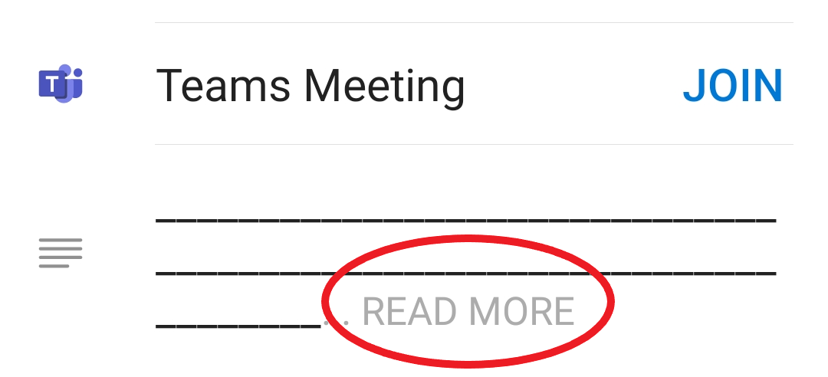
- Scroll down to Or call in (audio only)
- Select the link beginning +44
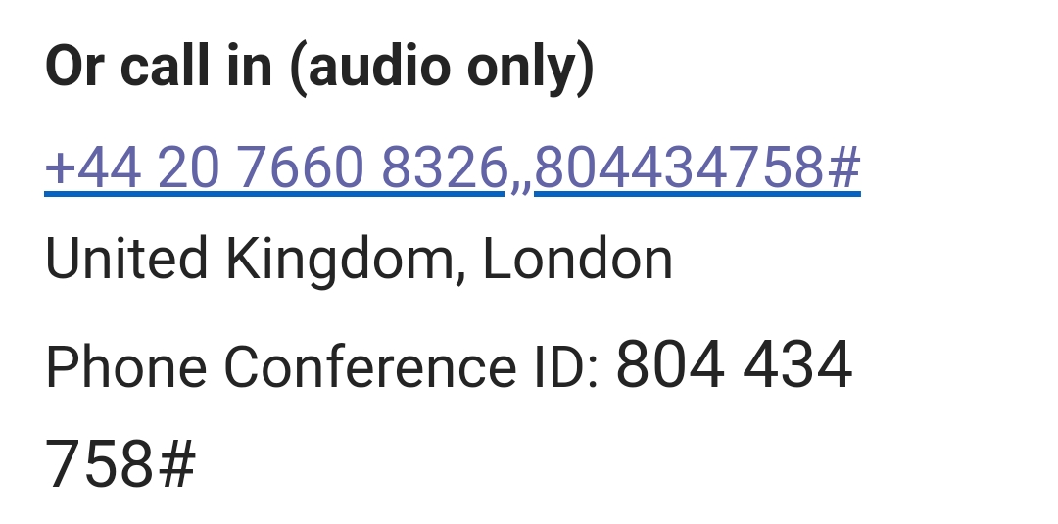
- Your phone’s dialpad will open, prepopulated with the meeting phone number and joining details
- Select the call button
- If prompted, enter the meeting ID and then #
- You will join the waiting room, and a meeting organiser or participant will be able to add you to the call.

Using the Teams Calendar to join a meeting using audio only
- On your mobile phone, open the meeting invitation in your Teams calendar
- Select See More
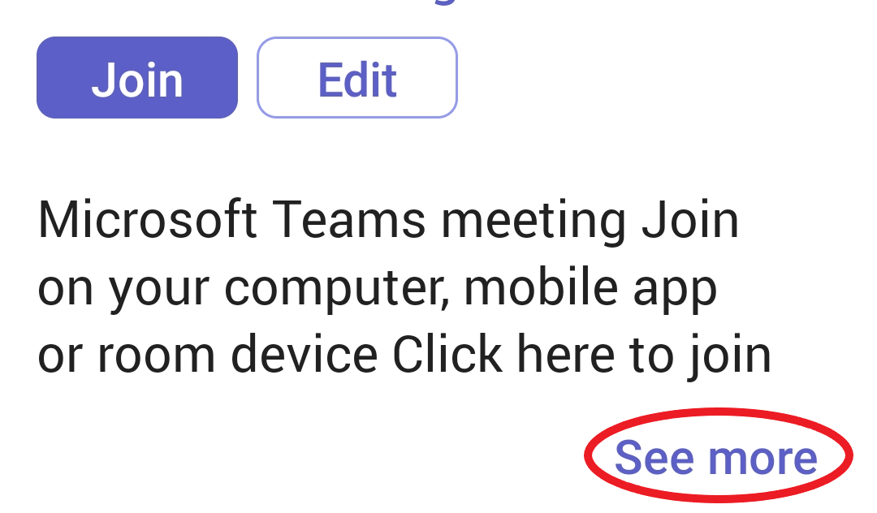
- Scroll down to ‘Or call in (audio only)’
- Select the link beginning +44
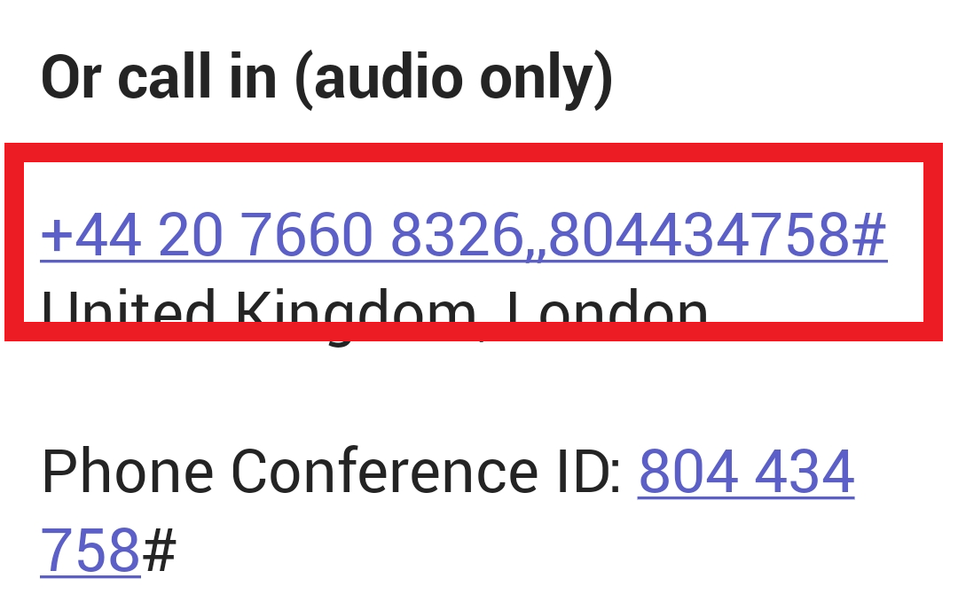
- Your phone’s dialpad will open, prepopulated with the meeting phone number and joining details
- Select the call button
- If prompted, enter the meeting ID and then #
- You will join the waiting room, and a meeting organiser or participant will be able to add you to the call.
Note: If you are the meeting organiser, you can use an audio call to start a Teams meeting. You will be prompted to enter a pin number to do this.
Your unique pin number will have been emailed to you by Microsoft Audio Conferencing (maccount@microsoft.com), in an automated email titled ‘You now have Audio Conferencing for Microsoft Teams or Skype for Business Online – Here is your dial-in information and pin’.

Turn off your camera in Teams calls or meetings
- In a Teams call or meeting, select the camera button at the bottom of the screen, and ensure your outgoing video is turned off


Turn off Incoming Video in Teams calls or meetings
- In a Teams call or meeting, select the More Actions (3 dots) at the bottom of the screen

- Swipe up on the panel that expands at the bottom of the screen to expand more options
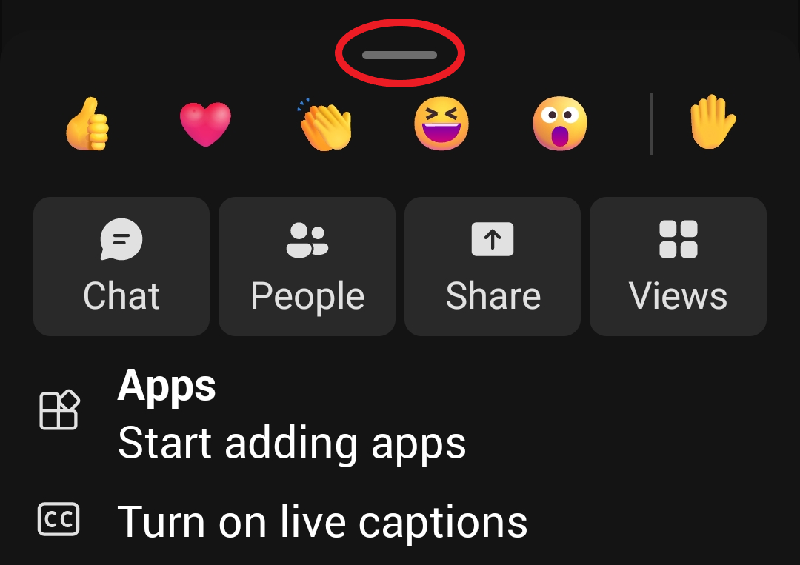
- Select Turn Off incoming video.

Reduce Video Call Data Usage
- Open your Teams mobile app
- Select your profile picture at the top left
- Select Settings
- Select Data and Storage
- Under video calls, select Reduce Data Usage
- Select On mobile Networks
- This will reduce data-use during video calls

Offline Files
- Open your Teams mobile app
- Select your profile picture at the top left
- Select Settings
- Select Data and Storage
- Under offline files, ensure Use mobile data for offline files is toggled to the off (left) position
- Offline files will only be downloaded when you are connected to Wi-Fi

Further help and support
If there is a problem with your mobile device, please email IS.Servicedesk@guidedogs.org.uk
If you are unsure on how to complete any of these steps and need educational support, please contact IS.KnowledgeManagement@guidedogs.org.uk

Version control table:
The table below contains two rows and four columns. (Only the original approval date and the most recent amendment should be included in the table.)
Date | Version | Status | Details of Change
08 Mar 23 | 1.0 | Creation | Created GP, Check CB. Content check NW.

End of document

