Setting up your Guide Dogs iPhone
Unique reference number BF IS GN 096
Document Owner: Clare Breen
Version: 8.0
Contents
Setting up your Guide Dogs iPhone 1
Purpose of Best Practice Guidance 1
Setting up your iPhone 1
Installing Intune 4
Installing the Company Portal App 4
Setting up the Company Portal App 4
If you experience problems with security criteria 7
Installing Outlook 8
Setting up Outlook 8
Making Images/Pictures compatible with Windows 10 8
Version control table: 9
End of document 9

Purpose of Best Practice Guidance
Intune is an IT system used to manage the security of Guide Dogs data on mobile devices. This can be a Guide Dogs issued mobile device or a personal device. This guide will take you through how to set Intune up on your iOS device.

Apple ID – before anything else

Setting up your iPhone
Please be aware that the options prompted and the order in which they appear may vary during setup on individual iPhones.

Note for Voiceover users: for this process, please be aware that Voiceover will revert to Standard Typing Mode regardless of your typing preference. Do not change this as Touch Typing provides only intermittent speech echo during setup.

- Insert your Sim card.
- Start the phone, then press the ‘Home’ key.
Note: Voiceover users should also press ‘Home’ key 3 times to restart Voiceover.
- On the ‘choose the language’ screen, select ‘English’, then ‘Next’.
- On the ‘choose your country/region’ screen, select ‘United Kingdom’.
Note: Voiceover users will experience a pause as the English UK voice loads up.
- On the ‘select Wi-Fi network’ screen, connect to the Guide Dogs guest Wi-Fi if you are in the office, or your own Wi-Fi network.
- On the ‘data & privacy page’ select ‘Continue’ if prompted.
- On the ‘remote management’ screen, select ‘Next’.
- Enter your username.
- Select ‘Next’.
- On the ‘Touch ID’ screen, select ‘Set up Touch ID Later’.
Note: when asked ‘Are you sure you don’t want to use Touch ID’, select ‘Don’t use’.
- Create a Custom Alphanumeric code. This can be changed by selecting Passcode Options and then selecting Alphanumeric Code. Create a strong passcode with 8 or more letters/numbers including one special character (for example !&!).
- Re-enter your ‘passcode’.
- When prompted for your Apple ID, enter your Guide Dogs Apple ID and password.
- Select ‘Agree’ to Apple’s terms and conditions.
- On the ‘iCloud Drive’ screen, select ‘Don’t Update to iCloud drive’.
- On the ‘location services’ screen, select ‘Enable location services.’
- If prompted with the ‘iCloud keychain’ screen, select ‘Don’t use iCloud keychain’.
- Select ‘Don’t Restore Passwords’ (if prompted).
- Select ‘Get Started’ on the ‘Welcome to iPhone’ screen.
- When prompted, select ‘OK’ on the ‘iMessage carrier charges’ screen.

Installing Intune
Once your device has been set up, you should land on the device home-screen.

Installing the Company Portal App
Leave your device for 10 Minutes, and the Company Portal app will automatically download.
If the Company Portal does not automatically download, you will need to:
- Open the ‘app store’ from your home screen.
- In the Search section at the top of the screen, search for ‘Microsoft Intune Company Portal’.


- Download Intune Company Portal
Note: when you download the App for the first time you will need to use your Apple ID password. This will trigger a notification prompting to set up App Store information. This will include:
- First and Last Name
- Address
- Post Code
- Contact Number
These details will be needed to progress your download.
- Select download on Intune Company Portal again and enter your Apple ID a second time.

Setting up the Company Portal App
- Open the ‘Microsoft Intune Company Portal’ app.
- You will be prompted to enter an email address, use your username@guidedogs.org.uk.
- Select ‘Next’
- You will be redirected to another login page. Enter your network login password and then select ‘Sign In’.
- Select ‘Begin’ on the Company Access Setup screen.
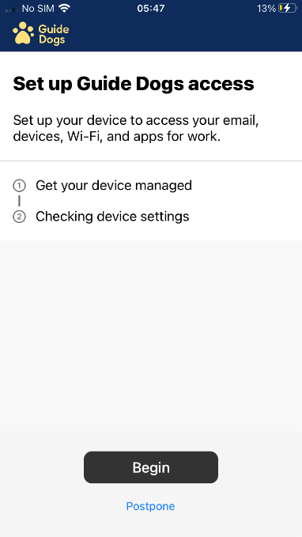

- Select ‘Corporate Device’ followed by ‘Continue’.
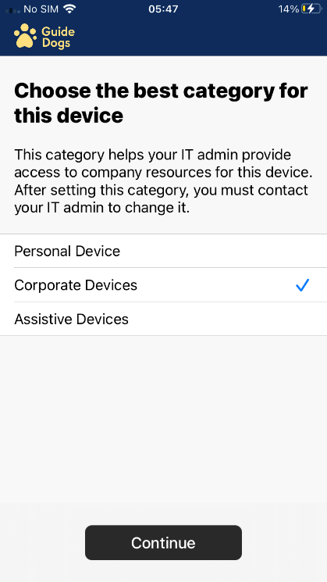

- Select ‘Continue’ on the ‘Set up Guide Dogs access’ screen.
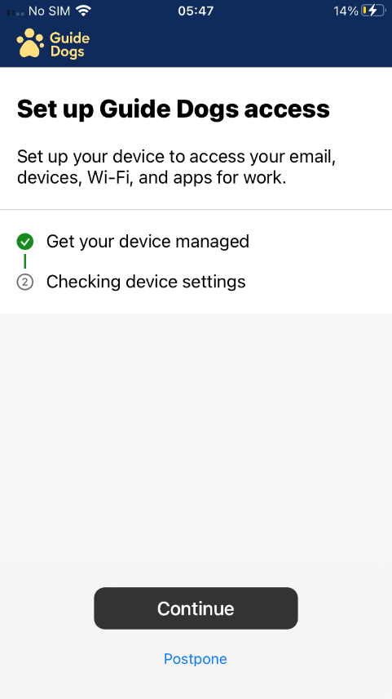
- Your device will run through a ‘Checking device Settings’ stage. This will look at pass codes on the device, making sure that the alphanumeric passcode meets the Guide Dogs policy requirements.
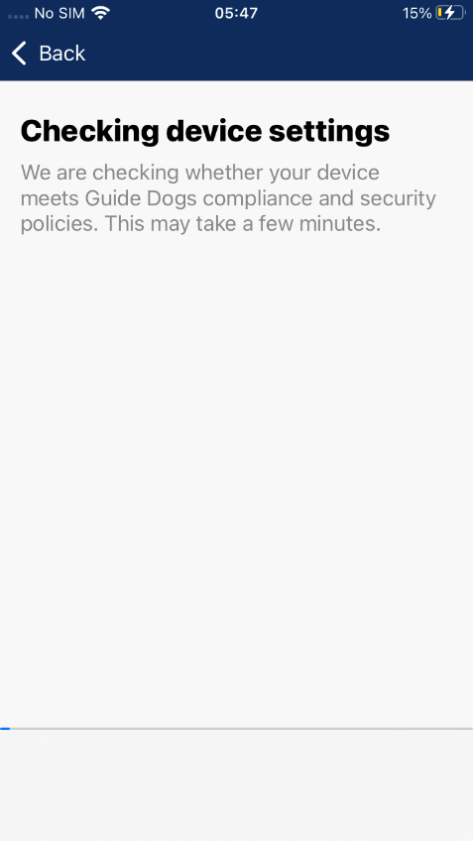

- If your Device meets Guide Dogs security criteria, the screen will show ‘You’re all set!’ click ‘Done’.
- You should now see your ‘iPhone’ listed in the Company Portal app. (If you have a laptop, you should also see this listed).

If you experience problems with security criteria
Select the ‘iPhone’ then select ‘check status.’
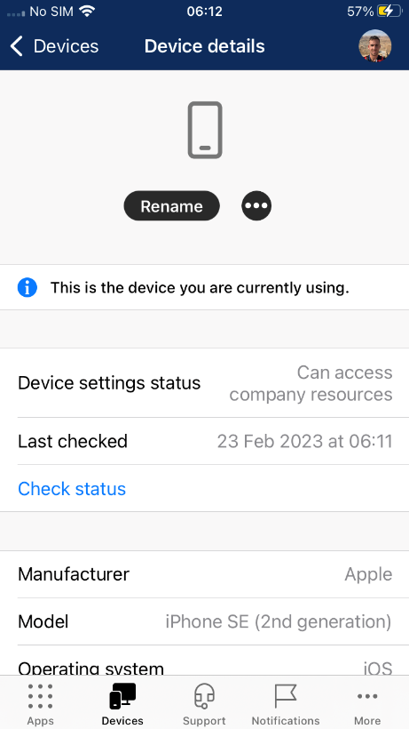
This will now run though the ‘Confirming device settings ‘check which can take some time. This check will flag up any reason why your device cannot proceed or where it is not compliant with policy. Reasons might include:
- The device passcode is not strong enough to secure the device. Try not to use words as a password, which should contain random characters, numbers, letters, and special characters (alphanumeric).
- IOS requires an update to the newest version. This can be updated by going to ‘Settings’, ‘General’ and selecting ‘software update’. Select ‘Update’ then leave the device whilst it downloads. Once complete, the device should restart. Once the device restarts return to the Setting up Company Portal instructions and re-attempt set-up.

Installing Outlook
- Select the ‘App Store’ from the Home Screen.
Note: This should be done using Wi-Fi.
- In the Search tab at the top of the screen, search for ‘Microsoft Outlook’,
Note: you may need to scroll down to see the correct app.
- Select ‘Get’.
- Select ‘Install’ to download the app.
- You may be prompted to re-enter your Apple ID.
- You can either select ‘Open’ from the app store or return to the Home Screen and open the app once it has finished downloading.

Setting up Outlook
- When you open ‘Outlook’ for the first time you should see your account already linked above. Select Add Account.
- Insert your login password below your username@guidedogs.org.uk
- The Device will prompt you to Approve Sign-in request.
- When asked if you would like to add another account, select Maybe later.
- When your inbox opens, a popup will appear. Select Turn On to enable notifications, then Allow.
Note: If the Device shows a message that your email has been blocked on this device by your admin, please email IS Servicedesk, including in your email the message about the device being blocked in outlook.

Making Images/Pictures compatible with Windows 10
- When you take pictures on your iPhone and upload them to OneDrive, they are imported by default as .heic files. This is not compatible with Microsoft products. To ensure you have no issues with images, in your iPhone please:
- Select Settings
- Select Camera
- Select Formats
- Change ‘high efficiency’ to ‘most compatable’
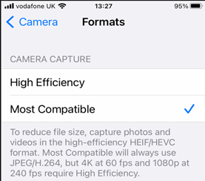
Images will now be saved as .jpg files, which are compatible with Windows.

Version control table:
The table below contains two rows and four columns. (Only the original approval date and the most recent amendment should be included in the table.)
Date | Version | Status | Details of Change
01 Mar 2023 | 7.0 | Updated | Updated and checked for use with current iPhone Simon Addison. Checked GP.
02 Jun 23 | 8.0 | Updated | Added info on file type for images. GP

End of document

