


Community Fundraising Groups Health and Safety Guidance

During your role as a fundraising volunteer, you have contact with many different potentials for harm, so it is very important that you operate in a way that ensures the safety and health of you and others is considered and managed. This document is designed to help you do this by explaining what harms are associated with your various activities and the controls and processes to be followed to reduce the risk of those harms occurring.

Section 1 - Risk assessments 4
General activities risk assessments 4
Specific event risk assessments 4
New activities/specific events 5
Section 2 – 3rd party contractors and venues 5
3rd party event organisers/venues request for health and safety documentation/information 5
Section 3 - Pop up charity Shops 6
Section 4 – Accidents, incidents, and emergency situations 6
Section 5 - Guidance, controls, and best practice 7
Volunteers working alone 7
Potential harms: 7
Best practice and controls: 7
Banking, handling, and transportation of cash 8
Potential harms: 8
Best practice and controls: 8
Donation collection by community fundraising group 11
Potential harms: 11
Best practice and controls: 11
Guide Dog stock and pet dogs at fundraising and engagement events 12
Potential harms: 12
Best practice and controls: 12
Wearers of dog mascot suit 14
Potential harms: 14
Best practice and controls: 14
Activities and events in changing and adverse weather conditions 15
Potential harms: 15
Best practice and controls: 15
Set up, take down, use and transportation of marquees and associated equipment 17
Potential harms: 17
Best practice and controls: 17
Handling and storage of merchandise and information literature 19
Potential harms: 19
Best practice and controls: 19
Handling and selling of food and drink – bought and homemade 20
Potential harms: 20
Best practice and controls: 20
Placement and collection of life-sized dog units/floor boxes and emptying of donations 21
Potential harms: 21
Best practice and controls: 21
Use of blindfolds, mind folds and simulation specs 23
Potential harms 23
Best practice and controls: 23
Use of electrical equipment 24
Potential harms: 24
Best practice and controls: 24
Using 3rd party venues 25
Potential harms: 25
Best practice and controls: 25
Manual handling 26
Potential harms: 26
Best practice and controls: 26
Review and update record 28
Appendix 1 – Community Fundraising Venue Checklist 29
Appendix 2 – A guide to safer manual handling 32

Section 1 - Risk assessments

Risk assessments are a tool used to identify the hazards (potentials for harm) associated with your fundraising activities and the controls that need to be implemented/followed to reduce the likelihood of these harms occurring.

Guide Dogs have overarching risk assessments for the standard activities/events our Fundraising Groups undertake on a regular basis. These risk assessments have been agreed and signed off by the Health and Safety and Community Fundraising management teams and are regularly reviewed and updates/changes made as required. There is no requirement for groups to complete/change or localise risk assessments.

Overarching risk assessments are in place which cover the following activities and events associated with Guide Dogs community fundraising groups:

General activities risk assessments

- Banking, handling, and transportation of cash
- Dogs at fundraising and engagement events (Guide Dogs stock and pet)
- Handling and selling of food and drink
- Handling and storage of merchandise and literature
- Set up, use, and take down of marquees and associated equipment
- Activities and events in changing weather conditions
- Placement and collection of floor box (life size dog)
- Use of electrical equipment
- Working alone
- Use of simulation specs, mind fold or blindfold
- Dog mascot costume

Specific event risk assessments

- Donation collections
- Dining in the dark event
- Lunch and learn event
- Meet Guide Dogs event
- Sponsored walks, cycle or run

For Dining in the dark and Sponsored walks, cycle or run events it is essential that you include your CRFM in the planning stages as there are specific requirements in relation to health and safety.

There will not be a specific risk assessment for every activity/event that you undertake as we have a bank of risk assessments and associated processes/procedures and guidance that cover various general events undertaken by Fundraising Groups. For example, the risk assessments for dogs at events, handling and selling food and 3rd party venue checklist would cover a coffee morning.

If you require a copy of a risk assessment you can request this from our Supporter Care team on 0345 1430234

New activities/specific events

If you are considering undertaking an activity/event not covered by the current risk assessments or guidance in section 5 of this document or you are planning to run a large-scale event you must contact your CFRM to arrange for an assessment to be completed by the health and safety team before commencement.

Section 2 – 3rd party contractors and venues

3rd party event organisers/venues request for health and safety documentation/information

If you are attending an event or undertaking an activity at a 3rd party’s event or premises and they require health and safety information from you, please liaise with our Supporter Care Team. This will ensure the relevant documentation is supplied and any paperwork is completed correctly.

If you are attending a 3rd party organised event it is important that you ask them to supply a copy of their event risk assessment for review by your CRFM and understand and implement any associated emergency procedures and other information such as visitor rules, specific hazards and control measures, site contact etc.

- Using 3rd party contractors to provide an experience or service

When Guide Dogs Groups invite other companies/organisations to an event to provide a service or experience there is a responsibility on Guide Dogs to ensure the 3rd parties we are using operate in a safe and legal way. If you are going to use a 3rd party at one of your events, you must first speak to your CFRM as they will need to implement Guide Dogs control of contractors/supplier’s process and obtain appropriate documentation in relation to health and safety.

Section 3 - Pop up charity Shops

There is a specific process to be followed for the setting up, running, and closing of short-term pop-up shops so you must contact your CFRM before starting work on one of these.

Section 4 – Accidents, incidents, and emergency situations

If you are involved in an incident that causes, or could have resulted in, an injury to you or any other person, it must be reported to your CFRM at the earliest opportunity.

Following a report by you, the CFRM will carry out an investigation with you. It is important to note that this is not done to apportion blame; it is done because we need to know why the incident happened and if there is something we can do to prevent it happening again.

If the injury is to a member of the public, we ask that you please take as much information from the injured person as possible, including their name, address, contact number and any other information you may feel relevant. This is for Guide Dogs records and allows us to follow up with the injured person.

If you are unsure if something should be reported, do not hesitate to ask your CFRM.

- Medical and emergency situations

If you find yourself in a situation where another volunteer or member of the public is having a medical emergency or is significantly injured, you should obtain assistance from the relevant emergency service by calling 111 (NHS direct) or 999, and follow the advice given.

It is important that you do not offer/agree to administer medication to another person as part of your volunteer activities. The only exception to this is in an emergency situation and you are following the advice of the emergency services where they advise you to do so.

If you have a medical condition which may impact your safety during volunteering activities, please ensure you discuss this with your CFRM so that an individual needs risk assessment can be undertaken, and measures put in place to manage any additional risks.

Section 5 - Guidance, controls, and best practice

As the risk assessments are kept by Guide Dogs the next section advises you of the potential for harms and controls that have been implemented for the known activities/events you may be involved in. It is important that you read these to ensure your understanding.

If there are any questions or concerns, you should direct these to your Group Coordinator in the first instance.

Volunteers working alone

Potential harms:
- Physical or verbal abuse by a third-party person causing severe, short, and long term, physical and mental injury
- Medical condition, illness or injury whilst alone preventing you from communicating, seeking assistance, or being identified

Best practice and controls:
If you have any concerns about working alone prior to or during the activity such as the location, environmental conditions, medical condition, illness, or disability, speak to your Group Coordinator.

To help secure your safety when volunteering for us it is always recommended that the activities you undertake are done so with at least one other person. However, there are times where this will not be possible and, in these cases, it is important to take all reasonable steps to ensure your safety. Below are some ways that you can do this:
- Have a mobile phone for use in emergencies which has enough battery to cover the time you will be alone
- Set up I.C.E on your mobile – this is a method of contact for use by emergency service personnel and hospital staff during emergency situations. It can ensure that they are able to contact the right person by simply dialling the number you have stored under I.C.E. All you need to do is store the details of a person or persons who should be contacted during emergency under the contact I.C.E. relationship i.e., I.C.E. Wife
- Advising a friend/family/volunteer group member of where you are going, how you are traveling, the route you are taking and what time you can be expected to return
- Agree with your friend/family/volunteer group member what to do if you do not make contact at the expected time, for example keep trying on the phone for 30 minutes, contact Guide Dogs or other group members, contact Police if they are concerned etc.
- Keep some form of identification on you
- If you feel unsafe or uncomfortable, move locations, stop the event/activity, and seek assistance
- When travelling, plan your routes, know where you are and avoid known ‘dangerous’ areas
- Be mindful of the time of year and the lighting conditions with regards to outdoor activities and timings for events

Banking, handling, and transportation of cash

Potential harms:
- Physical or verbal abuse by a third-party person causing severe, short, and long term, physical and mental injury
- Theft of donations by a third-party
- Carrying heavy containers/holdalls of coins causing musculoskeletal injuries

Best practice and controls:
If you have a medical condition that may affect your ability to undertake this activity, please discuss with your Group Coordinator so that alternative arrangements can be made.

It is always preferred that trips to a bank with money are made in pairs and arrangements should be made within the group to ensure this occurs.

Large amounts of coins can be heavy, so it is important that you are mindful of this, do not overload yourself. Only carry what you feel comfortable with and consider spreading them over multiple holdalls. Where required, distribute the holdalls between people or undertake more than one journey to the bank.

Arrange to empty the floor boxes on a regular basis to avoid having to handle a large number of coins.

Make sure you select a holdall that looks inconspicuous so that it is not easy to identify that cash is being carried and make sure that coins are not making a noise as they move.

Travelling to the bank should be undertaken during daylight hours where possible.

The preferred method of travelling to the bank is via driving and parking close by. During this it is advised that:
- all money is secured out of sight in the boot space during transport, but if this is not possible the rear footwell will be suitable ensuring it is not easily identifiable
- doors are kept locked whilst inside the vehicle
- windows are not too far down as to allow someone to reach in
- money is not left unattended in the vehicle
- you reverse into a parking space to allow easy pull away if approached

If walking or using public transport:
- carefully plan your route, ensuring you are using busy routes and avoiding known ‘hazardous’ areas
- walk facing oncoming traffic and keep to the far side (away from the road) of the pathway
- try to keep at least one hand free
- if approached by someone unknown, keep walking and try to enter a shop or somewhere where there are other people and seek assistance
- keep some form of identification on you

If you are approached/threatened by an unfriendly 3rd party who tries to take your donation buckets/banking or other items it is important that you do not put yourself at risk of harm by fighting or resisting, hand over what they want and get to safety and contact the Police.

Donation collection by community fundraising group

Potential harms:
- Physical or verbal abuse by a third-party person causing severe, short, and long term, physical and mental injury
- Theft of donations by a third-party
- Carrying heavy containers/holdalls of coins causing musculoskeletal injuries
- Extremes in weather causing you ill health or significant discomfort
- Selecting an inappropriate area to set up for collection i.e., blocking walkway, access/egress

Best practice and controls:
It is always preferred that donation collections are undertaken with two or more people and arrangements should be made within the group to ensure this occurs. If you are in a position where you are required to undertake a collection alone you must follow the lone working safety guidelines and only do it in safe and secure areas, for example within a supermarket (or just outside) or as part of a larger group who can keep an eye on each other/meet up on a regular basis.

Plan to undertake collections on the public highway during daylight hours. If collection is in the evening/night, ensure you situate yourself in a well-lit location/within premises.

When selecting a location for a collection ensure you are mindful of where you situate yourself. Make sure you do not block access to any entrance and exit, if on a walkway/path you should ensure you are not preventing others from using it and the area you are in is appropriate for cash collection and not known as ‘dangerous. If attending a 3rd party organised event, ensure that you set up in the location directed by the event organiser.

You are empowered to decide about moving/ending or cancelling a collection in the event of extreme weather, but you are asked to please discuss with your Group Coordinator.

Only use Guide Dogs supplied collection boxes/buckets that have a secure lid on them and ensure you follow your local procedure for securing the donations at the end of the collection.

Guide Dog stock and pet dogs at fundraising and engagement events

Potential harms:
- Dogs over boisterous/excited behaviour including mouthing, jumping up/knocking over/relief accidents etc.
- Contact with (dog) internal or external parasites causing illness, irritation, or allergic reactions
- Contact with secretions from dog/puppy e.g., vomit, urine, faeces, blood, etc. with infectious/Zoonotic disease-causing illness i.e., Salmonella, Campylobacter, Ringworm
- Dog or lead location causing a trip or fall or persons standing on dog
- 3rd party dog attack or dog fight resulting in significant injury
- Inappropriate interaction behaviours with dog by 3rd party person causing distress and aggression in dog
- Dog behaviour/character not suitable for attendance at events
- Excessive hot and cold conditions resulting in moderate injury to the dog

Best practice and controls:
If you are planning to bring a dog to a fundraising activity/event, please ensure this has been confirmed with the Group Coordinator and you have agreement from the organiser of any 3rd party event you are attending.

Only dogs which are of a suitable temperament should accompany you to an event. Please ensure you speak to your Guide Dogs contact before taking Guide Dogs stock to an event with you for the first time to ensure they are happy with this.

If you are planning to bring a pet dog (Non-Guide Dog stock) and wish for it to wear a Guide Dogs coat you must first complete the application, assessment, and authorisation to bring pet dogs to events process. For further information on this please contact your Group Coordinator.

The dog must be kept on a lead and under your control always during the event, it must never be left unattended within the event area.

Make yourself aware of the weather conditions and if there will be extremes in heat or cold you should consider making alternative arrangements for your dog.
Make sure you have plans/time in place to spend and rest the dog away from the event area and have selected suitable places to do this. If your dog relieves itself within the event area, please ensure you clear it away immediately and dispose of appropriately.

Your dog’s welfare must be monitored and if it shows signs of stress or is too excited you must remove them from the event area until they settle or take them home.

Hygiene is of paramount importance, and we ask you to:
- advise people who have touched your dog to wash their hands afterwards – you could even consider having some antibacterial hand gel for them to use
- not let your dog lick anyone
- make sure your dog is current with its preventative internal and external parasite treatments

If you are not happy with the way someone is behaving around/touching your dog do not hesitate to advise them to stop and move the dog away. Please be wary of children as some do not know how to behave appropriately around dogs and may accidentally cause your dog some distress.

If your dog is attacked or there is a dog fight do not intervene using your hands or body, try to get the dog away using the lead, whilst calling for assistance. Follow the advice you have been given previously by Guide Dogs regarding dog attacks.

Remember to bring:
- Water and bowls
- Poo bags
- Items for clearing away accidental messes
- Something for the dog to lie on

Wearers of dog mascot suit

Potential harms:
- Unclean suit leading to skin irritation or infection
- Lack of sight causing person to panic, disorientation, lose balance
- Collision in unfamiliar surroundings or tripping over unseen object/obstacle on the ground causing moderate injury
- Dehydration and/or overheating resulting in moderate illness

Best practice and controls:
You can get quite hot wearing the costume and your vision can be impaired so you should only agree to wear it if you feel you are physically capable to do so.

If at any time you feel disorientated, dizzy, or overly hot you should remove the costume. You should drink lots and take regular breaks when wearing the suit to prevent dehydration.

It is important that you have a person to guide and assist you with moving around when wearing the suit. You must not walk around without one!

The suit will be cleaned between users, but if you are not happy with the cleanliness of the suit you should not wear it.

Activities and events in changing and adverse weather conditions

Potential harms:
- Wet/Icy surfaces (seen and unseen) causing slips and falls
- Poor visibility causing slips, trips and falls or persons to strike against/be hit by unseen objects resulting in moderate injury
- Exposure to heat/sun causing heat exhaustion, sunburn and heat stroke resulting in moderate injury

Best practice and controls:
Normal practice is that volunteers will not undertake activities outside during snow and ice weather conditions and we ask you to follow this advice.

It is important that you consider all extremes in weather conditions and how this could affect your activities and if there are any changes that you need to make. You are empowered to decide to end/cancel or change an event due to extreme weather conditions, but you are asked to please discuss with your Group Coordinator.

If you find yourself out in icy, rainy, and windy conditions we advise you to consider:
- Allowing extra time to get from A to B, so that there is no rushing around
- Using handrails (if available) when on steps/stairs
- Keeping an eye on what is underfoot as some places will remain icy for longer than others
- Not taking short cuts through areas where the slipping hazards are greater i.e., across grassy, muddy surfaces etc.
- Wiping feet well when entering buildings to remove as much mud/dirt/wetness as possible
- Drinking warm liquid to keep hydrated
- Wear appropriate warm clothing, including hats, gloves, and footwear that has good traction and prevents slipping

If you participate in an event where you will be outside during dusk/dark hours, we advise you to:
- Wear something bright and reflective like a scarf, hat, shoes, arm bands, body lights etc. so that you can be seen
- Keep to designated pathways and well-lit areas where possible but have a torch with you for use when walking in dark areas
During high temperatures and sun exposure:
- Ensure you keep hydrated by drinking water throughout the day
- Keep covered up as much as possible and wear a hat that provides sun protection to the face, neck, and ears
- Use sunglasses
- Try to keep to shady areas
- Use sunscreen on areas that are exposed to the sun ensuring you follow the manufacturers advice on application

Set up, take down, use and transportation of marquees and associated equipment

Potential harms:
- Carrying, lifting, transporting of heavy items resulting in musculoskeletal injury
- Incorrect build/securing/faulty equipment causing unstable structures resulting in collapse/movement
- Contact with sharp/trapping parts of equipment, for example legs of structure/table, resulting in minor injury
- Inappropriate siting of equipment i.e., blocking walkway, access/egress resulting in moderate injury
- Guy ropes/legs/weights causing slips, trips and falls resulting in moderate injury
- Windy conditions causing movement/damage to structure and other property or significant injury

Best practice and controls:
Although Guide Dogs marquees are simple to build and dismantle, they are heavy items, and you need to ensure that you are physically capable of undertaking the required manual handling before you commence a set up or take down. If you have an existing injury or medical condition it is advised that you do not attempt to manage a marquee.

In some areas Guide Dogs can provide you with an equipment driver to transport, set up and take down a Guide Dogs marquee on your behalf and you should use this where possible. If you are going to do this yourself, ensure you follow best practice for manual handling and ensure that there is a minimum of two persons doing this. Always follow correct manual handling techniques.

When selecting an area to set up ensure you have enough room to set up/take down safely, away from slopes, on level ground and not blocking walkways, entrances or exits.

You should always refer to and follow manufacturer’s instructions and safety guidance for any piece of equipment you use. A visual check should be undertaken on any equipment before and after use to check for fault or damage and if you find any, the item should be removed from use until it has been repaired or a replacement sourced.

If you notice any damage or missing parts, please contact your CFRM.

Guide Dogs marquees will have a folder which contains; the manufacturer’s instructions and guidance, manual handling techniques and best practice guidance and inspection sign off sheet. Where appropriate, mechanical handling aids such as trolleys should be used to transport equipment.

You must ensure appropriate securing is used for your equipment. The securing should be in accordance with manufacturer’s guidance and securing’s should be checked on a regular basis when the equipment is in use.

If the weights/guy ropes/legs of equipment pose a trip hazard it is important that these are highlighted and cordoned off to prevent access.

Please ensure that you are mindful of the weather conditions when setting up, taking down or during use, especially strong wind, and rain conditions. You should not attempt to set up during strong winds and marquees should be taken down if the weather conditions during an event make its unsafe to keep it up.

Always keep a good standard of housekeeping practices to avoid tripping hazards during set up, take down and use of equipment.

Handling and storage of merchandise and information literature

Potential harms:
- Inappropriately stored/stacked goods falling over resulting in moderate injury
- Lifting and handling of heavy items, overreaching and stretching causing a muscular skeletal injury

Best practice and controls:
Storage
- Do not block any walkways or entrances/exits in the storage area
- When stacking containers of merchandise ensure they are stacked securely with the heavier items on the bottom
- Do not let items overhang shelving
- Items should not be stacked above head height
- If boxes/containers are damaged do not use them
- Secure any loose items appropriately

Handling
- It is important that you only conduct handling of merchandise if you are physically capable of doing so
- Do not lift ‘heavy’ items on your own, always use two people
- If you have any heavy items, split the loads into more manageable weights
- Follow best practice guidance on manual handling techniques
- Try to keep the distance that you are carrying loads to a minimum

Handling and selling of food and drink – bought and homemade

Potential harms:
- Poor storage of food, out of date food and poor food hygiene standards of person/utensils during preparation/serving causing contamination resulting in illness
- Unknown ingredients causing allergic reactions to consumers
- Spills of liquid and solids causing slips and falls/scolds resulting in moderate injury

Best practice and controls:
Allergic reactions to certain food items have the potential to cause significant medical conditions to some people so you must ensure that when selling homemade and store-bought food it is labelled advising the date it was made, the ingredients and should state that it may contain nuts or nut traces. This allows people to make an informed decision about eating something and prevents accidental contact with an allergen.

The first rule of good hygiene is to have clean hands when handling food so it is very important that you wash them with soap and water on a regular basis and if you will not have access to this take a hand sanitising gel with you. We would also recommend that you wear gloves when you come into direct contact with food, for example cutting a slice of cake.

It is a good idea to have a minimum of two people when selling food so that one can handle cash and one can keep their hands clean to handle the food. Have suitable cleaning products to keep your prep area clean, clean up spills and wash any utensils, cutlery, and tableware.

Have appropriate food storage in place and if you are selling cold items ensure you have a way of keeping them chilled. If you are selling hot food, please ensure you have suitable containers/receptacles and notices advising of any hot items.

Before use, check your utensils/crockery/cutlery to ensure there is no fault or damage and if there is, do not use them and source a replacement.

Placement and collection of life-sized dog units/floor boxes and emptying of donations

Potential harms:
- Inappropriate siting of unit resulting in slip, trip and fall over dog/anti-theft chain
- Physical or verbal abuse by a third-party person causing severe, short, and long term, physical and mental injury
- Theft of donations by a third-party
- Lifting and/or moving unit to get access to money drawer causing muscular-skeletal injury
- Contact with inappropriate items put into box (sharp items, soiled/dirty items, liquids) causing moderate injury
- Pulling out and lifting money drawer to collect money causing muscular-skeletal injury
- Spraying WD40 or other lubrication product into money drawer with possible over spray onto hands/face causing irritation

Best practice and controls:
It is preferred that there is a minimum of two persons undertaking this activity and a suitable trolley should be used to transport the unit. Always follow correct manual handling techniques.

The unit must be placed on a flat surface, not cause an obstacle or block walkways/entrance, or exits and if possible placed next to current static objects, for example, seating, bin, stand etc.

If used, ensure that the security chain is pulled tight and does not pose a trip hazard.

It is advised that the boxes are emptied a minimum of once a quarter and more regularly if it is placed in a busy location. It is extremely important that you should not allow the drawer to get full as it can be very heavy and difficult to move.

Let the location you are going to know in advance when you will arrive and if possible, have a member of staff/security present when removing the drawer.

Where possible move the drawer to a private area/out of view of the public when emptying. Never count the money in public, always return home or to a safe place to count the donations.
Do not place your hands directly into the money drawer, use a scoop to remove the money or empty directly from the drawer into the collection bag. When counting, empty the money onto a sorting area as this will allow you to see any items that have been put into the unit that may cause harm to you. If you find any non-money items, dispose of them safely and appropriately. It is recommended that you wear disposable gloves during and clean your hand thoroughly after sorting money.

Part of the maintenance of some units is to apply a thin coating of WD40 every time you empty it, on the rails of the metal drawer to ensure it continues to run smoothly. When doing so ensure:
- you read and follow the instructions on the can for safe use, storage, transportation, and disposal
- you use the nozzle provided with the can
- you only spray a small amount at a time
- you spray away from yourself and in an environment with plenty of ventilation

Use of blindfolds, mind folds and simulation specs

Potential harms
- Unclean blindfold or simulation specs used leading to eye infection
- Lack of sight causing person to panic, disorientation, lose balance
- Collision in unfamiliar surroundings or tripping over unknown object/obstacle on the ground causing moderate injury

Best practice and controls:
Some of the experiences you will be involved in during your fundraising events will include persons wearing blindfolds/simulation specs/mind fold and its very important that these persons are kept safe during this.

All blindfold activities must be supervised.

Before use, advise the participant that they can remove the blindfolds/simulation specs/mind folds at any time, especially if they feel disorientated or dizzy and ask them to verbally confirm that they are fit and capable to undertake the activity.

You need to ensure that blindfolds/simulation specs/mind folds are kept clean and that tissues are provided to be worn between them and the eyes if required.

Simulation specs should be cleaned between each use with appropriate cleaner.

The provision of a blindfold/sim spec walk on the public highway must only be undertaken by volunteers with Level 1 My Guide training with Guide Dogs which is refreshed as required (minimum every 3 years) and blindfold dog walks must only be undertaken by qualified Guide Dog staff.

Use of electrical equipment

Potential harms:
Electrical equipment, sockets which are damaged or faulty including items that are already in a property being used resulting in significant injury or fire.

Best practice and controls:
Before using any piece of electrical equipment undertake a basic visual check on sockets, cable, and equipment casing to ensure there is no obvious damage or fault. You should check for:
- signs of overheating or corrosion e.g., discolouration or distortion to the cable, plug or equipment casing
- kinking, crushing, or trapping of cable or coiling of long lengths of cable
- exposed inner wires or loose plug
- securing screws and back plates suitably tight on the plug
- equipment casing damage
- damaged or defective switches

Report any fault or damage immediately to the relevant person and remove it from use and identify as faulty to prevent use. Ensure it is appropriately repaired or disposed of.

Report any related electrical concerns with equipment supplied by Guide Dogs to your CFRM.

Using 3rd party venues

Potential harms:
- Inappropriate venue type, location and faults or damage with premises structure or fittings causing significant injury
- Lack of understanding of emergency evacuation procedures resulting in significant injury
- Incorrectly placed cables, items, objects, uneven flooring causing trips or falls
- Lack of space or objects preventing access/egress resulting in significant injury
- Insufficient lighting inside and outside causing collision with objects/confusion resulting in moderate injury
- Electrical equipment, sockets which are damaged or faulty causing significant injury

Best practice and controls:
If you are considering the use of a 3rd party venue such as a community centre or church hall etc. for one of your events, you must complete the 3rd party venue checklist – appendix 1. This document is a tool to ensure that the venues used are suitable and safe for the activities to be undertaken. It should be completed before use of the venue.

Depending on the venue some of the questions will not be relevant but it will help identify if the venue is suitable and any concerns or actions required before it is used. Any concerns with the venue should be discussed with your CFRM.

Manual handling

Potential harms:
- Musculoskeletal disorders (MSDs) caused by:
- Repetitive and/or heavy lifting
- Bending and twisting
- Repeating an action frequently
- Uncomfortable working position
- Exerting too much force
- Working too long without a break
- Adverse working environment

Best practice and controls:
Manual handling activities are the transporting or supporting of a load, including the lifting, putting down, pushing, pulling, carrying, or moving by hand or bodily force.

Musculoskeletal Disorders (MSDs) are injuries and disorders that affect the human body’s movement or musculoskeletal system (i.e., muscles, tendons, ligaments, nerves, discs, blood vessels, etc.). Pain is the most common symptom. Sometimes the sufferer also has joint stiffness, muscle tightness, redness and swelling of the affected area. MSDs may progress in stages from mild to severe.

Many factors affect our capabilities with regards to how much weight/how often we can manage a load, including our health, gender, bodily strength, and existing conditions so it is very important that you recognise your own capabilities and only undertake manual handling activities within these.

If you have any concerns with the manual handling tasks associated with your activities, you should discuss with your Group Coordinator.

General advice on manual handling
- Always use mechanical aids where possible, for example trolleys, bags with wheels
- Limit the number of times you conduct the same manual handling activity
- Always seek help if you need it
- Report any injury or problems as soon as possible to your GP
- Follow manual handling best practice guidance – appendix 2 – A guide to safer manual handling
What can you do if you sustain an MSD?
Most pain comes from the irritation of chemicals released by the inflammatory process following injury and is often disproportionate to the actual injury that has occurred.

Use an ice pack over the injured area for approximately 15 minutes even if there is no visible swelling. In the first 48 hours repeat this several times a day and continue using ice packs at least once a day while the pain persists. For back and neck injury heat may be used instead of ice to reduce muscle spasm.

Try to modify your activities to rest the injured area but it is important that you keep gently moving the injured area within your limits of pain.

Anti-inflammatories will reduce the inflammatory response thereby reducing the pain, whereas painkillers dampen down the pain response to normal movements allowing you to move more normally. Taking anti-inflammatories and/or painkillers regularly after injury will often speed up your recovery. Painkillers and anti-inflammatories will not mask harmful pain. Before taking medications, please consult a pharmacist or GP.

If your pain does not ease over a few days, you should consult your GP for better pain management or further assessment of your injury. Most musculoskeletal injuries will gradually resolve within 6 weeks.

Review and update record

Date of review | Reviewer | Version | Overview of changes/updates
10.04.2024 | Sarah Newton | 5 | Update to section 4. Ref to health conditions and medication.
05.04.2022 | Sarah Newton | 2 | Removal of specific COVID hazard and controls - new overarching COVID RA in place
09.11.21 | Sarah Newton | 1.1 | Update to following sections:  - Section 1 – Risk assessment/Specific event risk assessments  - Volunteering and specific COVID-19 measures  - Use of blindfolds, mind folds and simulation specs

End of document.

Appendix 1 – Community Fundraising Venue Checklist

This document is a tool for fundraising group volunteers to ensure that the venues used are suitable and safe for the activities/event taking place. It should be completed before use of the venue. Depending on the venue some of the questions will not be relevant but it will help identify if the venue is suitable and any concerns or actions required before it is used. Any concerns with the venue should be discussed with your Community Fundraising Relationship Manager.

Date of completion:
Completed by:
Venue name and address:
Name and telephone number of venue contact:

Question | Answer | Comment/further information
A copy of the venues public liability has been obtained

Clear communication channels have been established with the venue and a contact name for the day provided
There is safe access and egress from the venue including outside areas

There is suitable on-site parking or public transport to the venue

The venue is clean, tidy, furniture is set out to allow for safe movement around the room, lighting and temperature levels are adequate, walkways and stairs are clear from obstacles, floors are in good order, any mats are flat to the ground and secure

There is no obvious damage or fault with furniture, fixtures, and fittings

There are suitable welfare facilities

Fresh drinking water is available

Emergency evacuation procedures are in place and information has been provided to the Fundraising Group

There is first aid cover in place in the event of an injury and a procedure for summoning professional medical assistance if required

There are sufficient security procedures in place to ensure the safety of all attendees

Room size is suitable for numbers of participants and activities to be undertaken

There is an adequate area for rest breaks, eating and drinking

There are sufficient waste receptacles

Appendix 2 – A guide to safer manual handling

This document has been produced to provide you with an overview of best practice guidance to assist you in undertaking manual handling activities safely.

- Definition of manual handling

The transportation or supporting of a load by hand or bodily force including, lifting, and lowering, holding, and carrying, pushing, and pulling, throwing.

- Guidance weights

There is no such thing as a “completely safe” manual handling operation, but the health and safety executive (HSE) has issued the following guidelines on levels of loads that are unlikely to pose hazards for most people.
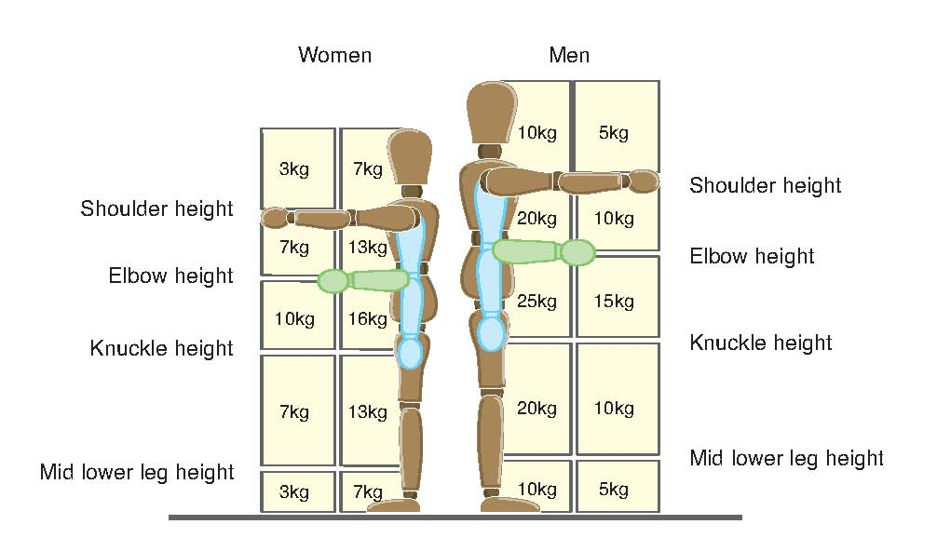

These weights are NOT what HSE say people must lift but loads which are unlikely to cause the average person harm. These figures assume that the load can be gripped with both hands, lifting is infrequent, the person is in good health and of average strength and build and there is no twisting.
- Before you undertake any manual handling – Think!

Before you undertake any manual handling, you should first think about the operation to make sure that you are physically capable, and the load is suitable to be moved. Do not undertake any manual handling if you have an existing muscular-skeletal problem i.e., bad back, shoulder, arm etc.

Always remember that you should be in charge of the load and never the load in charge of you.

- Good handling technique for lifting

Stop and think – plan the lift
- Where is the load to be placed?
- Do you need help with the load?
- Use appropriate handling aids if possible
- Remove obstructions from your route
- Is there a long distance to travel? Consider resting the load mid-way on a table or bench to change grip

The following description of good manual handling technique is represented by drawings on the right of each step.

Position the feet
- Adopt a stable position with feet apart and one leg slightly forward to maintain balance

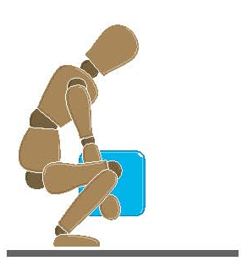Adopt a good posture
- At the start of the lift, slight bending of the back, hips and knees is preferable to fully flexing the back (stooping) or fully flexing the hips and knees (squatting)

Get a firm grip
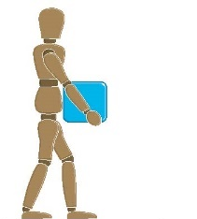
- Try to keep the arms within the boundary formed by the legs. The best position and type of grip depends on the circumstances and individual preference; but it must be secure. A hook grip is less tiring than keeping the fingers straight. If you need to vary the grip as the lift proceeds, do it as smoothly as possible

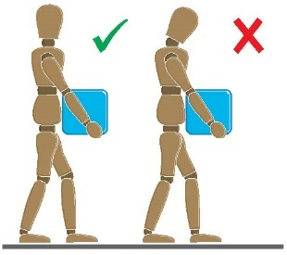
Lifting and moving
- Try not to flex the back any further while lifting
- Avoid twisting the back or leaning sideways
- Shoulders should be kept level and facing in the same direction as the hips

Turn by moving the feet not the body
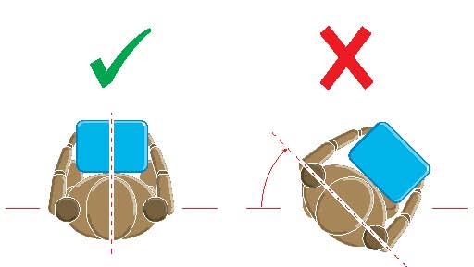
- Keep your head up when handling
- Move smoothly, try not to jerk
- Keep the load close to the trunk of your body for as long as possible
- Keep the heaviest side of the load next to the trunk
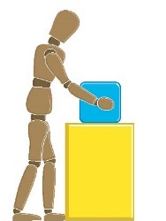
- If a close approach to the load is not possible, slide it towards you before trying to lift

Put down and then adjust
- If precise positioning of the load is necessary, put it down first then slide it into the desired position

Good handling technique for pushing and pulling

To make it easier to push or pull, you should keep your feet well away from the load and go no faster than walking speed.

Lifting may be replaced by controlled pushing or pulling in certain cases, such as sliding or rolling an object along. However uncontrolled sliding or rolling, particularly of large or heavy loads, may introduce additional risks thus increasing the risk of injury.

For both pulling and pushing a secure footing is necessary and the hands need to be applied to the load between waist and shoulder height wherever possible.

Pulling Pushing
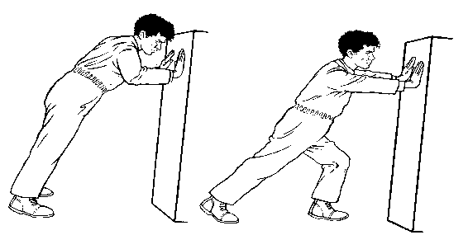
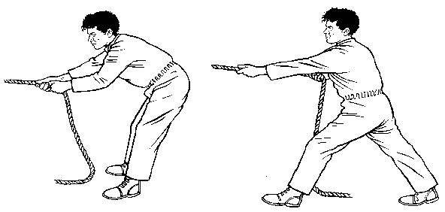

Wrong | Right | Wrong | Right
Mechanical handling

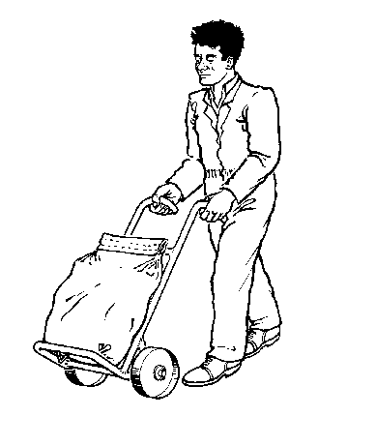
Mechanical assistance involves the use of handling aids – an element of manual handling is retained but bodily forces are applied more efficiently, reducing the risk of injury.

A trolley, sack truck or roll conveyor can reduce the effort required to move a load horizontally.

Handling devices such as hand-held hooks can simplify the problem of handling a load that is difficult to grasp.

Aids such as trolleys should have handle heights that are between the shoulder and waist. Devices should be well maintained and comply with any relevant standards, with wheels that run smoothly.

Lifting dogs

Before handling or lifting a dog, it is essential to assess the task and consider the following:
- The reasons for/against lifting, handling, or carrying
- The size and weight of the dog/puppy and the nature of its medical needs
- The distance and ground to be covered
- The capabilities of yourself and/or your helpers
- Any form of transport available

You may have to lift a dog for several reasons but, if you do, there is a real risk of hurting the dog and/or injuring yourself. Ensuring the safety of yourself and the dog must be your first concern:
- Do not endanger yourself
- Do not move a dog on your own if help is available
- Do use the correct lifting technique (below)
- Do give verbal commands to your helpers and work in unison

Whenever you lift anything (not just a dog) it is important to think of your own safety.

It is important not to attempt to lift a dog which is too heavy for you, so the following methods should be used. Always remember to adopt the best practice lifting techniques.

Dogs should always be encouraged to jump, use stairs or ramps but there will be times where there may be a need to lift a dog and it is important that it is done in a way to limit the risk of injury to you or the dog.

- Dog lifting methods

One person lifting a small dog or puppy
Place one arm under and around dog’s neck, the other arm is placed under the dog’s rump (ensure arm is over tail).

Two person lifting larger adult dog
- First person at the shoulder, with one arm curled around the dog’s neck, holding the dog’s head against the handler’s shoulder to control it, second arm passes under the thorax just behind front legs
- Second person stands at the hindquarters, places one arm under the abdomen, just in front of hind legs, second arm passes around the pelvis, over the tail, a third person can support the back
- Communicate and lift together so the weight of the dog is distributed evenly

