Make Every Cuppa Count 2024

Volunteer toolkit
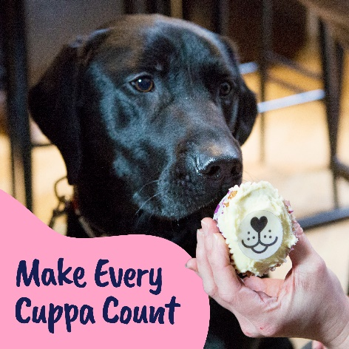

Introduction
For this year’s annual Make Every Cuppa Count campaign, we’re asking our supporters to Make Every Cuppa Count when they host a tea party, coffee morning or bake sale for Guide Dogs.

Our aim is to sign up around 2,160 supporters to fundraise this April and raise £135,000, with each supporter receiving a fundraising pack which features a new fundraising guide, cardboard money box, puppy sweepstake and more.

Small or large, at home, work or school, every penny a supporter raises will go towards helping us provide life-changing services.

If there’s a better excuse to get together over a cuppa cake, we haven’t heard it!

How can supporters get involved?
DIY supporters can sign up via our website guidedogs.org.uk/cuppa and receive a free postal fundraising pack, downloadable tools and everything they need to Make Every Cuppa Count.

Ideas:
- Love to bake or just eat cake? – Whether supporters catch up together at home, work, school or in their community, they can decorate with our bunting and show-off their baking skills with our cake toppers and flags. Will they bake it or fake it?
- Cake to go – Our brand-new cupcake recipe is available for supporters to bake up some delicious treats either on their own or as a team. There’s even a recipe for our tail wagging friends too!
- Doggy delights – Supporters are encouraged to gather their dog-owning friends to organise a nice walk and warm up after with a brew and biscuits encouraging everyone to donate to take part. Every cake, cookie and crumb really does make a difference.

What do supporters get when they sign up?
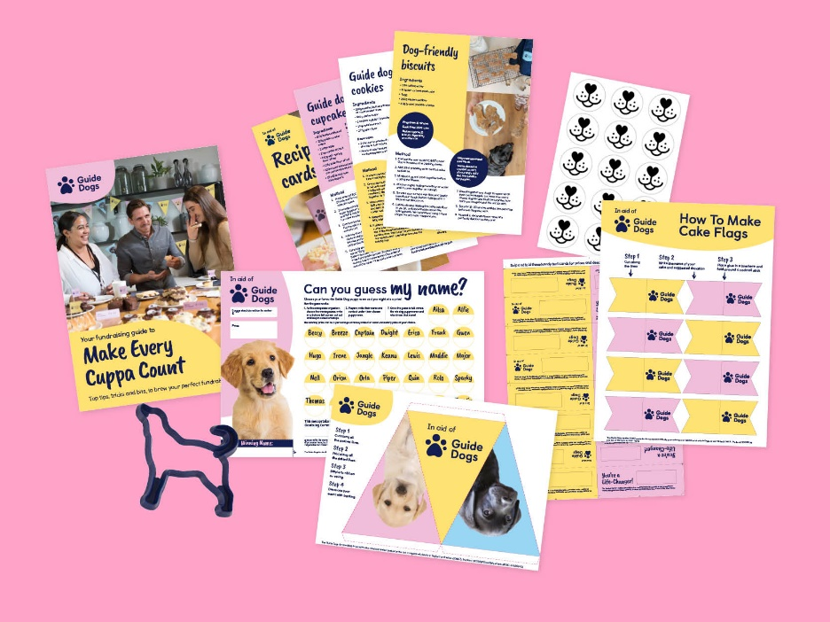

Alt text: Image of a Make Every Cuppa Count fundraising pack which includes a guide, cookie cutter, puppy sweepstake, recipe cards, bunting, donation labels, cake toppers and cake flags.

- Postal fundraising pack sent within 10 working days of their registration, including a new 12-page guide, cardboard money box, bunting, puppy sweepstake, and more!
- Bespoke fundraising advice from our Community Fundraising experts as part of our stewardship to build life-time value from each new supporter, in addition to an automated email journey.
- ‘I’m fundraising in aid of Guide Dogs’ t-shirt and dog ears can also be ordered on request.

Fundraising hard copy pack:
- 12-page fundraising guide.
- Poster.
- Cake flags.
- Cookie cutter.
- Cake nose toppers – 2 sheets.
- Donation labels.
- Puppy sweepstake.
- Bunting sheets.
- Money box.
- Gift aid form.

Downloadable resources:
- New! Jam jar labels.
- New! Quiz.
- Editable poster.
- Editable invitations.
- Donation tent cards.
- Bake off score cards.
- Recipe cards.
- Cake flags.

Exclusive invitation to visit Guide Dogs
Fundraisers will also receive an exclusive invite to our National Centre once they pay in the funds they have raised. This is to help welcome them to the Guide Dogs family and inspire them to do more fundraising or volunteering by showing them first-hand how their fundraising helps with a behind the scenes tour, guide dog demonstration, and talk from a volunteer speaker and guide dog owner.

Top tip: The easiest way for DIY supporters to pay in is via guidedogs.org.uk/payin.

How can volunteers support this year’s campaign?
Volunteers can access all the promotional and fundraising tools via the Community Fundraising Volunteer Newsletter, Intergroup meeting, Facebook and VIP .

- Promote Make Every Cuppa Count to everyone!
- Share your fundraising plans using our template press releases. Contact your local newspaper or radio station and let your local community know how they can support your fundraising efforts.
- Use our template emails to let any local contacts, your workplace, or community groups you are part of know about how they can get involved too.
- Re-engage with volunteers by inviting everyone to take part.
- Get involved with your own fundraiser and enjoy some cake and a cuppa.
- Share your photos and stories on social media and with press contacts. Our team would also love to see how you made every cuppa count – fundraiseforus@guidedogs.org.uk

If you want any additional fundraising resources such as a cookie cutter or cake toppers, please contact your regional Supporter Care team.

Top tip: Don’t forget when paying in the money you raised to use the code TEA PARTY on your banking slip.

Suggested Meta content for volunteers:

Promoting your fundraiser locally:

Join us as we Make Every Cuppa Count on <Add date and location of your event>! ☕

Visual description: XXX

Join us to Make Every Cuppa Count and host your own tea party, bake sale, or coffee morning on 19 April! 🧁 Sign up here guidedogs.org.uk/cuppa

Visual description: XXX

We’re making every cuppa count this April! ☕

The XX team are raising funds from our cakes and bakes to support Guide Dogs this XX (specify date of your fundraiser) April. Why don’t you join us?

Visual description: XXX

Why not create your own event on your Facebook Fundraising Group pages! Here’s some content to get you started:

Event name – XX(ENTER ORGANISERS WHOLE NAME e.g SEVENOAKS FUNDRAISING GROUP or YOUR LOCAL GUIDE DOGS TEAMXX) Make Every Cuppa Count fundraiser ☕ 🧁

We are popping the kettle on to Make Every Cuppa Count and we would love for you to join us!

Let’s celebrate our life changing work over a cuppa and lots of delicious cake at <VENUE> on <DATE> at <START Time>-<End Time>.

If there’s a better excuse to get together over a cuppa and cake, we haven’t heard it!

Visual description: XXX

Got a question?
So, what are you waiting for? Put the kettle on, invite everyone you know and let’s Make Every Cuppa Count!

Contact the Make Every Cuppa Count team at fundraiseforus@guidedogs.org.uk or call 0345 143 0192.

End of document.

