Foreign currency: social media template
Here is an example of how to make the most out of our social media assets for volunteers in relation to our foreign currency fundraising.

All assets are available in 1080x1080 (Instagram) or 1200x630 (Facebook, Twitter, or LinkedIn) for optimal use. Images can be downloaded via Facebook Sharing Ideas and VIP.

Facebook / LinkedIn post template 1 – English language:
Back from holiday but unsure about what to do with all those leftover foreign coins – why not donate them to Guide Dogs? 🌎✈️💰

Whether you have a handful of cents, or a few dollars. Our local Guide Dogs fundraising group can now accept foreign and out of date currency coins and notes donated via our collection boxes, collections, and other means. Your donation will then be converted thanks to our partnership with Leftover Currency and help provide our life-changing services. 🦮

[Visual description: Text ‘In support of Guide Dogs - Please donate your foreign and out of date UK currency to Guide Dog’ with an image of a yellow guide dog puppy lay next to a pile of foreign currency coins.]

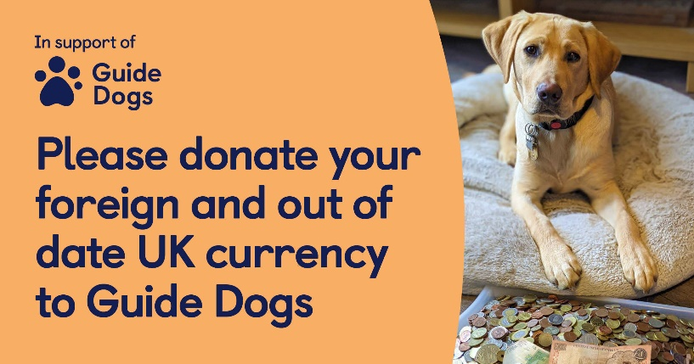

Twitter / Instagram post template 2 – English version:
Did you know our fundraising group can now accept foreign and out of date currency coins and notes? 💰 Donate them via our local collection boxes, store and street collections, or please get in touch.
[Visual description: Text ‘In support of Guide Dogs – Small change can change lives’ with an image of a yellow guide dog puppy lay next to a pile of foreign currency coins.]

Facebook / LinkedIn post template 1 – Welsh version:
Back from holiday but unsure about what to do with all those leftover foreign coins – why not donate them to Guide Dogs? 🌎✈️💰

Whether you have a handful of cents, or a few dollars. Our local Guide Dogs fundraising group can now accept foreign currency coins and notes donated via our collection boxes, collections, and other means. Your donation will then be converted thanks to our partnership with Leftover Currency and help provide our life-changing services. 🦮

[Visual description: Text ‘Yn cefnogi Guide Dogs – Rhowch eich arian tramor, neu hen arian Prydeinig, i Guide Dogs’ with an image of a yellow guide dog puppy lay next to a pile of foreign currency coins.]

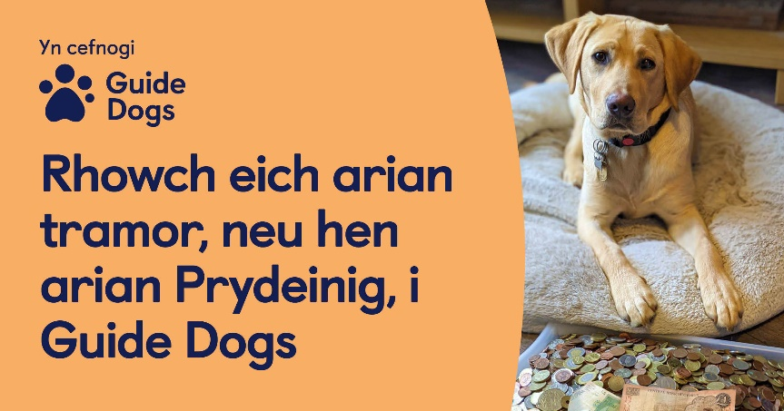

Twitter / Instagram post template 2 – Welsh version:
Did you know our fundraising group can now accept foreign and out of date currency coins and notes? 💰 Donate them via our local collection boxes, store and street collections, or please get in touch.

[Visual description: Text ‘Yn cefnogi Guide Dogs – Gall arian man wneud newidiadou mawr’ with an image of a yellow guide dog puppy lay next to a pile of foreign currency coins.]

End of document.

