# Image of running man.Ready, set…Fund Race!

# Image of a primary school boy running a blindfolded race, guided by rope. Text overlay reads Ready, set...Fund Race Image of secondary school children running the blindfolded race, guided by rope.

**Fund Race** is our key integrated fundraising and awareness campaign for all ages of schools and youth groups. It’s a learning experience about sight loss and inclusion, including assembly and class resources, that builds up to a fun sporting challenge to demonstrate what has been learned. Fund Race was developed after hearing Guide Dogs staff share their experiences of growing up with a vision impairment, and how their schools successfully adapted sports events. Each school who signs up on our website will receive a free downloadable or postal pack. Addnoddau Cymraeg ar gael – Welsh resources are available too.

## Key messages to the public

* **Fund Race** is a learning experience about sight loss and inclusion, building to a sports challenge that everyone can enjoy.
* The free assembly in the resource pack shares the lived experience of a young person with sight loss. There are also class activities and take-home reminders about the importance of regular eye tests.
* **Fund Race** includes a race or obstacle course for students, parents, and teachers – with a twist! Everyone in the race is blindfolded and uses a rope or partner as their guide.
* In the UK today, there are around 28,000 children who have a vision impairment. We’ve created this challenge to start important conversations about sight loss and being more inclusive and accessible.
* Schools and youth groups can make **Fund Race** part of their calendar and raise vital funds while also learning more about sight loss. It works as part of an existing sports day or a standalone event, whatever the time of year.
* We’re best known for our incredible guide dogs. But we also support thousands of children and young people across the UK.
* Every pound raised by **Fund Race** will make a difference. Just £48 could buy a child a custom-made, large print book so they can read a paper book just like their friends.
* Find out more at [**guidedogs.org.uk/FundRace**](http://guidedogs.org.uk/FundRace)**.**

## No *sweat* required to get involved

You can signpost any school/group to sign up via [**guidedogs.org.uk/FundRace**](http://guidedogs.org.uk/FundRace)to receive our free downloadable or postal resource pack, specific to their age range, which includes:

* Guidance about organising the event and fundraising ideas.
* An assembly plan including learning about accessibility and inclusion, with a PowerPoint and YouTube videos of children and young people with sight loss sharing their own stories.
* Information on how to invite a Guide Dogs speaker.
* Lesson resources including the all-important blindfold to cut out and decorate with an inclusivity pledge. The pledge can also be written on a take-home postcard to show parents/guardians which includes a reminder about regular eye tests for children.
* Editable posters, stickers, certificates – and more! 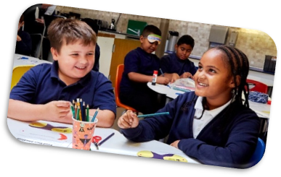

## Money clipartTop tips for schools to *run* up funds

Asking race participants to pay to enter.

Running a refreshment stall for all those thirsty racegoers (and spectators)!

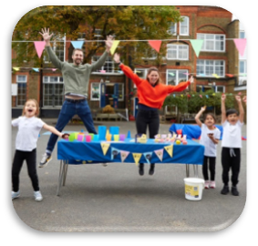

Asking for donations at the event or via a [**JustGiving**](http://www.Justgiving.com/campaign/FundRace) page which can be set up at [**justgiving.com/campaign/FundRace**](http://www.justgiving.com/campaign/FundRace).

Setting up blindfolded mini-games or obstacle courses, with a small fee to join in the inclusive fun.

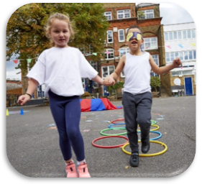

Schools and groups that pay in their fundraising total will receive a **Guide Dogs Champion for Active Inclusion** accreditation to display.

## We want you on our team! Image of teenage boys high fiving during the Fund Race event.

There is so much you can do to help support our **Fund Race** campaign.

### Image of bronze medalA quick sprint

Hit 'like' on our **Fund Race** social media posts or share content on pages you are linked to. This free action takes seconds but can help increase our engagement and reach even more potential supporters.

### Image of a silver medal.A steady jog

Are you a parent/guardian or connected to a local school or youth group? Maybe you already have school contacts through your Guide Dogs role? Tell them directly about this exciting opportunity with one of our **flyers** or **template email**, both available to download from VIP. Signpost them to [**guidedogs.org.uk/FundRace**](http://www.guidedogs.org.uk/FundRace)so they can register for a free resource pack.

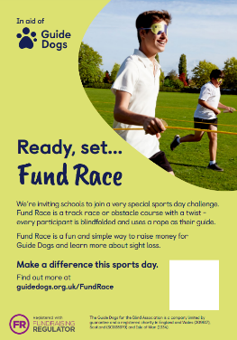

### Image of a gold medal.A marathon effort

* Take the first hop, skip, and jump in making a difference by volunteering to be part of the fundraising team at your local school or youth group if they sign up to **Fund Race**. Showcase your gold medal work on social media using **#GuideDogs** so we can see and respond.
* Share regional fundraising stories on your social media channels and support any local press coverage with our help.
* Going to any events? Take our **English and Welsh flyers** with you to pop up on noticeboards or leave on reception desks.

#### Any questions?

Email the project team: [**FundRace@guidedogs.org.uk**](mailto:FundRace@guidedogs.org.uk)

Thank you. 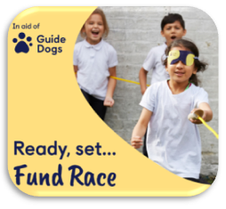

#### End of document.