The Guide Dogs Puppy Appeal – VIP update.

Heading: The Guide Dogs Puppy Appeal

Download all the resources you need to support this year’s Guide Dogs Puppy Appeal. If you are a Fundraising Group and need any additional resources, contact your Regional Supporter Care Team for their help.

On this page
< Training pups to become life-changing guide dogs
< Promotional resources
< Social media
< Generic fundraising resources
< Schools and youth groups fundraising resources
< Press release

Training pups to become life-changing guide dogs
<Please remove this video>


<Please replace with this image>



Visual description: A group of guide dog puppies pictured playing outside on the grass together. The text overlay reads Guide Dogs Puppy Appeal.

Living with sight loss can be incredibly difficult. Without the right support, people can be left feeling alone and isolated. From their friends and family, careers and communities, from the world they knew and the lives they planned.

But our dogs transform the lives of people with vision impairments; being partnered with a guide dog reduces loneliness and enables people with sight loss to get out and live the life they choose.

Every year around 1,350 puppies start their journey to become a guide dog and we’re asking supporters to join the pack this October and support Guide Dogs so that we can create the life-changers of tomorrow.

We’re also bringing the Guide Dogs Puppy Appeal into assembly halls across the UK. Tell schools to save the date of Thursday 9 October so they can join our interactive live Guide Dogs Puppy Appeal assembly for fun, learning, and, of course, puppies!

Promotional resources
Volunteer Toolkit
Remove Flyer – English
Remove Flyer – Welsh
Template email for local contacts
Template email for local nurseries, schools and youth groups
Editable poster
Collection request template – Single date
Collection request template – Multiple dates

Social media
Remove template social media posts
Remove champion image 1080 x 1080
Remove champion image 1200 x 630
Remove donate an hour image 1080 x 1080
Remove donate an hour image 1200 x 630
Keep all of these:
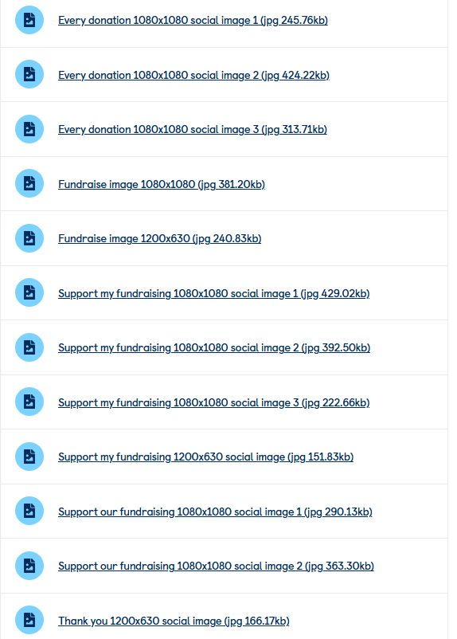

Generic fundraising resources
Remove Champion fundraising guide and replace with DIY Fundraising ideas leaflet
Donation jar labels
Remove Guide Dogs Puppy Appeal puppy sweepstake 30
Remove Guide Dogs Puppy Appeal puppy sweepstake 50
Puppy sweepstake
I’m fundraising/thank you poster

Please remove this section completely:
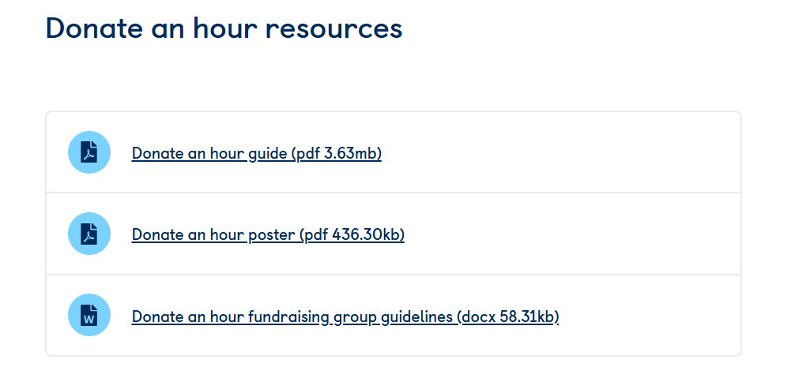

Schools and youth groups fundraising resources
Fundraising ideas leaflet – schools & youth groups
Young people sponsorship form
We’re fundraising/thank you poster
Colour in for Puppy Walk sheets

Press release
Remove Champion Regional Press Release
Remove Donate an hour Regional Press Release
Fundraising press release

Got a question?
Your local Community Fundraising Manager is here to help you or your group fundraising as volunteers. If you want any additional fundraising resources, you can also contact your regional Supporter Care team.

If you need any further information or advice, please contact the Guide Dogs Puppy Appeal Team.

Email: guidedogsappeal@guidedogs.org.uk
Phone: 0345 143 0192

End of document.

