Arco: Volunter User Guide

Follow this link to go to the Arco homepage: https://www.arco.co.uk/

[The image below shows a little silhouette of a person located on the top right of the Arco home page, and under that there are two links displayed next to each other, saying ‘Register’ and ‘Sign In’]
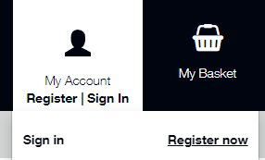
At the top right hand side of the Homepage for Arco, please select ‘Register’

[The image below shows text saying ‘Registration’ and ‘Enter your email address’ with a free text box just below, and a ‘Continue’ button below that]
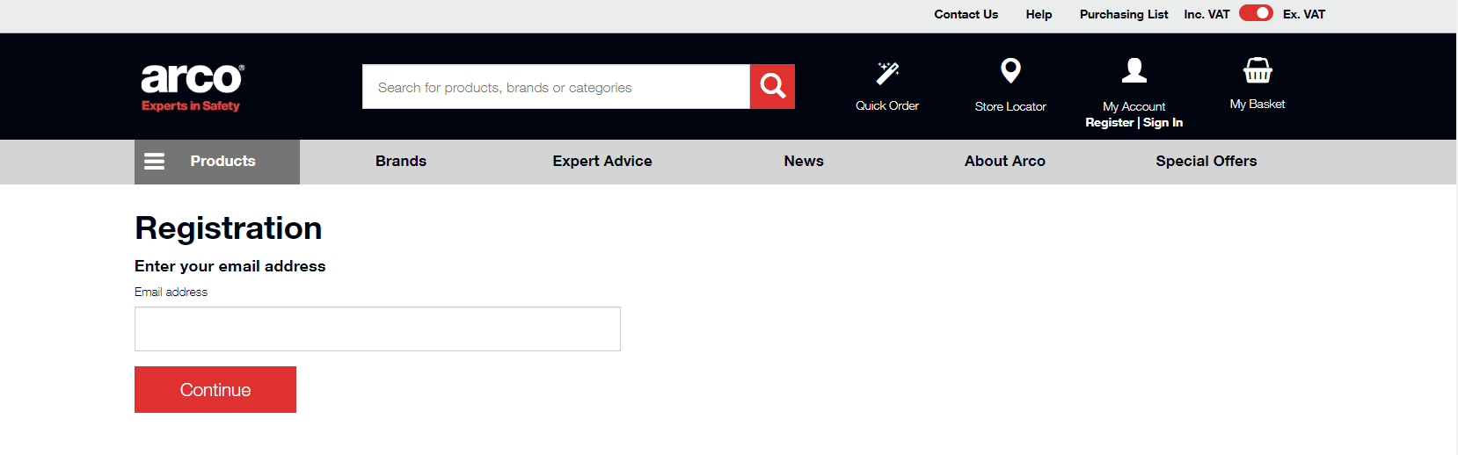
When you first go to the webpage, click on the text near the right hand side at the top of the screen that says ‘Register’ and pop in your email address

[The image below shows the text ‘Registration’ along with ‘Do you have an account number?’ and a tick box of ‘yes, I have an account number’. A free text box is below that and a ‘Continue’ button is below that]
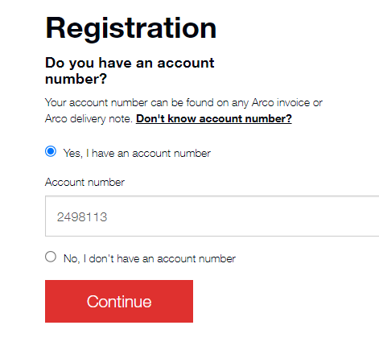
When prompted to enter an account number, select ‘yes’ and then in the free text box write: 2498113 and proceed to ‘Continue’

[The image below shows the text ‘Registration’ and below that it says ‘Please enter the post code registered to this account’ and below that is a free text box, below that is a ‘Continue’ button]
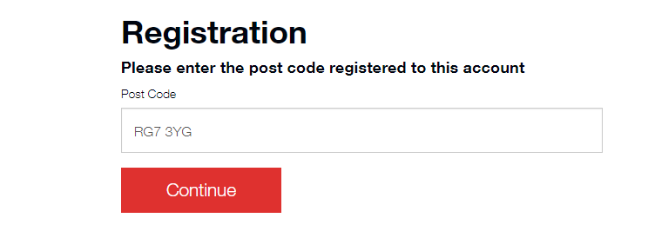
When prompted, please enter the postcode of our Head Office which is RG7 3YG so Arco can link your account to our official Guide Dogs Volunteering Account

[The image below shows the text ‘Registration’, below this it says ‘Enter your personal details’ along with a drop-down box for your title, followed by four free text boxes to enter your information]
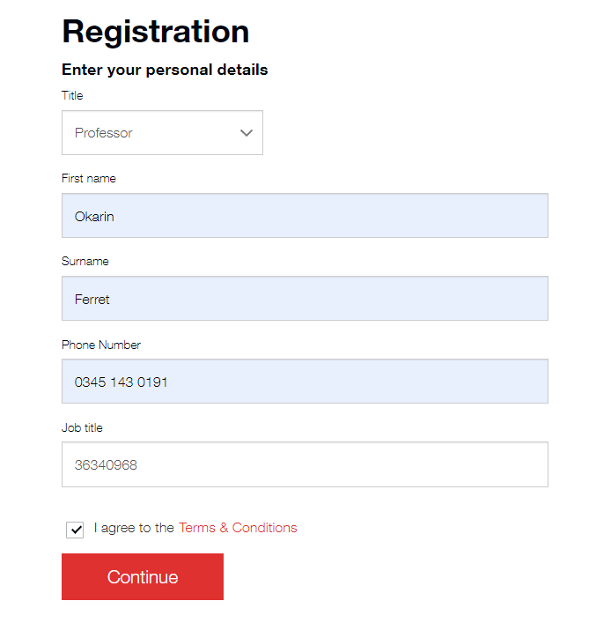
Please complete your details of First Name, Surname and Phone Number in the free text boxes, and in the last box where it says ‘Job Title’ please enter your Volunteering number which can be found on your Volunteering ID Card (alternatively if you are unsure what your number is please contact the Volunteering Office by email at volunteer@guidedogs.org.uk or by phone on 0345 143 0191)

Please ensure that you have read the Terms & Conditions, and if happy with them, tick the box on the left hand side of this text before going to the ‘Continue’ button below the tick box.

[The image below shows text saying ‘Registration’ and ‘Finally, create a password’ along with two free text boxes for you to enter a secure password for your account, followed by a ‘Continue’ button below that]
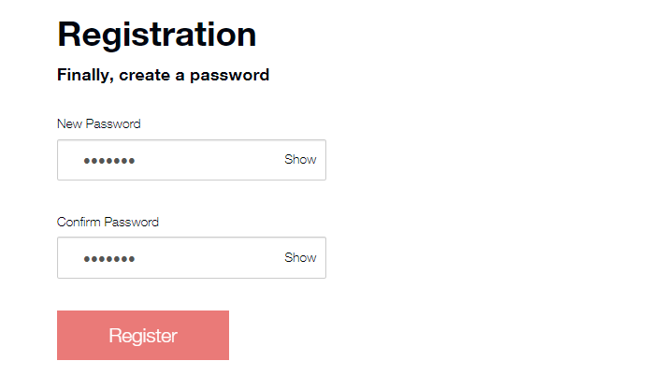
Please then enter a secure password for your account
You will then be promted to log in to your email which you are using to register your account, and go to the email that you should have received from Arco about verifying your email address with them. Please follow the link in the email to verify your account, to enable you to log in successfully.

You will then need to wait for the Volunteering Office to verify your account before you can move on to the next step. Our office hours are Monday-Friday, 9:00am-5:00pm and we have a 3 day turnaround to action and respond to an account request. Once you have received a second email from Arco to say that your account has been verified, please follow on to the next steps in this guide.

[The image below shows a little silhouette of a person located on the top right of the Arco home page, and under that there are two links, saying ‘Register’ and ‘Sign In’]
Go to ‘Sign In’ and enter your email address and password that you have set up in the previous steps.

[The image below shows an overview of your new Arco account, including information such as Account Information, Recent Orders and a Purchase List]
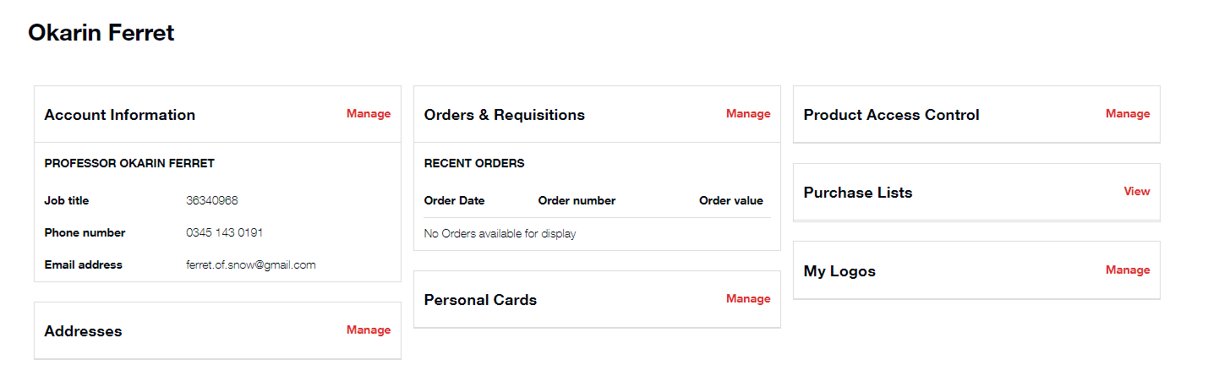
On the right hand side of this screen, the third column along, the second row text box displayed is ‘Purchase List’ and to the right of this is a link you can select which says ‘View’, please follow this link.

[The image below shows text ‘Purchase Lists’, a free text box is below this titled ‘Search’ and below that is a link titled ‘Clothing – Volunteers’]
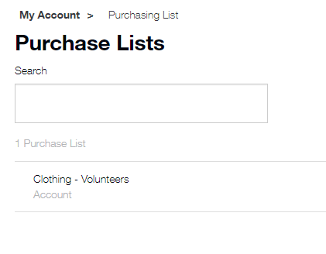
Please follow the link ‘Clothing – Volunteers’ to be brought to the page which displays all of the current available Guide Dogs Volunteering Clothing

[The image below shows text ‘Clothing – Volunteers (account) with a free text Search box below that, and directly to the right of that a drop-down menu to arrange the order that volunteer clothing is displayed. Below these there are multiple images of the various volunteer clothing styles with text below the images describing what they are]
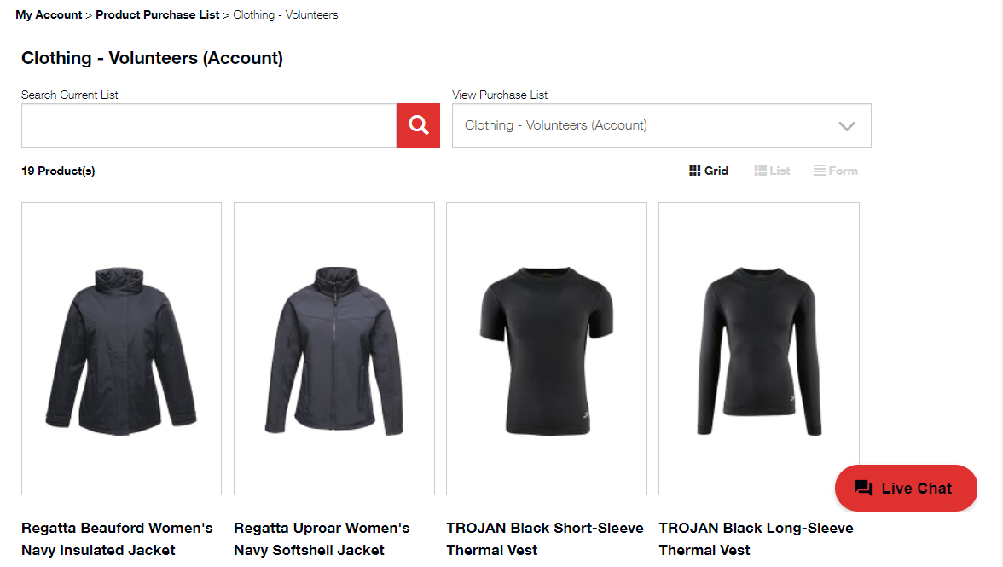
You can now browse through the range of volunteer clothing items we have to offer, and when you wish to select an item click on the ‘Add to Basket’ box displayed below each individual item.

[The image below shows a pop-up box that has text displaying the name of the item you have selected to add to your basket, followed by the price just below that. A tickbox will be pre-filled in saying ‘Standard Products’ and below this is a drop-down menu for you to select your required size of clothing. At the bottom of this pop-up box slightly to the right there is a button that says ‘Add to Basket’]
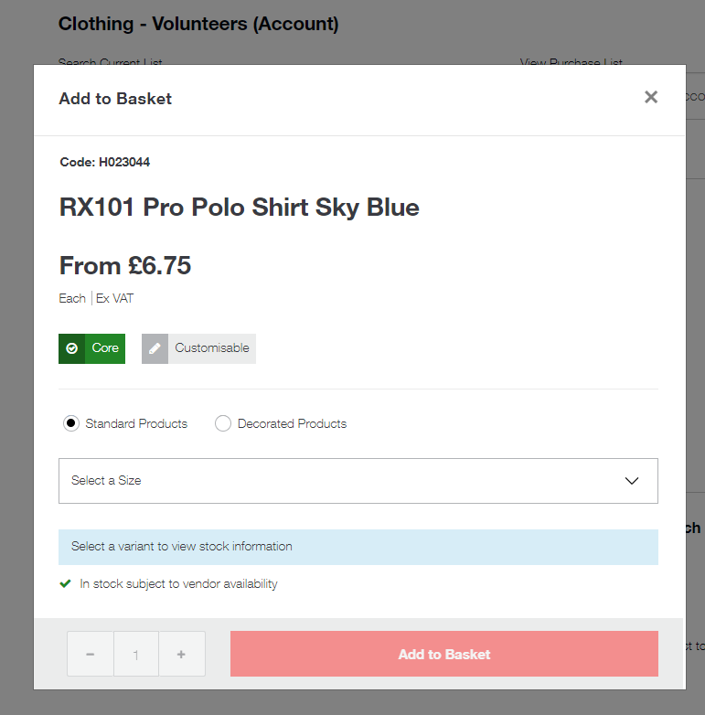
When prompted please select your required size, and follow the button Add to Basket.

[The image below shows the contents of your basket, with an image of your chosen item of clothing on the left hand side and the cost of the item(s) displayed on the right. A ‘Decoration Applied’ box is below the image’. The ‘Checkout’ button is to the right hand side of the page below the price list]
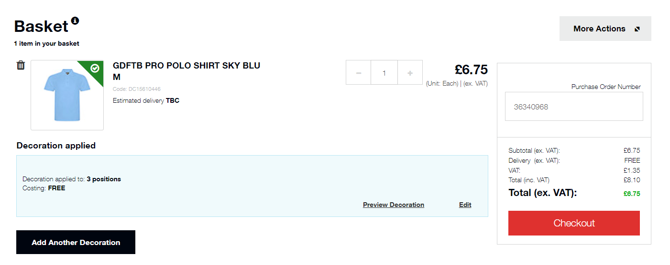
Once you have chosen your item(s) a ‘Decoration Applied’ section will be shown to let you know that our logo will be printed on your chosen item(s), you can follow the ‘Checkout’ button once you are happy with your selection(s).

[The image below shows text saying ‘Checkout’ followed by five small tables of context displaying sections related to delivery]
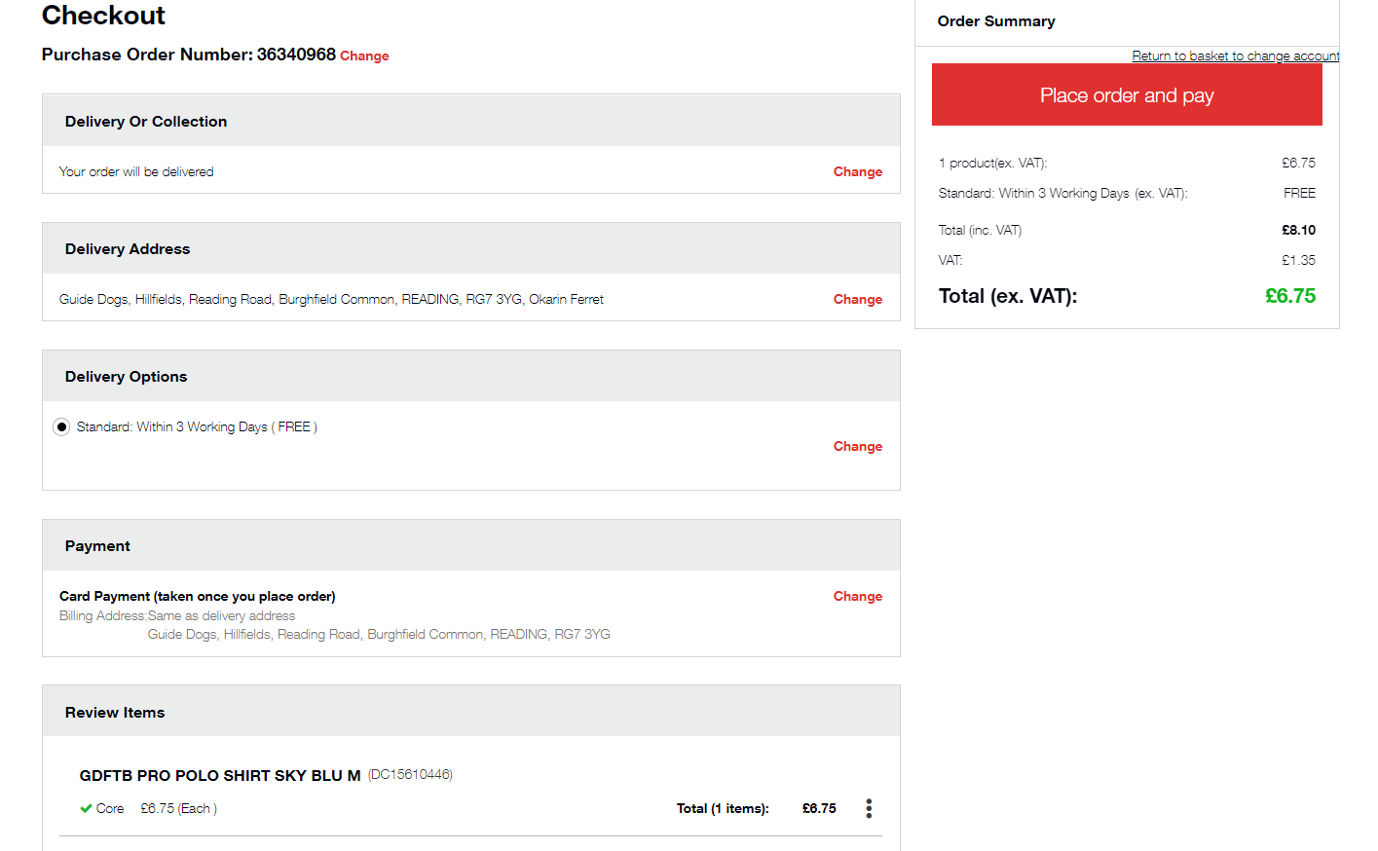
In the second table where it says ‘Delivery Address’ please follow the ‘Change’ link to the right hand side of this table, and enter your address where you wish your clothing to be delivered to.

The fourth table that says ‘Payment’ will require your card details, please follow the ‘Change’ link to the right hand side of this table to edit and add your card information.

Once you are happy with your selections and that all of the delivery and payment information are accurate and correct, please select the ‘Place Order and Pay’ button on the top right of the screen to complete your order.

